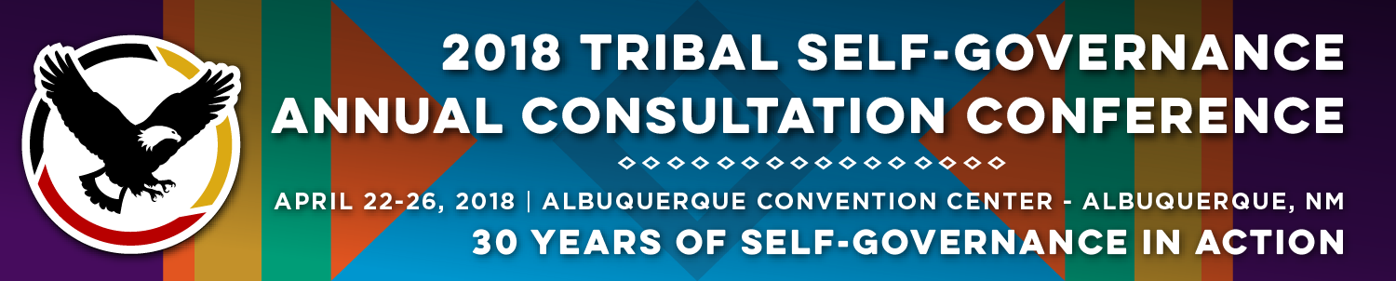

Recorder Form

Onsite Contact Tami Snow 918.388.7428
Recorder: Megan Lenaghan | Date: April 24, 2018
Session Title: Indian Health Service/Tribal Workgroup Updates
Panelists:
- Elizabeth (“Liz”) Fowler, Deputy Director for Management Operations, Federal Co-Chair, PRC Workgroup
- James (“Jim”) Roberts, Senior Executive Liaison, Intergovernmental Affairs Alaska Native Tribal Health Consortium
- CAPT Mark Rives, DSc, Director, Office of Information Technology, IHS, Federal ISAC Representative
- A. Stewart Ferguson, PhD, Chief Information Officer (CIO), Alaska Native Tribal Health Consortium, TSGAC Representative, ISAC
Summary of Issues and Items Discussed:

Liz Fowler:
Serves as Federal partner on Workgroup; description of acronyms (IHCIF - Indian Healthcare Improvement Act, LNF - Level of Need Funded – how funds are allocated, FDI - Federal Disparity Index; interchangeable with LNF; every Native American have health benefits; calculated at IHS and Area level and at every specific site; gives benchmark, establishes; how much it should cost us; subtract out
Funds Needed – Funds Available = Funds Deficiency (factors to calculate Need – population, costs, health, local)
Factors for funds available (IHS, Federal state, private); looking at conceptual framework (image), benchmark trying to reach, set of funds available to reach, factors that go into establishing; adjusted for health status and local/regional cost differences; basic model what newly established workgroup is looking at

Jim Roberts:
Heard that IHS is only funded at 50-60% of funding level; this statement comes from this workgroup; using this basis to determine how much of this basis is needed Federal health benefit; resurrection of this workgroup from DTLL; subsequent workgroup into improving population of information; recommendations around issues, briefly described; have access to data to improve and refine components; prompted by Congressional action with providing of funding, there will be a final consultation process; and then funding provided not all Tribal operating site will be able to receive this money depending on previously described methods; adjusting benchmarks for sites; 2011 Findings and Recommendations; IHS Director (at time) decided not to change IHCIF until sites reach 55% of need; 2018 reconvene workgroup meetings; had to reacquainting with previous work and what other discussions had come about through Tribal Consultation; summary of issues that came back around (outlined on slides), using insurance model benchmark, limited to services provided by insurance; using IHCIA looking at many other services; alternate resources (25%) – most controversial right now; Decision Points – BlueCross, Blue Shield model, IHCIA authorization – move from insurance model to benchmark National Health Expenditure Plan (HHS produces national health expenditure report that wrap ups all services; components of this model is more representative of this); this increase is the per capita benchmark increase; living adjustment made for Alaska; takes into consideration dental and vision (NHEM includes dental and vision; other public health factors that are included in this model of care as is healthy educators and CHRs; insurance model underrepresented needs of Indian Country; assess current user population used in user model; may not be resourced to provide care for someone outside CHSDA, this may help support/provide adjustment for non-CHSDA users; get breakdown of what current accounts include; discussion of fractionalized user; not financed to provide resources to user; data systems may not be refined enough to do this calculation; but something to look at for the future; not a final recommendation; action look at Priority I denials; come back with recommendation

Mark Rives:
CIO from IHS; health IT modernization – draw link between data that is needed in developing the changes and this is the data that drives modernization; FITARA and data ware house, interconnectivity; need better systems to get questions posted by Congress and others; IT Strategic Plan and human capital management plan; where do we want to go and how to get along; VA announcement and DOD mentioned going off VISTAA; VA will use same system as DOD to support out-processing, etc.; brought to light to IHS; timeline broken down to Periods – in explanation of what could we do… talk to other Tribal health systems as well as, for example, military health system; infrastructure workflows and technology and what is needed to support any changes; Period 2: gap analysis between what we are buying and what we need; and what we could need; go through acquisition; how to successfully pull data out, 17 years of data available and cannot lose this; security and privacy approvals Period 3-7 – new RPMS system or third party off the shelf; HIP modernization – augment, modernize, or replace 40 responses from all big EHR (Cerner, NextGen, etc.) and from current IHS contacts; movements to cloud, restructure operation of system; unique ideas that hadn’t been shared before; modernize RPMS included – centrally hosted cloud platforms; next steps- refining what is needed; there is a wealth of information, it is taking a significant amount of time but it is being looked at; continuing conversations with those that can help and support; working on integrated data collection system; set-up for success; moving one system ahead to what is needed in the future; National Data Warehouse environment- capture data and engagement of information; need to maintain data collection for sharing the data to support needs; Strategic Initiatives – Strat Plan to be brought in alignment with quality initiatives with new Office of Quality and IHS Strategic Plan; HHS and IT Strategic Plan; FITARA approved by Congress – flag acquisitions going on; work on more economical buying models several other initiatives; newest one is looking to figure out how much has been spent on initiatives (Plan View); QLIK – dash boarding system used mostly from Office of Quality; electronic prescribing controlled substances; electronic credentialing system; track documents and help; Mark.Rives@ihs.gov

A.Stewart Ferguson
Representatives from TSGAC to IHS Systems Advisory Committee; Information Systems Advisory (ISAC) is established to guide the development; membership is defined by nine positions plus eight members for Federal; ISAC Revised Charter – defines purpose, it is currently going under revision – many components will be changing; outside looking in – still doing a lot of work moving underlying technology to modern ensemble version; clinical quality measures, ISAC decided to re-add; sign Commercial Off the Shelf (COTS) – 72% increase to COTS, yet still RPMS usage is greater; question (does this actually demonstrate the workload); Alaska – not cohesive; why change to COTS – pricing models are so different; ambulatory systems that don’t work in hospital; how do you choose a system; do you share a domain?; share clinical domain with data gathering; centralize services – does it offer optometry?; Use with Dentrix; how to use with data and analytics; what IHS does now will not be how they operate in the future; if go after COTS system IHS will need to have staff trained and available for this; should this be centralized or distributed? Can look at other Tribal Partners; look at standardization versus impact of making own decisions; opportunity to grow; how to document and manage care – make operational and strategic decisions
Questions from the Audience:

- Is there talk about creating a matrix of information to help Tribes make better decisions about integrating systems, training staff?
    - Response: Can put on a to do list

Follow Materials, Documents, Websites for Reference:

- Ability to track, trend, and analyze all the information regarding electronic systems

