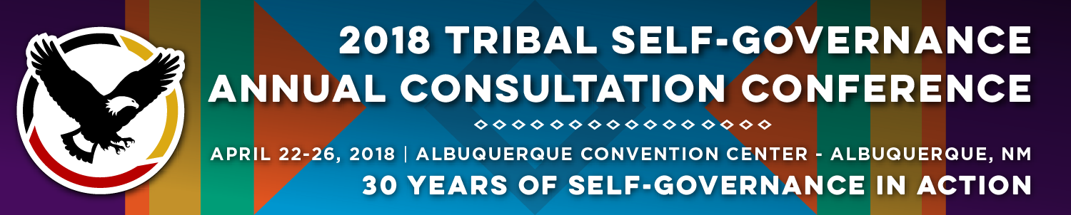

Recorder Form

Onsite Contact Tami Snow 918.388.7428
Recorder: Megan Lenaghan | Date: April 24, 2018
Session Title: Purchased and Referred Care (PRC) Workgroup Update and IHS PRC Policy Consultation
Panelists:
- Terri Schmidt, RN, Acting Director, Office of Resource Access & Partnerships, IHS
- James (“Jim”) Roberts, Senior Executive Liaison, Intergovernmental Affairs Alaska Native Tribal Health Consortium
- Elizabeth (“Liz”) Fowler, Deputy Director for Management Operations, Federal Co-Chair, PRC Workgroup
Summary of Issues and Items Discussed:

Terri Schmidt:
Review input (from DTLL for suggestions) received to improve; Director’s Workgroup on improving PRC; evaluate existing formula for PRC funds; workgroup had an aim and vision; ensure PRC services; guiding principles of program and purpose; address needs and eligibility in a fair and equitable manner; apply future decisions and formula funding; members committed to inform current policies and practices for future health; recommendations set to define unmet needs; subcommittee goals - calculating unmet needs; consultation on evaluation set aside for screening and health prevention; conducted Tribal consultation and optional set aside for prevention services; improve system wide training and orientation process; delay consultation - discuss GAO recommendations; GAO policy and implementation; policy is not yet published - GAO won’t close recommendations; recommendations are the unmet needs; updated data collection; to reflect more accurate estimate of the need; this is contained within the new chapters; update area directors on what to do when run out of funds for PRC; written policy and direction is within the Policy of the Manual; when distribution of new program funds; recommendations from GAO on the “high risk list”; coincide with laws and regulations; RN care coordination; PRC listserv; CHEF funding – short and long term goals; base funding remain unchanged; workgroup influential on improving PRC; first time in history reviewing CHEF; 2007 discussed MLR in his

Jim Roberts:
Review and provide input; evaluate PRC; recommend improvements – PRC Workgroup goals; workgroup met in June 2017, first time group met in almost two years; re-familiarization with operations and formula and past decisions of workgroup; focused on catching up; re-appointed to workgroup; after acclimation process second meeting focused on formula; one GAO (Government Accounting Office) reports included information regarding unequitable access to PRC resources; provided recommendations that IHS could review; anytime formula is changed there are politics - winners and loser depending on decisions made (example: areas that have access to hospitals); there are PRC dependent areas; agency line items; accessibility; hope was ACA to reduce need for PRC; GAO wanted to understand implication of recommendations; high risk list reported to Congress; findings were still valid but GAO agreed to close out; should be close to closing out GAO findings affecting PRC (anyway); pending Manual (PRC Chapter)l for Tribal Consultation until final outcome in Redding litigation

Liz Fowler:
PRC under her portfolio of duties; Federal co-chair for PRC workgroup; workgroup critical for those at IHS; relies on recommendations for IHS decision making; senior staff representation; consultation on PRC Chapter – it is Policy for Federally administered programs (Indian Health Manual includes policies and procedures); Agency states need to wait to update Manual until Redding case closed; moving forward with update on PRC Chapter; helping to resolve and close GAO recommendations; send out chapter for consultation – consideration of two-step consultation process; trying not to result in confusion; Weahkee took this recommendation into consideration; determined can update chapter and include statement of chapter relating to decision of litigation and will move forward with sending out chapter for consultation (mid-May) - still some internal clearance processes that need to be included anytime a policy is updated; once obtain clearances will move forward with sending out; plan on discussion with workgroup to review change with workgroup; encourage involvement with monthly All Tribes Call
Questions from the Audience:

- Jim – Manual’s effect on Tribes; what would attendees like workgroup to look at in evaluation
- Chief Malerba – understand scope/needs of PRC; suggestion: quantify level of tertiary care is available to the operating unit; what kind of specialty care, what is the travel distance to that - travel is so significant to so many people and that impacts the burden on PRC, these are some of the things we should be thinking about; 20 emergency departments and operating rooms at IHS at last count, so no matter what you will be sending people out
- Maria (Feather River) – California does not have hospitals; being able to use ACA at hospital and pay premium to get them eligible, now seeing people not applying since going away and access to care is not fully balanced with change of ACA going away; in the past patients willing to sign-up
- Update priorities of care – example: acupuncture and alternative medicine is still on exclusion list; especially when facing opioid epidemic, looking for other sources to deal with pain when this is an issue
- Already seeing people say the process of signing up for the open market plans is so awful and now that they don’t have to they won’t do it

Response from Liz:
- Comment about incorporating impact on ACA – lots of discussion incredible effect on some of our programs; approving priorities level III and IV; expanded Medicaid; some Tribes still can’t cover due to no Medicaid expansion; one reason IHS relooking at formula because of impact; still don’t know impact if sustained – past implementation; recognize priorities need to be updated on routine basis

Response from Terri:
- Works with CMO on updating priorities; Areas can do their own medical priorities, but have to fit within national; even if not updated if it becomes Medicare approved and on Priority V you can use it; you have to annotate approved by Medicare; Tribal programs can do their own medical priorities, you don’t have to go by the Manual

Questions
- Concern with no ACA and impact on sources

Response from Jim:
- Repeal and replace response, states that have expanded Medicaid in Republican states; shift in policy away from Congress/DC; Medicaid expansion related; effect on overall market at ACA

Questions
- Navajo Nation- in facilities 638 hospitals; lack of education; Compact PRC
  - Training possibly can come out of SGCE
- Rolling Hills Tribe – Tribe shorted in process, given to another Tribe that isn’t supposed to be there; receive PRC based on 1994 survey and funding is only for 11 members, Tribe has over 300 members; currently Tribe I and moving to Title V, using money; one of the programs is getting the funding for the people that we have; have a lot of undocumented Tribal members coming to Clinic for support

Response from Terri:
- Training materials are on the way

Questions
- North Dakota – guidelines and priorities

Response from Jim:
- Not necessarily bound by prioritizing level that agency has implemented; you can decide what is you your Compact and what is included in priorities levels

Questions
- Tribe response - was told could not use PRC for money because independent guidelines during an audit

Response from Liz:
- Will review on audit

Questions
- Increase in preventive care
- Tribe in Nebraska – CHR; loss of baby if this is not level one then what is
- Does Agency have Plan – remote change that there could be some issues that remain (with Redding case)
Follow Materials, Documents, Websites for Reference:
- Education materials for PRC and use of the program

