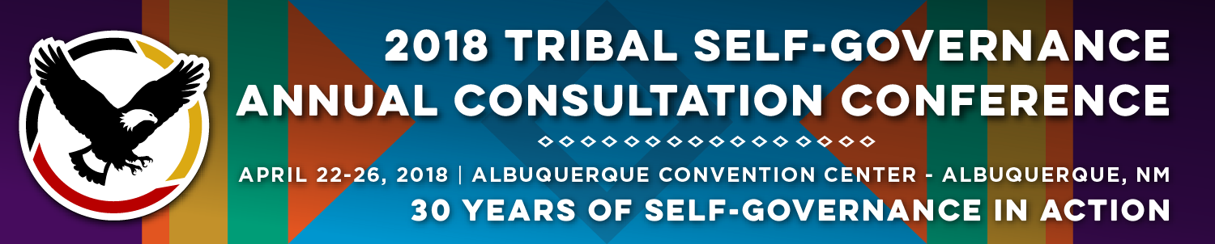

Recorder Form

Onsite Contact Tami Snow 918.388.7428
Recorder: Michaela Stroup-Madrid | Date: 4/25/18
Session Title: Self-Governance Success Stories
Panelists:
- Jeri Loretto, Grants and Contracts, Jemez Pueblo
- Kara Horton-Wright, Administrator, Director of Tribal Services, Port Gamble S’Klallam Tribe
- Margret Zientek, Assistant Director Workforce and Social Services, Citizen Potawatomi Nation and Co-Chair 477 Tribal Workgroup
- Steve Osborne, Partner, Hobbs Straus Dean and Walker LLP
Summary of Issues and Items Discussed:

- Margret
  - What is 477?
    - 64 tribes that are currently 477 tribes
    - Started in 1993
    - Have to take funds from at least two different funding streams and develop a plan that works for your tribe
      - Every tribe’s plan and combination of services is unique
    - You can take any of the funds that are in the tribes 477 account and apply directly to economic development
      - Citizen Potawatomi first used their money to make a tribal grocery store
      - Next, they made a revolving loan pool—eventually turned it over to the local CDC to manage
  - What are the new 477 amendments?
    - December 18 2017
    - Fixed problems in the demonstration project
    - Reduced the number of reports—formerly could require upwards of 22 reports, now there are just 3
    - The whole purpose is better service to clients
      - Steps toward sovereignty
    - Agencies must pay full IDC costs (IDC is the cost of running the program)
    - Expanded the number of agencies that can be in 477 programs to 12
    - Timelines that give specific number of days agencies have to approve
      - If they fail to act in time, it is automatically approved
      - Gave a repeal process to denials

- Kara—Social Services at the Port Gamble S’Klallam Tribe
  - Has been running since 1980s
  - First tribe in the nation to run a federally approved Title IV-E foster care starting in 2012
  - Two childcare intervention version of positive Indian parenting (NICWA) and family group decision making which is a form of family engagement
  - Lets them use their cultural definition of extended family
  - Children and families Assistance Programs
    - Part of tribal TANF
    - The biggest program in their 477 program
    - Food bank, SNAP benefits, clothing bank,
  - Child support program
    - Started in 2002
    - Work with families to strengthen relationship of the family
    - Kinship navigator funding can buy kids glasses, etc. Lots of flexibility in spending
  - Health clinic and behavioral health
    - medical dental
    - mental health
    - chemical dependency
- Steve— New Amendments to 477
  - PowerPoint is a step by step roadmap for how to get in to 477 and the possibilities with the new law
  - New agencies eligible for inclusion: interior, HHS, education, labor, justice, agriculture, commerce, energy, homeland security, HUD, transportation, and veterans affairs
  - program must be for the purpose of job training and economic development to qualify for 477
  - Source of funding must be from a tribe, block grant, funds eligible to be received solely or in part of their status as Indians under federal law
  - Application process
    - Must have funding from two or more sources (eligible agencies)
    - Submit 477 plan to Interior
    - Interior consults with all agencies that are contributing funding
    - Interior approves or denies plan in 90 days
      - Deemed approved if nothing happens in 90 days
      - Must be approved unless there is an explicit violation of the legislation
      - Tribes have the opportunity to repeal a denial
  - Once approved, the tribes can take the funds and begin using them as demonstrated in plan
  - Waiver requests to overturn administrative, regulatory, and statutory requirements in order to customize plan to fit community
    - Again, must be approved unless it is deemed inconsistent with the intent of 477
    - If two agencies disagree on the waiver, the agencies must go through an interagency dispute resolution process—tribes sit back and watch
  - Tribes have full control over how programs are designed and implemented
  - MOA to develop implementation plans must be signed by December 18, 2018
    - Sounds like it will be done much sooner than the deadline
  - You don’t get more money going 477, but you use it more efficiently
  - Can recover 100% of IDC
  - There is a lot of potential and innovation with the expansion of eligible agencies, but be prepared for some tension from the agencies
Questions from the Audience:

- Q: Susanville Indian Rancheria: We are a member of the California TANF consortium which is what kept us from 477, can we run other programs? We can’t get enough funding from the state for social programs which is why we work with the consortium and 477 sounds like an answer to our issue. A: absolutely!
- Q: Kotzebue: Say a tribe is 638 and they have all their programs and are reporting separately, so with 477 they only have to report one time and they don’t get any more money its just in one place? A: One 477 bank account that you can draw down from for all 477 programs, one report with three parts.
- Q: Alaska: In our communities, we have ex-convicts—can 477 programs provide job training for felons? A: Yes, you get to decide how to design your programs in a way that best serves your community. There are still places that won’t hire felons, we can’t help that. But we can train them for jobs that will hire them. Q: How do we access non-tribal funds for childcare? A: through HHS grants—just note that you want to use it for 477 programs. Childcare is considered part of job training because it allows the parents to go to training and not have to worry about their child. Q: My tribe has 230 people and we have a very small amount of base funding. A: There are small 477 tribes that couldn’t qualify for grants without 477 that now do because the programs are combined.

Follow Materials, Documents, Websites for Reference:

- Margret handed out thumb drives with 477 history/information on new legislation
- 477 conferences found at ninaetc.net
- National conference in April week of 14th in 2019

