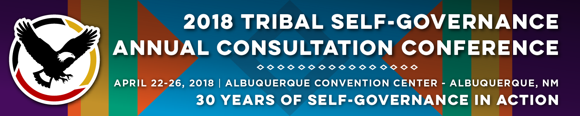
Recorder Form

Onsite Contact Tami Snow 918.388.7428
Recorder: Rhonda Beaver | Date: April 24, 2018
Session Title: Health Revenue Cycle Improvement
Panelists:
Brenda Teel, Executive Officer, Revenue, Chickasaw Nation
Doneg McDonough, TSGAC Technical Advisor
Angie Wilson, Executive Director, Washoe Tribal Health Center
Raho Ortiz, Director, Division of Business Office Enhancement, Office of Resource Access and Partnerships, IHS
Summary of Issues and Items Discussed:

Increase in revenue through use of virtual technology; Medicaid reimbursement for pharmacy by encounter rate; Tribal FQHC and care coordination agreements by state plan amendments; update on PBM rejections and denials

Questions from the Audience:

Questions raised were billing virtual visits; billing encounter rates for nonbeneficiaries; example of care coordination agreements and updating state plan; and timeframe for DTLL regarding CVS email address

Follow Materials, Documents, Websites for Reference:

https://www.mendfamily.com/

Would like example of care coordination agreement

mailto:ihs_cvs_govtclaims@cvshealth.com

Would like copy of DTLL regarding Caremark claims

