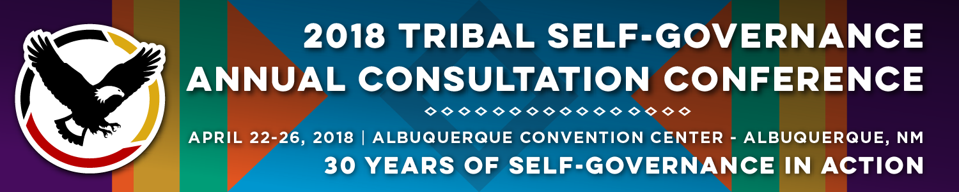

Recorder Form

Onsite Contact Tami Snow 918.388.7428
Recorder: Dee Sabattus | Date: April 24, 2018
Session Title: Medicaid Issues- Including Work Participation Requirements
Panelists:
- Elliot Milhollin, Hobbs, Straus, Dean and Walker, LLP
- Devin Delrow, Director of Policy, NIHB
- Doneg McDonough, TSGAC Technical Advisor
Moderator: Melissa Gower, Senior Advisor/Policy Analyst, Chickasaw Nation

Summary of Issues and Items Discussed:
Overview of the Medicaid Program and how it affects Tribal Nations.
- 1976 the Indian Health Care Improvement Act amended the Social Security Act to authorize Medicaid and Medicare reimbursement to IHS and Tribally operated programs.
- 100% FMAP- CMS recognizing and upholding the Federal Trust Responsibility, authorized 100% FMAP for Medicaid services received through IHS and Tribal Facilities, thereby not shifting the trust responsibility to the states.
- Medicaid Expansion- Expanded coverage to all individuals living at or below 138% of the federal poverty level, allowing for more AI/ANs to have access to Medicaid. However, only for those states that chose to expand.
Medicaid Reform Efforts:
- Congressional Actions to repeal and replace the ACA, Imply Caps on Block Grants, Medicaid Work Requirements.
- Administratively, on March 14th 2018 the CMS administrator issued guidance to State Medicaid Directors stating that they would be open to waivers that impose certain changes to abled bodied adults, premium contributions.
- To date, ten 1115 waivers have been submitted that will impose work requirements, 3 of those have been approved.
  - State by State Waiver proposals were summarized for workshop attendees.
Work Requirements will not work in Indian Country:
- IHS Relies on Medicaid to supplement an underfunding program.
- Work Requirements will not incentivize AI/ANs to work
- Mandatory work requirements are inconsistent with the federal treaty and trust obligations.
- Tribal Nations, Tribal Organizations and Technical Advisory groups have been providing comments regarding concerns of the Administrations position of not being allowed a blanket exemption for AI/ANs.
Legal Actions to date:
- In of January 2018, Kentucky Medicaid enrollees filed suit in DC District Court against HHS, CMS and curtained named federal officials for approving waiver.
Legal Standard:
- Morton v. Mancari. “As long as the especial treatment for Indians can be tied to the fulfillment rationally the fulfillment of Congress’ unique obligation toward the Indians, such legislative judgments will not be disturbed.
- “The decisions of this Court leave no doubt that federal legislation with respect to Indian tribes, although relating to Indians as such, is not based upon impermissible racial classifications. Quite the contrary, classifications singling out Indian tribes as subjects of legislation are expressly provided for in the Constitution and supported by the ensuing history of the Federal Government’s relations with Indians.” United States v. Antelope, 430 U.S. 641, 645 (1977).

Next Steps for Work Requirements:
- HHS states they need a statutory justification to give exemption to AI/ANs. However, HHS has previously made special exceptions for AI/ANs in years past for various programs that never caused a race-based discrimination.
- Tribes will need to educate and stress upon the political status, and that we are not Race based entities.
- Continue to gain support from States that would support the proposed exemption.

Tribal Self Governance Advisory Committee (TSGAC) Priorities under Medicaid:
- TSGAC is working to identify needed changes in the federal Medicaid law that will help advance the federal trust responsibility to AI/ANs.
  - Looking to identify a state that has a preferred federal Medicaid law;
  - Develop a strategy to achieve the preferred end state, such as identifying which components might be phased in, advocating for certain components to be at state option and others required under federal law.
- Goal of the study would be to strengthen the Medicaid program infrastructure for AI/ANs and (Indian Health Care Providers (IHCPs) under federal law across all states, will create greater uniformity in program eligibility, providing consistency in 100% federal funding across al IHCPs for services provided to AI/ANs.

Questions/Comments from the Audience:

- If a waiver proposes a work requirement program, and considers a Tribes’ 477 program as meeting the work force program, is that limited to just our Tribal Citizens or all federally recognized Tribes that come to the clinic?
- What about our Treaty/Sustenance hunters, fisherman and gatherers? Would those types of jobs be deemed as meeting workforce requirements? Its not a standard 9-5 job.
- If Tribes don’t get a blanket exemption, Tribes should be able to define the work requirement programs that then states would deem as meeting those requirements.
- This is a philosophical shift in the Administration approach in dealing with Tribal Nations. CMS is one agency, but it won’t be long before other agencies follow suit. We need to really get together and raise our voices in a very unified way.
- Tribes in WI have been trying to work toward resolution with the state, but they aren’t getting anywhere. I think the next step is to take legal action.
- What are the pros and cons about Navajo exploring its own Managed Care Organization?

Follow Materials, Documents, Websites for Reference:
2 PowerPoint Presentations and 1 Handout.

CMS State Medicaid Director Letters
https://www.medicaid.gov/federal-policy-Guidance/index.html

CMS Tribal Technical Advisory Group
https://www.cms.gov/Outreach-and-Education/American-Indian-Alaska-Native/AIAN/Tribal-Technical-Advisory-Group.html

National Indian Health Board
www.nihb.org

Tribal Self Governance 2018 Health Actions
http://www.tribalselfgov.org/health-reform/2018-health-actions/

