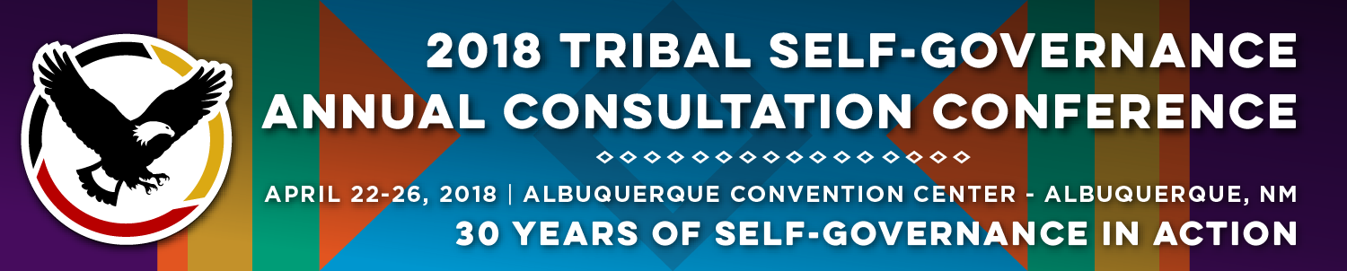

Recorder Form

Onsite Contact Tami Snow 918.388.7428
Recorder: Dee Sabattus | Date: April 24, 2018
Session Title: CDC Tribal Advisory Committee Update and Public Health Initiatives
Panelists:
- Carolyn Angus-Hornbuckle, Deputy Director and Director of Public Health Programs and Policy, NIHB
- Lisa Pivec, Senior Director of Public Health, Cherokee Nation
- Amy Groom, CDC/National Center for Chronic Disease Prevention and Health Promotion, TECPHI Project Officer
Moderator: Melanie Fourkiller, Policy Analyst, Choctaw
Summary of Issues and Items Discussed:

Overview of “What is Public Health?”
- Public Health monitors the health of a populations, promotes healthy behaviors, mobilizes communities for action, develops policies to protect and promote healthy behaviors and responds to public health emergencies.
Public Health Accreditation, why it’s important and how it connects with Self Governance?
- Assists Tribes and health programs evaluate programs to understand strengths and weaknesses to build and/or advance programmatic activities.
- Accredited or not, the process assists with advancing the care provided to the individual communities.
Summary of IHS and Cuts to Public Health:
- IHS has some targeted investments in Public Health including maintaining support for Tribal Epidemiology Centers, Substance Abuse and Suicide Prevention (SASP) funding for 175 projects for total of $32M; Domestic Violence Prevention Programs funding 83 projects for $11M; Special Diabetes Program for Indians funding 301 I/T/U grantees at $150M/year.
- FY 2019 President’s budget proposed to eliminate several public health programs including, health education, community health representatives. FY 19 proposed decreases would be decreased by $69M from the 2018 funding level of $158M.
- Summary of CDC Support for Public Health in Indian Country.
Centers for Disease Control and Prevention (CDC) Tribal Advisory Committee: Priorities
- Develop a policy for CDC to engage with Tribes during the agency’s budget formulation process
- Direct funding via set aside for Tribal public health
- Include Indian Tribes and Tribal organizations as eligible entities for direct funding in all FOAs
- Require that states receiving CDC funds actively engage with Indian Tribe(s) within their state
- Acknowledge the value and applicability of cultural and traditional practices as viable grantee activities.
Tribal Public Health Initiatives within the CDC: Partnering with Tribal Nations and Tribal Epidemiology Centers help make sure what CDC is doing is making a difference.
- Good Health and Wellness in Indian Country (GHWIC)- 5-year funding opportunity funding 35 grantees at $79M.
- Tribal Practices to Promote Wellness (New and awardees will be released April 30, 2018) 3-year Cooperative Agreement funding 21 Tribal Nations/Tribal Organizations and 15 Urban Indian Organizations at approximately $5M per year.
- Tribal Epidemiology Center Public Health Infrastructure (TECPHI): 5-year funding opportunity for 12 TECs and 1 Coordinating Center at $8.5M per year.
- Tribal Umbrella Agreement (NEW) 5-year funding mechanism. Small funding amounts that will eventually have opportunity to submit for Funding Priority 2 that will come in future years.

Opportunities/Challenges in Public Health:
- Resources- Many Tribal and non-Tribal examples out there. No need to recreate the wheel.
- Knowledge Base- Opportunity to evaluate and education health delivery system and community. The more informed people are the more likely they will stay engaged.
- Leadership Support- Need for maintaining support of leadership and community.
- Defining Public Health as a Tribe- Each Tribe can define this on their own.
- Inclusion of internal and external Partners- Public health is a big picture issue and needs to include other non-health partners.
- Educating non-Tribal partners- Awareness of the Tribal Health care delivery systems
- How CDC’s funding reach can impact even more Tribal Nations.

Questions from the Audience:

- Is there a training opportunity to have a Community Health Representatives?
- Are there opportunities for Inter Agency collaborations? Not a time to be siloed. For example, CDC and Environmental Protection Agency need to work together to address common issues like the impacts of Superfund Sites on Tribal Lands and how it impacts the health status of those communities. How can CDC be intermediary for that?
- Small Tribes have limited resources and can’t write for the CDC opportunities. How can CDC work with small Tribes to access public health funding? Has CDC ever looked into the model that SAMHSA initiated for those smaller Tribes that need grant funding but doesn’t have the administrative resources to write for these large funding opportunities.
- Tribal Nations vary in infrastructure. How can our federal partners assist Tribal Nations with these issues?
- How will the new Leadership at CDC impact the support that CDC has had for Tribal Nations and Organizations in the future?

Follow Materials, Documents, Websites for Reference:

- 3 PowerPoint Presentations

- Frieden’s A Framework for Public Health Action, The Health Impact Pyramid: http://dhhs.ne.gov/publichealth/Documents/Health%20Impact%20Pyramid.pdf

- NIHB Public Health Summit
http://www.cvent.com/events/2018-national-tribal-public-health-summit/event-summary-aa505ecade034327994093068dd43bc1.aspx

- CDC Tribal Advisory Committee Charge and Membership
www.cdc.gov/tribal/tac/

- Summary of Good Health and Wellness in Indian Country
www.cdc.gov/chronicdisease/resources/publications/aag/indian-country.htm

- Summary of TECPHI
www.cdc.gov/chronicdisease/tribal/tecphi.htm

- National Tribal Epidemiology Centers
https://tribalepicenters.org/

