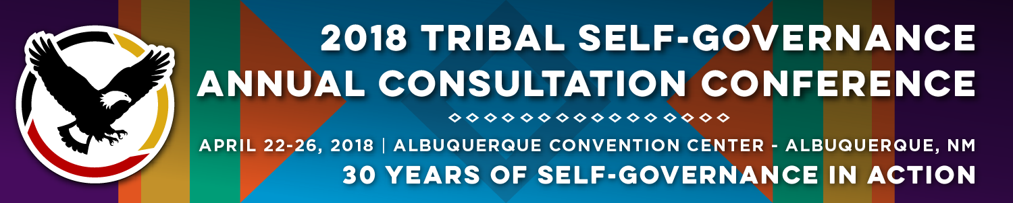

Recorder Form

Onsite Contact Tami Snow 918.388.7428
Recorder: Terra Branson | Date: 4/25/18
Session Title: OST Updates
Panelists:
Will Micklin, 2nd Vice-President, Central Council of Tlingit & Haida Indian Tribes of Alaska
Sonya McIntosh, Manager, Realty Trust Services Department, Muscogee (Creek) Nation
John White, Deputy Special Trustee – Program Management, Office of the Special Trustee for American Indians, DOI
Eldred Lesansee, Director, Office the Special Trustee for American Indians, Albuquerque Office of Appraisal Services
Elizabeth Wells Shollenberger, Director, Office of Trust Review and Audit, Assistant Office of the Special Trustee for American Indians, DOI
Summary of Issues and Items Discussed:

Tribal Trust Evaluations (Ewiiaapaayp Band of Kumeyaay Indians) – 25 CFR 1000.350
- Tribes have responsibilities
- OTRA Auditor’s Responsibility
  - Collect and review data, Review Tribes Responses and make recommendations for improvement
- Procedures verify the trust programs are carried out properly.
- Review Internal control processes, conflicts, compliance issues
- Test transactions if applicable
- Questionnaires include waivers for trust transactions, amount of tribal trust acres, tribal enrollment, any investigation, lock box coordinator issues, key duties and responsibilities, org chart, and financial statements.
- Overall Performance Rating is provided after the evaluation.
- TTE evaluates the trust programs and function administered by the Tribe.
- One deficiency that has arisen is that there are missing mandatory provisions in MYFA. (25 USC 5363 (D) (L) & (2)). However, the law allows redesign and reallocation of funds and that language is the MYFA.
- OTRA is requesting that OSG require inclusion of specific language related to the code.
- Tribes are requesting consultation on this proposed language and some assert that tribes are subject to the code and additional language is not necessary.
- OST needs to provide funds and staff to travel and explain the new language to tribes negotiating this new language.
- In Ewiiaapaayp Tribe’s TTE OTRA issued the following statement “The Band has been working on an IRMP since 2006, and OTRA in its next evaluation will follow-up on their IRMP to ensure that it is “completed and properly utilized,” and recommends the Tribes “seek assistance from the BIA to ensure timely com-pletion and implementation of the IRMP.”
- OTRA TTE’s lowering a tribes performance rating due to inability to achieve goals and deliverables of unfunded trust programs and functions is a misreading of SG law and regulation; however, if so, the remedy is tribe’s retrocession of trust program/function to the Secretary and then an audit of the Secretary would lead to a compliant on the Secretary’s failed trust responsibility.

Elizabeth Wells Shollenberger, Director, OTRA, Office of the Special Trustee
- OTRA thinks that inclusion of the new language is necessary because some new tribes do not know that they are subject to audit and evaluation
- Trustee functions are required in the audit report and could be an opportunity for tribes if there is an agency or office that is impeding a tribe’s ability to implement trust functions.
- Growth in the number of Self-Governance Agreements has caused OTRA to develop an electronic form to conduct TTE.
- This will allow audits to occur remotely.
- The software has been developed and completed development in March 2018, but they are working on internal approvals and anticipate approval by end of FY18.
- They will open the system to the 9 participating tribes and then provide the full roll out in mid 2019.

John White, Deputy Special Trustee – Program Management, Office of the Special Trustee for American Indians, DOI
- Section 304 Update
- The section requires that the Secretary submit a plan to reorganize or transfer functions to other offices.
- In 2016, OST conducted consultation session throughout the entire Nation.
  - 43% of the comments supported keeping OST intact.
  - That begged the question, where should OST go?
- Now the OST is proposing that the office be realigned under the Assistant Secretary of Indian Affairs.
- The process is now that the Principal Deputy Director of OST, then a Director of OST will be hired and Jerry Gidner, current PD Director will report to that Director of OST.
- OST Trust Fund Accounting has received an unmodified audit opinion for five years.
- One of the biggest reasons that OST needs to stay intact because any change could negatively impact the financial security of the Office.

Eldred Lesansee, Associate Deputy Director of Appraisal and Valuation Service Office
- Section 305 Update
- Consolidation of the Valuation Services Offices and Appraisal Services became effective March 2018.
- Intermediate Steps:
  - Office of Appraisal Service Information System (OASIS) and Interior Valuation Information System will be consolidated.
  - Evaluating costs, including space costs in order to effectively manage overhe3ad.
  - Maintain workload alignment with funding source
  - Revise appraisal policy.
- Four Divisions
  - Indian Trust Property Valuation Division
  - Federal Lands Division
  - Land Buy Back Program Valuation Division
  - Division of Minerals Evaluation
- Waiving Departmental Review of Appraisals and Valuations of Indian Property.
  - Upon request the department will accept appraisals without review if they tribe requests a waiver.
- The Department will review and approve some appraisals depending on the law.
- Legislation sets minimum appraisal qualifications.
- If the Indian tribe or individual Indian does not agree with the appraisal or valuation they cannot submit to the department for review and approval if a waiver has been invoked.

Questions from the Audience:
- Appraisal Requests? These requests still go through the OASIS System.
- What is the timeframe for advanced notice to request an appraisal waiver?
  - There’s no advanced requirement you just submit the report and state that you are invoking the right to wave the departmental review and approval.
- OSG update: the negotiation revised is guidance to update some of the sections and this year negotiators will be working with you to
- Legislation requires minimum standard and there’s an anti-deficiency provision in the legislation, why do Tribes have to opt out of the federal review versus just accepting the appraisal.
  - The OST was not sure why the Solicitor made this recommendation.
- Can a waiver by invoked retroactively?

Follow Materials, Documents, Websites for Reference:
- Description of the proposed OST reorganization is available on their website and their budget request for FY19.

