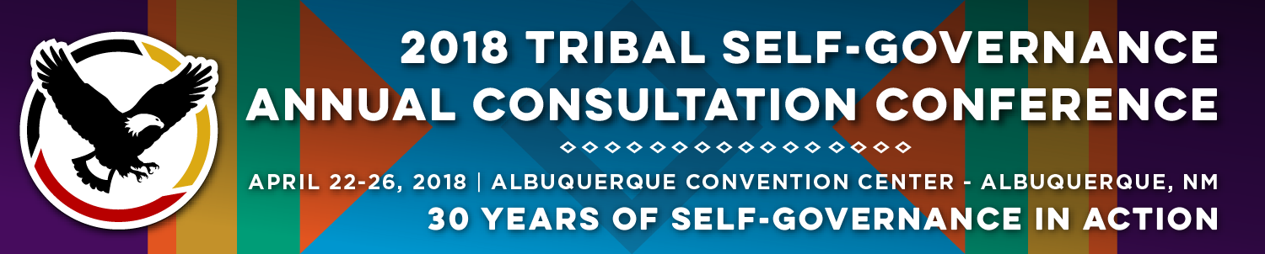

Recorder Form

Onsite Contact Tami Snow 918.388.7428
Recorder: Cyndi Ferguson | Date: 4/24/18
Session Title: Recruitment and Retention of Health Professionals
PANELISTS:
Heidi J. Frechette, Deputy Assistant Secretary for Office of Native American Programs, Department of Housing and Urban Development
Dr. Jason L. Hill, D.O., Chief Medical Officer, Choctaw Nation Health Services
CAPT Paul Jung, Director, Division Of Health Professions Support, IHS
Melanie Fourkiller, Policy Analyst, Choctaw Nation
Summary of Discussion and Questions from the Audience:

Ms. Frechette provided a PPT presentation. Want to share HUD programs and tools that are available for Tribes. Housing is an important part of recruitment. Office of Native American Programs oversees the largest Indian Housing program in Indian Country. Also helps tribes with community development. We have a strong Tribal consultation policy. Overview of Indian Housing Block Grant. About $650 million annually is distributed by Tribal governments. Title VI Loan Guarantee program; authorized by NAHASDA and has a budget of approximately $17 million annually. Indian Development Block Grant Program (competitive grant). Over 200 applications received a year. Newest program is the Tribal HUD-VASH; joint program between HUD and Department of Veterans Affairs. Provide housing voucher to homeless Native American veterans in Indian Country. Section 184 program is a home mortgage product specifically designed for American Indian/Alaska Native families, Tribes, Alaska villages or tribally designated housing entities. We have new authority from House appropriators to include professionals; provides more flexibility.

Are these available for single family units? You can do 1-4 units.
Tribal member currently has a land assessment and is waiting for BIA-long delays. We are working to make this process more efficient. We can connect with you to get more information to assist with this delay.
Does the land need to be in fee land or trust? It can be used on both fee and trust land.

Section 184: Housing for Professionals. We are working with Indian Health Service to utilize this program. In closing, Ms. Frechette also introduced her other staff.

Dr. Jason Hill provided a PPT presentation entitled Successful Recruiting to a Rural Tribal Health System. We have 1800 employees providing a wide range of services and specialities. We are located in a very rural part of Oklahoma. We are competitive with private sector on salaries; relocation bonuses, incentivized call pay and student loan repayment. Our benefits are better than private sector. Honesty and kindness; tell the pros and cons of living in your community. We have made a commitment to medical education. Medical student core rotations. In 2012, we started a family medicine residency. It is accredited by AOA and ACGME for 12 years. First class graduated in 2015; total of 9 students so far. 6 of those graduates hired within the system. This has been one of our better recruiting tools.

CAPT Paul Jung addressed the break-out session and discussed programs that are available at IHS Headquarters. Scholarship, Loan Repayments. Must work at IHS, Tribal or Urban site. Most of the students who receive IHS scholarships go back to their community to do their service obligation and tend to stay longer. Loan repayment is to bring more health care providers into Tribal service. Provides up to $20,000 a year for loan repayment. $5,000 - $6,000 for taxes to cover the cost of the loan repayment. There is no limit to how many years you receive loan repayments as long as you are serving. The last program is smaller is scope (USUSHC) – nation’s medical student in Bethesda, MD. They owe 10 years in Comm. Corp. Military benefits and salaries. There are several medical officers within IHS that rise up through the system. In addition to the IHS programs, the National Health Service Corp is also available. All IHS sites (federal and Tribes) are eligible. Their program is bigger than IHS. Gives you more versatility. Comment about Millennials—they’re interested in a job that makes a difference. They are looking for something different; how can I make my patients healthier.

Ms. Fourkiller provided a PPT presentation entitle Utilizing MOA/IPA in a Self-Governance Transition. Two ways to transfer federal staff (IPA or MOA). The tribe assuming the program under Self-Governance will determine what mix they would like to have. Tribe needs to evaluate its Human Resources policies. With IPA, the agreement is entered between, the IHS, Tribal and the federal employee; 2 year agreements. These IPA/MOA are directed and supervised by the Tribe. This is treated a buy-back in the Funding Agreement. Need to make determinations as early as possible. Complete a comparison of federal versus Tribal benefits and policy (side-by-side comparisons). Get data from IHS as early as possible (number of staff, title, etc.) Resources included: Personnel Aspects of the ISDEAA Handbook; and Office of Tribal Self-Governance.

Questions:
Individual from remote Alaska Native village requested more information on the IHS loan re-payment program and how they applied. They can apply once they are accepted into school. Once someone has finished medical student, then they can apply for the loan re-payment. CAPT Jung also referred them to the IHS website.
For Chotaw - Do you do you recruiting or use an agency? We do it ourselves, but we sometimes use a recruiter. But lately, the residency has been our most successful. The infrastructure we have built has help that.
More information on the VASH – What is the eligibility for the veterans? They have to be eligible for VA benefits.

Follow Materials, Documents, Websites for Reference:

All PPT presentations and contact information is included.

