self governance:
A How-To aPPLICATION and information Guide
for prospective tribes

U.S. Department of the Interior
Indian Affairs
Office of Self-Governance

Headquarters Office Northwest Field Office
1849 C Street, NW 500 W 12th Street
Suite MIB - 2071 Suite 226
Washington, D.C. 20240 Vancouver, WA 98660
(202) 219-0240 (360) 699-1007

TABLE OF CONTENTS

- WHAT IS TRIBAL SELF-GOVERNANCE?
- Goals of Tribal Self-Governance 2

- BRIEF HISTORY OF SELF-GOVERNANCE
- Timeline 3
- PROCESS FOR ENTERING INTO SELF-GOVERNANCE
- Eligibility Criteria 4
- Entering the Self-Governance Applicant Pool 4
- Advantages of Self-Governance 5

- WHAT IS NEGOTIATED BETWEEN TRIBES/CONSORTIA AND THE U.S. GOVERNMENT?
- The Self-Governance Compact 5
- The Self-Governance Funding Agreement 6
- The Reprogramming Request 6
- Negotiation Guidance 7
- The Negotiation Process 7

- THE SELF-GOVERNANCE DATABASE (SGDB)
- SGDB Homepage (Screenshot) 8
- SGDB Reports Page (Screenshot) 9

- IMPORTANT DEADLINES
- When to Apply 10
- Annual Conference 10
- Negotiations 10

- WHO WE ARE AND CONTACT INFORMATION
- Organizational Chart 11
- OSG Staff and Office Locations 12
- Website 12

- HOW-TO CHECKLIST
- Checklist 13

- WHAT IS TRIBAL SELF-GOVERNANCE?

The right to Tribal Self-Governance flows from the inherent sovereignty of Indian Tribes and nations. The United States recognizes the special Government-to-Government relationship with Indian Tribes, including the right of Tribes to self govern, as reflected in the United States Constitution, treaties, Federal statutes, and dealings of the U.S. with Indian Tribes. As such, the principles of Self-Governance are inseparable from Tribal sovereignty.

In more practical terms, Self-Governance returns decision-making authority and management responsibilities to Tribes/Consortia. Through the transfer of Federal funding available for programs, services, functions, and activities (PSFAs), Tribes take control of the administration of those PSFA’s. Self-Governance allows Tribes to be accountable to their own people for resource management, service delivery and development and other tribal operations.

Goals of Tribal Self-Governance
Tribal Self-Governance creates opportunities for Tribes to exercise their inherent self-governing powers through enhanced Tribal governmental responsibilities. Listed below are some of the goals of Self-Governance expressed by Tribes.

- To create an even more formal relationship between the United States and Indian Tribes on a Government-to-Government basis as provided for in the U.S. Constitution.
- To recognize Tribal rights to determine internal priorities, redesign and create new tribal programs and reallocate financial resources to more effectively meet the needs of tribal communities.
- To promote greater social, economic, political and cultural stability and self-sufficiency by better utilizing resources obligated in treaties, Executive Orders, and acts of Congress.
- To establish better fiscal accountability through expanded Tribal Governmental decision-making authority.
- To institute administrative cost efficiencies between Tribal Governments and the United States through reduced bureaucratic burdens and streamlined decision-making processes.
- To change the role of the Federal departments and agencies serving Indian Tribes by shifting their responsibilities from day-to-day operations.

“…I’ve learned, as an individual, the magic of a seized opportunity is that they multiply…so Self-Governance offers just an amazing spectrum of opportunities.”
-Fawn Sharp, President
Quinault Indian Nation

- A BRIEF HISTORY

Timeline of Important Events in Self-Governance History

1975: Passage of the Indian Self-Determination and Education Assistance Act (ISDEAA), also known as Public Law 93-638.

- The law recognized the Government-to-Government relationship between the Federal Government and Indian Tribes.

- P.L. 93-638 meant to ensure effective and meaningful participation by tribal people in the planning and administration of programs and services provided to Tribes by the Federal Government.

- P.L. 93-638 provides Tribes with the option to exercise their right to self-determination – to assume control and management of Federal Government run programs.

1988: Visionary Tribal leaders asked Congress to pass legislation that would allow Tribes to negotiate their share of the Federal Budget.

- The 1988 bill entitled “New Federalism” was introduced giving Tribes the ability to negotiate shares of the Federal Budget and giving them greater flexibility to use the funds to operate their own programs.

- The bill was revised to reaffirm the Federal Government’s Trust Responsibility in P.L. 100-472 – or more commonly known as Title III or the Tribal Self-Governance Demonstration Project.

1990: The first Self-Governance agreements were negotiated with the Department of the Interior – Indian Affairs.

1994: The 1994 Amendments to the Indian Self-Determination and Education Assistance Act of 1975 created Title IV – The Tribal Self-Governance Act – as a permanent part of the legislation.

Self-Governance
Fact
There were seven (7) Tribes who, as part of the Self-Governance Demonstration Project, initially paved the way for other Self-Governance Tribes.
They are:
◊ Absentee Shawnee Tribe of Oklahoma
◊ Cherokee Nation of Oklahoma
◊ Hoopa Valley Tribe of California
◊ Jamestown S’Klallam Tribe of Washington
◊ Lummi Nation of Washington
◊ Mille Lacs Band of Ojibwe Indians of Minnesota
◊ Quinault Indian Nation of Washington

A: id you know the first Self-Governance Tribes were part of the Tribal Self-Governance Demonstration Project?

Title III of ISDEAA

- PROCESS FOR ENTERING INTO SELF-GOVERNANCE

The ability to enter into Self-Governance is triggered by the January Federal Register Notice indicating the deadline to submit an application to begin participation in the program.

Eligibility Criteria

The law and regulations stipulate that Indian Tribes and Consortia of Indian Tribes are eligible to participate in Self-Governance. Up to 50 additional Tribal Nations per year may be selected from an applicant pool to participate in Self-Governance, including a Consortium, which counts as one Tribe for the purposes of calculating the 50 additional Tribes.

(NOTE: The regulations for Self-Governance can be found at 25 CFR Part 1000. Please refer to the regulations when completing an application).

Entering the Self-Governance Applicant Pool

- Tribes/Consortia must request participation by a Tribal Resolution.
- Tribes/Consortia must have three (3) previous years of audits containing no material audit exceptions.
- Tribes/Consortia must complete a planning phase consisting of:
  - Legal and budgetary research.
  - Internal tribal government and organizational planning.
- Tribes/Consortia must produce a planning report (based on internal findings during the planning phase). The planning report must:
  - Identify BIA and non-BIA programs the Tribe/Consortium wishes to include.
  - Describe the Tribe’s/Consortium’s planning activities for both BIA and non-BIA programs.
  - Identify the major benefits derived from the Tribe’s/Consortium’s planning activities.
  - Identify the Tribe’s/Consortium’s process to resolve any complaints by service recipients.
  - Identify any Tribe/Consortium organizational planning.
  - Indicate if the planning efforts reveal that the Tribe’s/Consortium’s current organization is adequate and ready to assume programs under Tribal Self-Governance.

Tribes/Consortia must also describe the process to debate and decide the setting of priorities for the funds it will receive through Self-Governance Funding Agreement.

Additionally, Tribes/Consortia must describe how the Tribe/Consortium proposes to perform non-BIA programs under a Self-Governance Funding Agreement.

Advantages of Self-Governance

- The law requires advance lump sum payments.

- Less Federal Agency control.

- Ability for Tribes to redesign programs to better suit tribal needs.

- Ability for Tribes to merge and assign Tribal funds to better serve the needs of the Tribal population.

- Ability for Tribes to retain savings from program funds to be re-invested in the program.

- Reduced reporting requirements.

- One basic agreement document that provides funding to Tribes instead of multiple contracts and amendments.

- Ability to view the Self-Governance Database (SGDB) website with funding agreement and Federal and Tribal budget information.

- WHAT IS NEGOTIATED BETWEEN TRIBES/CONSORTIA AND THE U.S. GOVERNMENT?

The Self-Governance Compact

A Self-Governance Compact implements the Tribal Self-Governance Act of 1994 (P.L. 103-413) by providing resources to new and existing self-governance Tribes. The Act enables Tribes to plan, conduct, consolidate, and administer programs, services, functions, and activities for tribal citizens according to priorities established by their tribal governments. Tribes have greater control and flexibility in the use of these funds, including reduced reporting requirements, the ability to reallocate funds during the year and carry over unspent funds into the next fiscal year without Secretarial approval.

A Self-Governance compact is an executed document that affirms the Government-to-Government relationship between a Self-Governance Tribe and the United States. It is an agreement between Nations. The compact differs from a Funding Agreement (FA) in that the compact applies to all bureaus within the Department of the Interior rather than a single bureau.

A Self-Governance Compact should generally include:
- The authority and purpose of the compact.
- Terms, provisions, and conditions of the compact.
- Obligations of the Tribe/Consortium and United States.
- Other provisions.

A Model Compact is available at the request of a Tribe/Consortium and can be found in the federal regulations that govern Tribal Self-Governance. See Appendix A of 25 CFR Part 1000.

The Self-Governance Funding Agreement
Annual Funding Agreements (AFAs) are legally binding and mutually enforceable written agreements negotiated and entered into annually between a Self-Governance Tribe/Consortium and Indian Affairs. The AFA must specify:
- The programs, services, functions and activities assumed by the Tribe/Consortium.
- It must also specify the applicable funding that is:
  - Retained by the BIA for “inherently federal functions” identified as “residuals.”
  - Transferred or to be transferred to the Tribe/Consortium.
  - Retained by the BIA to carry out functions that the Tribe/Consortium could have assumed but elected to leave with the BIA.

Multi-Year Funding Agreements (MFAs) are an option of the Tribe/Consortium. Many MFAs have 5-year terms, and a handful of Tribes/Consortia have negotiated 10-year funding agreements. MFAs are amended each year to include an annual Reprogramming Request.

A model Funding Agreement is available to Tribes/Consortia upon request and is attached to the Annual Self-Governance Negotiation Guidance.

A Reprogramming Request, also known as an “FA Online,” is an attachment to the AFA or amended MFA that identifies programs and amounts of funding that a Tribe/Consortium elects to take. The funding amounts in the Reprogramming Request are based on the President’s Budget Request to Congress (Greenbook).

A Reprogramming Request:
- A key financial document to be completed during negotiations.
- Specifies BIA programs.
- Specifies funding amounts.
- Specifies the sources of funding to be transferred to the Tribe/Consortium.
- Contains footnotes (FNs) that identify unique factors concerning specific programs and/or amounts.

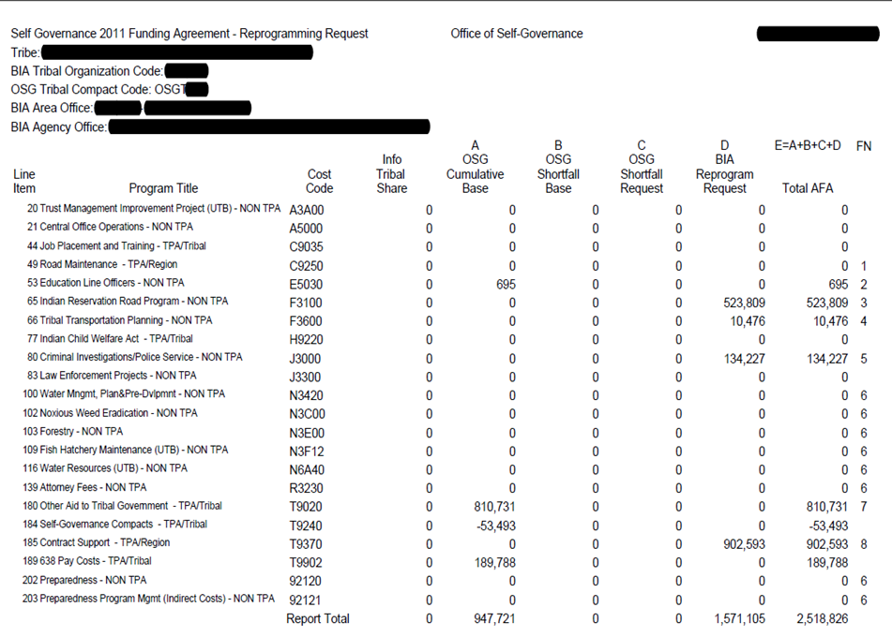
Reprogramming Request

Negotiation Guidance
The Office of Self-Governance releases a Draft Annual Negotiation Guidance in March of each year. The Guidance is first made available for Bureau of Indian Affairs and Office of the Special Trustee (OST) for review and input. Tribes and other Federal partners are encouraged to submit comments on the Draft in mid-April, prior to the Annual Self-Governance Consultation Conference. At the Conference, Self-Governance Tribes are provided an opportunity to offer additional comments on the Draft Negotiation Guidance, and in mid-May the Office of Self-Governance releases the Final Annual Self-Governance Negotiation Guidance.

The Negotiation Guidance gives Tribes/Consortia informational insight and explanation about changes, if any, which will occur (and be negotiated) in the coming year. It also includes a collection of very helpful attachments, like the model Funding Agreement.

The Negotiation Process
Tribes/Consortia negotiate on either a Fiscal Year (FY) or Calendar Year (CY) basis. The Office of Self-Governance initiates negotiations after the Annual Self-Governance Conference, beginning in early May of each year. OSG works with FY Tribes/Consortia to complete negotiations by June 30th, and with CY Tribes/Consortia to complete negotiations by September 30th. Meeting these year-end dates takes commitment from both the Tribes/Consortiums and OSG to finalize the negotiation process in a timely manner. When the negotiation process is complete, the Tribe/Consortium signs two (2) original copies of the Funding Agreement (or Amendment to the Funding Agreement) and a Reprogramming Request. These documents are then sent to either the BIA Regional Office (depending on the BIA Region) or to the OSG Compact Negotiator for signature. They are then forwarded to OSG’s Washington, D.C. office for final signature via a Federal surname process. It should be noted that the BIA Region is a full participant in the negotiation of Self-Governance Funding Agreements and Reprogramming Requests.

- THE SELF-GOVERNANCE DATATBASE (SGDB)

The Self-Governance Database is a web-based financial management tool that supports the management and maintenance of Self-Governance Tribal compact data. The SGDB serves essentially as a tracking and reporting system for funds negotiated to be included in Self-Governance funding agreements. The SGDB is an integral component of the core critical functions of the Office of Self-Governance.

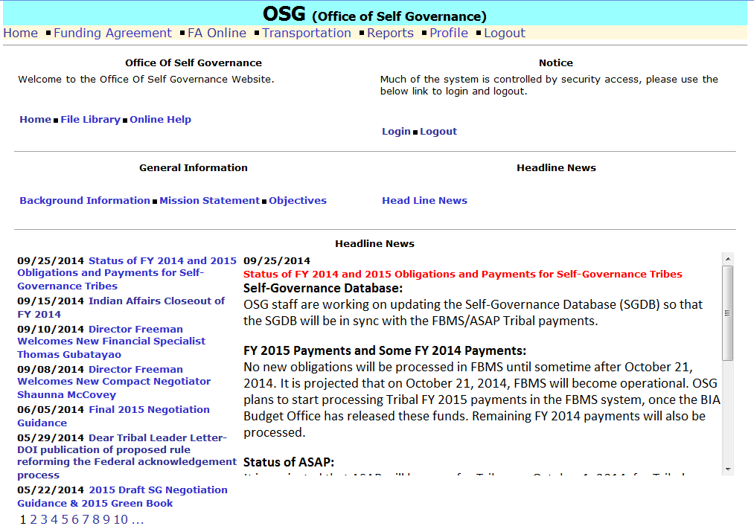
SGDB Homepage

The SGDB contains a number of financial reports to assist OSG staff and Tribes in producing each annual Reprogramming Request. The SGDB allows the user to see funding status reports, what funds have been obligated to a Tribe, and whether there are any outstanding funds that still need to be transferred from the Bureau of Indian Affairs. There is explanatory information in the SGDB for each column in a report, and SGDB users can view data from previous compact years as far back as 1994.

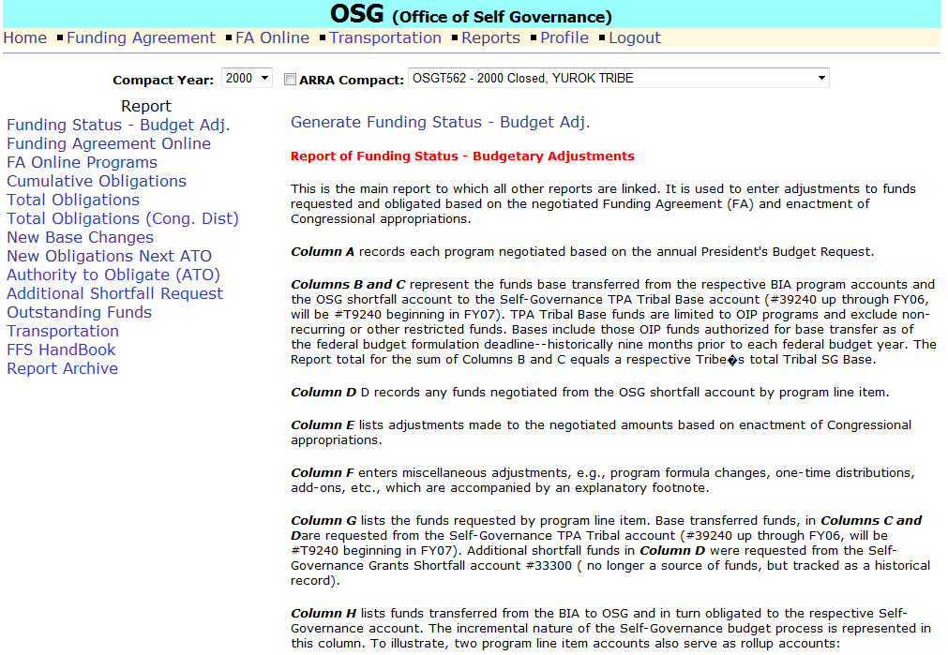
SGDB Reports Page

Participating Self-Governance Tribes can visit the Self-Governance Database at
www.osgdb.org

Self-Governance Fact:

- In 2019, there are 285 Tribes participating in Self-Governance.

- 49% of the nation’s 573 Federally Recognized Tribes are Self-Governance Tribes.

- IMPORTANT DATES

- JANUARY: Federal Register Notice is published detailing the Application process.

- MARCH 1ST: Deadline to submit the application packet to the Office of Self-Governance.

- APRIL/MAY: Annual Self-Governance Consultation Conference – Location TBD each year.

- MAY/JUNE: Negotiations begin for OSG and Self-Governance Tribes.

- JUNE 30TH: Negotiations completed with Fiscal Year Tribes.

- SEPTEMBER 30TH: Negotiations completed with Calendar Year Tribes.
- WHO WE ARE AND CONTACT INFORMATION

Below is the organizational chart for the Office of Self-Governance within the Department of the Interior, Office of the Assistant Secretary - Indian Affairs.
Assistant Secretary
Indian Affairs

Principal Deputy Secretary
Indian Affairs

Deputy Assistant Secretary
Policy and Economic Development

Program
Analyst
Administrative Specialist
Director
Office of Self-Governance

Senior Policy Analyst
Manager/Negotiator Northwest
Field Office

Finance
Specialist

Finance
Specialist
Compact
Negotiator
Program Assistant

Finance
Specialist
Compact
Negotiator

Finance
Specialist
Finance
Specialist

Finance
Specialist

Finance
Specialist

OFFICE OF SELF-GOVERNANCE STAFF

Washington, D.C. Northwest Field Office – Vancouver, WA
1849 C Street NW 500 W. 12th Street
Suite MIB-2071 Suite 226
Washington, DC 20240 Vancouver, WA 98660

Sharee Freeman, Director Matt Kallappa, Manager and Negotiator
202.219.0244 360.699.1013
Sharee.Freeman@bia.gov Matthew.Kallappa@bia.gov

Kenneth Reinfeld, Senior Policy Analyst Gordon Smith, Compact Negotiator
703.390.6551 360.699.1011
Kenneth.Reinfeld@bia.gov Gordon.Smith@bia.gov

Danny Santiago, Finance Specialist Thomas Gubatayao, Finance Specialist
202.219.0245 360.699.1010
Danny.Santiago@bia.gov Thomas.Gubatayao@bia.gov

Vickie Hanvey, Program Analyst Rufina Villicaña, Finance Specialist
908.931.0745 360.699.1006
Vickie.Hanvey@bia.gov Rufina.Villicana@bia.gov

Celeste Engles, Finance Specialist Miles Reader, Finance Specialist
202.208.5955 360.699.1004
Celeste.Engles@bia.gov Miles.Reader@bia.gov
Lance Fisher, Finance Specialist Maureen Marcellay, Program Assistant
202.513.7707 360.699.1007
Lance.Fisher@bia.gov Maureen.Marcellay@bia.gov

Emma Phillips, Administrative Specialist
202.219.0240
Emma.Phillips@bia.gov

Visit the Self Governance Database at:
www.osgdb.org

HOW-TO CHECKLIST

Begin planning phase:
- Ensure three (3) previous years of audits with no material audit exceptions.
- Conduct legal and budgetary research.
- Conduct internal Tribal Government/Organizational planning.

Write Planning Report:
- Include BIA and non-BIA programs Tribe wishes to compact.
- Describe planning activities for BIA and non-BIA programs.
- Identify major benefits derived from planning activities.
- Identify a process to resolve complaints by service recipients.
- Identify the organizational planning that took place.
- Describe process to debate and decide the setting of priorities for funds.
- Describe how you propose to perform non-BIA programs under a Self-Governance Funding Agreement.
- Indicate if your organizational structure is ready to take on Self-Governance.

Refer back to the regulations at 25 CFR Part 1000.10 – 1000.31.

Watch for publication of Federal Register Notice in January.

Submit application by the March 1st deadline.

- Include a Tribal Resolution requesting participation in Self-Governance with your application/planning report.

Receive notice of determination of eligibility from the OSG Director.

Upon determination of eligibility, decide when to begin Compact and Funding Agreement negotiations.

Schedule and complete negotiations with an OSG negotiator and BIA staff.

