Draft
March 27, 2019

2020 SELF-GOVERNANCE
NEGOTIATION GUIDANCE
FOR BIA PROGRAMS

Office of Self Governance

Office of Self Governance

Central Office Northwest Field Office
1849 C Street, N.W. MIB 2071 500 W. 12th Street, Suite 226
Washington, D.C. 20240 Vancouver, WA 98660
Telephone (202) 219-0240 Telephone (360) 699-1013
Telefax (202) 219-1404 Telefax (360) 699-1012

Table of Contents

I. Purpose Page 4
II. Interpretation and Process Page 4
III. Tribal Self-Governance Base Budgets Page 5
IV. Tribal Shares Page 6
V. Negotiations Process Page 6

VI. Disputes Page 7
VII. Amendments Page 8
VIII. Reporting Requests Page 8
IX. Budget Formulation Page 9
X. Documents for Self-Governance Negotiations Page 9
A. Compacts Page 9
B. Funding Agreements (FAs) Page 9
C. Proposed Effective Date Page 10
D. Adjustments/Mistakes Page 10
E. Self-Governance 2019 Annual Funding Agreement - Page 11
Reprogramming Request Worksheet
F. Footnotes Page 11
G. Tribal Resolutions Page 12
H. Final Reports for Federal Negotiators Page 12
I. Incorporation of Title I Self-Determination Provisions Page 12
XI. Programs Requiring Special Attention Page 13
A. Trust Programs Page 13
1. Identification of Trust PSFAs Page 13
2. Real Estate Appraisal Services and Beneficiary Page 14
Processes Program Funds
3. Requirements for Tribes to Access DOI Information Page 14
Technology Trust Systems
4. Trust Records Management Page 17
B. Programs Involving Contact With Children Page 18
C. Contract Support Page 19
D. Welfare Assistance Page 19
E. Road Maintenance Page 20
F. Law Enforcement Page 20
G. Indian Employment Training and Related Services Page 21
Consolidation Act of 2017 (P.L. 115-93) Permanent
477 Program
H. Tiwahe Initiative Page 23
I. Construction, Wildland Fire Preparedness, Wildland Page 24
Fire Prevention and Non-Recurring Projects
J. Tribal Transportation Program (TTP) Page 25
K. Consortium Breakout of Participating Tribes’ Shares Page 26
L. Program Funding Not Included in the President’s Page 26
Budget Request to Congress
M. Program Funding Levels Reduced in the President’s Page 26
Budget Request to Congress
N. Motor Vehicle Operation Policy Page 26
O. Single Audit Copies Page 26
XII. Summary - Final Negotiations Packets Page 27

List of Attachments Page 29

2020 DRAFT SELF-GOVERNANCE
NEGOTIATION GUIDANCE
FOR BIA PROGRAMS

Office of Self Governance

I. Purpose

This document is prepared as a tool to guide Federal negotiators in Indian Affairs, including the Office of Self Governance (OSG), Office of Facilities, Property, and Safety Management) (OFPSM), Office of Indian Energy and Economic Development (OIEED), Appraisal and Valuation Services Office (AVSO), Office of the Special Trustee for American Indians (OST), the Bureau of Indian Education (BIE), the Bureau of Indian Affairs (BIA), (including the Office of Justice Services) (OJS), and the Office of the Solicitor (SOL), in conducting, on a government-to-government basis, the 2020 self-governance (SG) negotiations. This final guidance is provided to Tribes/Consortia for informational purposes.

For the most part, 2020 negotiations will be conducted telephonically/electronically. Under limited budgets, travel to conduct face-to-face negotiations will only be approved if it meets a test of what is mission critical.

II. Interpretation and Process

Prior to negotiations, if there are questions about the content or meaning of this Guidance, please contact the OSG in Washington, DC at (202) 219-0240 or the Northwest Field Office in Vancouver, WA at (360) 699-1013. As in past years, the OSG Negotiator will be the lead negotiator for the Assistant Secretary - Indian Affairs (AS/IA) and the BIA Regional Director will be the negotiator for BIA programs, services, functions, or activities (PSFAs) pursuant to guidance issued by the BIA Director for non-base programs. The BIA Regional Director has responsibility to coordinate with and notify all pertinent BIA program offices regarding dates and locations of the negotiations to support the timely completion of negotiations. The OSG Director will coordinate with the BIA Director, the BIE, AVSO, OST, OIEED, OFPSM, and OJS Line Officers. When OJS and OFPSFM funds are involved, OJS and OFPSFM have requested that their representatives be contacted so that they may be present during self-governance negotiations. AVSO has also requested that its representatives be contacted so that they may be present during self-governance negotiations on an as needed basis. See Section XI.

The Regional Director and the OSG Negotiator will surname and date the Final Report of a Tribe’s/Consortium’s 2020 negotiations (see Attachment 6) once negotiations have concluded and after the funding agreement has been signed by the Tribe’s/Consortium’s designated official(s). The BIE and OJS Line Officers may surname and date the Final Report as participants in the negotiations. The BIE Director and the OJS Deputy Director will participate in the OSG Central Office surname process only when the funding agreement is new or there are Education or Law Enforcement and Detention/Corrections program issues or funding changes from the previous funding agreement. The OSG Director will sign funding agreements and amendments with review and comment from the BIA Director, the BIE Director, the OIEED Director, and the OJS Director as appropriate. Subject to revision by Congressional action, when negotiations include a Fixing America’s Surface Transportation (FAST) Act Tribal Transportation Program (TTP) Addendum, a separate TTP Addendum Final Report Form will be used (see Attachment 6) that includes the date and surname of the Regional Roads Administrator. The OSG Director will sign TTP Addenda after considering any comments received from the BIA Director and Chief, BIA Division of Transportation for those Tribes receiving TTP funding through a Self-Governance funding agreement.

It is the intent of the OSG to have 2020 negotiations completed for fiscal year Tribes/Consortia by June 30, 2019, and for calendar year Tribes/Consortia by August 31, 2019. This allows OSG to obtain the necessary signatures 90 days before the proposed effective date of the agreement. The 90-day review period is required by Section 403 (f) of P.L. 93-638, as amended. Under normal budget and appropriation circumstances, this allows OSG to obligate funds to Self-Governance Tribes/Consortia on a more efficient and timely basis. This also allows OSG to meet an October 1 deadline to incorporate base transfers as changes in the next President’s budget. It is important to meet these deadlines so that Tribes/Consortia receive the funds necessary to continue their tribal operations without interruption and avoid the cost of borrowing other funds.

III. Tribal Self-Governance Base Budgets

Once a Self-Governance Tribe/Consortium has elected to establish a Self-Governance base budget for Operation of Indian Program (OIP) funds and the amounts have been base transferred in the Tribal Priority Allocation (TPA) portion of the FY 2020 President’s Budget Request to Congress, the tribal shares which make up the base budget shall only be adjusted in accordance with 25 CFR §1000.109. Language in funding agreements regarding the Secretary’s responsibility for Self-Governance base budgets shall be identical to P.L. 93-638, Section 404, 25 U.S.C. § 5364. Language in funding agreements regarding adjustment of base budgets shall be identical to 25 CFR § 1000.109. Self-Governance base budgets shall be established and maintained in accordance with 25 CFR §1000.105-109. The base budget language in the funding agreement shall include the citation to 25 CFR § 1000.109. Tribal Self-Governance base budgets do not include Contract Support Cost funds. These funds and Law Enforcement funds are awarded separately from Tribes’ base budgets.

Examples of funds from sources other than the OIP accounts are Fire Preparedness funding, FAST Act Tribal Transportation Program (TTP) funds from the Department of Transportation as well as Indian Employment, Training and Related Services Consolidation Act of 2017 (Public Law 115-93) Permanent 477 Program funds from the Departments of Agriculture, Commerce, Education, Energy, Health and Human Services, Homeland Security, Housing and Urban Development, Interior, Justice, Labor, Transportation, and Veteran Affairs.
In accordance with 25 CFR §1000.105(b) and (c), non-recurring funds and any other one-time funding are not eligible to be included as part of the Tribe’s base budget and shall not be base transferred. The BIA’s Reprogramming documents and OSG’s Authority to Obligate (ATO) Award documents will identify funds that are awarded on a one-time-only basis and are not guaranteed to be funded in subsequent fiscal year(s).

A Tribe/Consortium may choose to base transfer funds or remove funds from its base budget for a certain program or category of programs. If a Tribe/Consortium chooses to establish or remove a base amount in a certain program or line item, there must be a clear indication in the Self-Governance funding agreement that the item is to be base transferred or removed from the base budget. In instances where funding for a program is to be base transferred or removed from the base budget, the following footnote shall be applied to that program line:

“The amount identified in Column D is requested to be transferred [SELECT: into OR out of] the [SELECT: Tribe’s OR Consortium’s] Self-Governance TPA Base Budget as soon as possible.”

The FY 2020 President’s Budget to Congress requested that $178.909 million be included on the Self-Governance Compacts line item. The deadline for making further base changes to the Self-Governance Compacts line item base transfers in the FY 2020 President’s Budget Request to Congress has passed. The next opportunity to request base changes to the Self-Governance Compacts line item will be the FY 2021 President’s Budget Request to Congress.

IV. Tribal Shares

Subpart E of the Self-Governance regulations deals with funding agreements for BIA programs and the tribal shares process.

The FY 2020 President’s Budget Request to Congress contains proposed appropriation language that “no funds available to the Bureau of Indian Affairs for central office oversight and Executive Direction and Administrative Services (except executive direction and administrative services funding for Tribal Priority Allocations, regional offices, and facilities operations and maintenance) shall be available for contracts, grants, compacts, or cooperative agreements with the Bureau of Indian Affairs under the provisions of the Indian Self-Determination Act or the Tribal Self-Governance Act of 1994 (Public Law 103-413).”

V. Negotiations Process

Subpart G of the Self-Governance regulations describes the process for negotiating funding agreements. Generally, that process is oriented toward new funding agreements and consists of an information phase and negotiation phase.

For continuing Self-Governance Tribes/Consortia, pre-negotiations and actual face-to-face negotiations may not be necessary. As a general rule, teleconferencing and videoconferencing are encouraged.

Section 403(b)(5) of Title IV of P.L. 93-638 (25 U.S.C. § 5363(b)(5)), as amended, requires that self-governance funding agreements specify the Programs, Services, Functions, and Activities (PSFAs) to be provided and performed, and the responsibilities of the Tribe/Consortium and the Secretary pursuant to the funding agreement. This should be specified in all funding agreements. Please see Section XI. Programs Requiring Special Attention, A. Trust Programs, 1. Identification of Trust PSFAs which addresses the required specificity for Trust PSFAs. Tribes/Consortia and the BIA shall identify the PSFAs which are being assumed by the Tribe/Consortium and which functions the BIA will continue to perform. The funding agreement shall at a minimum identify the PSFAs that the Tribe/Consortium intends to provide by Tribal/Consortium budget categories. It should be noted that specifying the services to be provided and the functions to be performed by the Tribe/Consortium does not limit in any way the Tribe’s/Consortium’s authority to reallocate funds and consolidate/redesign programs as authorized by Title IV of P.L. 93-638, as amended, except for PSFAs and funds appropriated and/or authorized for specific purposes.

In instances where there is a need to identify who is performing different functions, wording shall be negotiated and included in the funding agreement to clarify the matter. Detailed Memoranda of Understanding (MOU) may be negotiated between the Tribe and the BIA or other entities such as AVSO and OST and may be included as funding agreement attachments or amendments to provide greater clarity regarding the respective roles and responsibilities of the Tribe and the BIA or other entities for PSFAs included in the funding agreement. The OSG Compact Negotiator shall provide the OSG Director with a draft BIA MOU and suggested funding agreement (FA) language prior to final signature of the BIA MOU and FA.

Tribal self-governance base budget information will be pre-loaded in the BIA reprogramming request and supporting financial information will be provided by the OSG based on the FY 2020 President’s Budget Request to Congress. A Self-Governance Negotiations Checklist to help participants through the 2020 negotiations process is provided. See Attachment 1.

When a funding agreement specifically indicates, either in the narrative or the reprogramming request, that a Tribe/Consortium has elected to assume a certain PSFA, the funding for that PSFA will be awarded, once available and known, without further amendment to the funding agreement. When there is no indication in the funding agreement that the Tribe elects to assume a certain PSFA, an amendment will be required to add the PSFA and associated funding to the funding agreement.

VI. Disputes

If, during negotiations, the policies and/or processes of this Guidance become an issue of dispute, the OSG Negotiator will contact the OSG Director for further discussion and thereafter make necessary decisions to complete the negotiations. If the negotiation agreement cannot be completed, the OSG Negotiator will complete with the Tribe a draft agreement that includes the items that are in agreement and set a date to resolve the remaining issue(s).

Disputes concerning negotiation of the compact, funding agreement or other matters involving the funding agreement will be addressed through the appropriate dispute resolution process referenced in 25 CFR Part 1000 Subpart R – Appeals.

Disputes language, disagreements, differing views and the like shall not be included in funding agreements, MOUs, reprogramming documents, or footnotes to them. Funding agreements are reserved for matters on which the parties agree.

Language which reserves specific rights of the Secretary or Tribe may be considered dispute language. A “Memorialization of Matters Remaining in Dispute” may be attached to the funding agreement where there are disagreements or the Tribe and the Department have differing viewpoints. The Memorialization of Matters Remaining in Dispute must state that it is not part of the funding agreement. See Attachment 12.

VII. Amendments

If either the Tribe/Consortium or Department wishes to amend a funding agreement, then the amendment process as prescribed by each respective funding agreement shall be used. Negotiations of the amendment shall be completed and the amendment executed.

BIA (including OJS, as well as all regional and central offices), BIE, OIEED, OFPSM, the Public Law 102-477 Office (now implementing Public Law 115-93), AVSO, and OST shall provide award letters and funding distribution lists by Tribe to OSG for funding awards made throughout the year. These documents are also needed to facilitate the timely transfer of funds. Occasionally additional programs and funds may be added to the FA. Some may require amendments.

VIII. Reporting Requests

As in past years, the Assistant Secretary – Indian Affairs’ (AS/IA) Office is requesting the cooperation of Tribes/Consortia to provide program performance data and information as required by the Government Performance and Results Act of 1993 (P.L. 103-62) (GPRA) for budget formulation purposes. This information and data is required on a quarterly basis. The following language is provided as a starting point for the Tribe’s/Consortium’s negotiations with its respective Regional Office:

“The [SELECT: Tribe OR Consortium] agrees to provide applicable data and information to the BIA [INSERT: Name] Regional Office pursuant to the Government Performance and Results Act of 1993 (P.L. 103-62). Before providing such information, the [SELECT: Tribe OR Consortium] will work with its respective Regional Office GPRA Coordinator to determine applicable data and information needed to meet the requirements pursuant to the Act.”

Attachment 2 lists the BIA Regional Office GPRA Coordinators. Attachment 4 identifies possible information requests that Self-Governance Tribes/Consortia may receive during the 2020 operating year. It should be understood that actual requests for data and information received by individual Tribes/Consortia, as well as the timing of the requests, may vary from this list. Not included are any requests for information that might come from Federal courts, OMB or Congress, or other sources.

The current DOI Strategic Plan has an item being compiled by OSG headquarters for GPRA purposes: the percent of Single Audit Act reports submitted during the reporting year for which management action decisions on audit or recommendations are made within 180 days.

IX. Budget Formulation

The BIA Central and Regional Offices are responsible for budget formulation for all Tribes, including Direct Service, 638 Contract, and Self-Governance Tribes. Self-Governance Tribes are strongly encouraged to participate in all Regional Budget meetings and the BIA Regions are strongly encouraged to address the budget formulation needs of all Tribes in the region. Tribal Interior Budget Committee (TIBC) Regional Representatives receive quarterly budget updates and are responsible to represent all Tribes from their Region. They are also expected to share budget and related information with all Tribes in their region.

In addition, BIA Regional Offices are responsible for collecting 638 Pay Cost information from all Tribes in their Region, including Self-Governance Tribes. This information will be used to determine increases in pay cost funding for all Regional Tribes.

X. Documents for Self-Governance Negotiations

A. Compacts

Newly selected Tribes/Consortia should prepare their draft compacts in advance of negotiations using as their guide the model compact that appears in Appendix A of the final Self-Governance regulations at 25 CFR Part 1000. This model compact applies to all bureaus within the Department of the Interior and provides a starting point for compact negotiations. However, it is noted that pursuant to 25 CFR § 1000.164, at the Tribe’s/Consortium’s option, the Tribe/Consortium can have an FA without entering into a compact.

Changes from the model compact to fit the Tribe’s/Consortium’s particular situation are negotiable. However, any changes must comply with Title IV of P.L. 93-638, as amended, and 25 CFR Part 1000. Tribes/Consortia should allow ample time for the proposed compact to be reviewed by OSG and SOL.

The proper title of the federal signature line of the compact is “Assistant Secretary – Indian Affairs.” The federal signature line must not contain the name of an individual. This allows the Assistant Secretary – Indian Affairs to designate, if necessary, an authorized designee to sign the compact. .
Prior to final signature the Tribe/Consortium should check with the Negotiator for direction on the date and time-line for the Assistant Secretary – Indian Affairs signature.

Negotiations to reach agreement on compact language should be scheduled as needed. One unsigned version of the compact as agreed to at the field negotiation will be routed through the Federal surname process. If issues are identified during the surname process, then negotiations may reconvene. If no issues are identified during the surname process, then the Tribe will be notified by OSG. The Tribe can then submit two originals to OSG. After the Tribe signs both originals of the final compact, the Assistant Secretary – Indian Affairs will sign the compact and OSG will return one original of the final signed compact to the Tribe.

OSG requests that changes or amendments to existing Compacts be delayed until after January 1, 2020, when the initial payments for 2020 funding agreements have been completed. If the Self-Governance Tribe/Consortium is not willing to delay changing the compact by amendment, please notify OSG as soon as possible. OSG will work with the Tribe/Consortium to establish a timeline for the amendment process.

B. Funding Agreements (FAs)

A model funding agreement has been developed for Tribes. (See Attachment 5) Existing Self-Governance Tribes/Consortia may wish to review this model funding agreement to see if there are provisions for inclusion in their respective funding agreements. A copy of the model funding agreement is also on the OSG web site www.osgdb.org. OSG requests that the Tribe/Consortium assume the responsibility for preparing the funding agreement and reprogramming request.

When preparing the final funding agreement for signature, type in Director, Office of Self Governance. Do not type in a specific name. Once final decisions have been reached, Tribes/Consortia should submit two signed original funding agreements, along with two signed original reprogramming requests as agreed to at the negotiation, to the OSG Negotiator or the Regional Office for further processing.

C. Proposed Effective Date

Section 403(f) of Title IV of Public Law 93-638, 25 USC § 5363(f) provides that the Secretary shall submit a copy of a funding agreement no later than 90 days before the proposed effective date of the agreement to each Indian Tribe served by the Agency that is serving the tribe that is a party to the funding agreement; to the Committee on Indian Affairs of the Senate; and to the Subcommittee on Indian and Alaska Native Affairs of the Committee on Natural Resources of the House of Representatives. For annual funding agreements, the following language shall be included:

“Section (xxx) --- Proposed Effective Date. The proposed effective date of this Agreement will be 90 days following the submission of the signed Agreement to the Congress and to the other Tribes served by the BIA Agency Office. The proposed effective date is [SELECT: October 1 OR January 1]. The successor Agreement shall be controlled by 25 CFR § 1000.90. This Agreement shall remain in effect until [INSERT: APPROPRIATE date Agreement ends.]”

25 CFR § 1000.85 authorizes Tribes/Consortia to negotiate a funding agreement with a term that exceeds one year, i.e. a multi-year funding agreement. Multi-year funding agreements shall include the following language:

“Section (xxx) --- Proposed Effective Date. The proposed effective date of this Agreement will be 90 days following the submission of the signed Agreement to the Congress and to the other Tribes served by the BIA Agency Office. The proposed effective date is [SELECT: October 1 OR January 1]. The successor Agreement shall be controlled by 25 CFR § 1000.90. This Agreement shall remain in effect until [INSERT: APPROPRIATE date agreement ends]. In subsequent years, the parties shall negotiate an amendment incorporating the annual REPROGRAMMING REQUEST(s) into the Multi-Year Funding Agreement by [SELECT: July 1 OR October 1] of each year.”

D. Adjustments/Mistakes

Consistent with practices of previous years, the following mistakes language shall be included in the funding agreement:

“It is recognized that during negotiations, there may be errors in calculations or other mistakes which may need to be renegotiated. Both parties agree to take corrective action when such errors are identified.”

E. Self-Governance 2019 Funding Agreement – Annual Reprogramming
Request Worksheet

The key financial document to be completed at negotiations is the Self-Governance 2020 Funding Agreement – annual reprogramming request worksheet. The reprogramming request data entry table is available online via the Internet located on the OSG Website www.osgdb.org.

OSG Financial Management will pre-load 2020 Self-Governance base budget data into each Tribe’s/Consortium’s annual reprogramming request. Negotiated amounts and associated footnotes will be entered into the annual reprogramming request via the Internet.

For Tribes/Consortia negotiating their first Self-Governance agreements, 2020 budget information will be provided prior for the negotiation by the BIA Regional Self-Governance Coordinator.

It is essential that all negotiation participants work from the same reprogramming request during negotiations and decisions are clearly documented in the reprogramming request. After negotiations are completed, those Tribal Self-Governance employees who are security cleared are encouraged to enter negotiation data on the online reprogramming request in coordination and notification with the OSG Compact Negotiator. Otherwise, the OSG Compact Negotiator will enter such data.

Tribal employees may have access to the Self-Governance Data Base in a READ ONLY capacity without undergoing a background check. Tribal employee security clearance for accessing the Self-Governance Database funding agreement online component can be requested from the OSG Finance Office, phone: (202) 513-7709. In cases where the Tribal employee’s security clearance for accessing the Self-Governance Database funding agreement online component has not been completed, the OSG Negotiator will prepare the reprogramming request.

In order to properly verify and document the funding to be provided to the Tribe/Consortium in subsequent years of a multi-year funding agreement, it is necessary that a reprogramming request worksheet be completed and signed for each year of the multi-year funding agreement. For administrative and signatory purposes, subsequent year reprogramming request worksheets shall be incorporated into the multi-year funding agreement by an amendment which will be signed by the Tribe and the OSG Director. The Tribe/Consortium should provide a copy of completed documents to the OSG Negotiator and the BIA self-governance coordinator in advance of obtaining Tribal signatures.

F. Footnotes

A footnote shall be written to cover every item where there is some uncertainty concerning the amount, unusual circumstance, or need for documentation about a program. For example, a footnote could identify the circumstances under which the amount could change. Typical examples include line items in the BIA budget which are formula driven, projects, or competitive programs where the Tribe/Consortium may or may not receive an award or the amount to be awarded is not certain. Footnotes shall not be used to document disagreements of the Tribe’s/Consortium’s and the Department’s differing positions.

G. Tribal Resolutions

The Tribe/Consortium should review its resolutions authorizing participation in Self-Governance to determine whether additional resolutions are necessary for authority to sign funding agreements in 2020. Tribes/Consortia, including those negotiating their first funding agreement, should provide to the OSG negotiator at the time of negotiations the tribal resolution being used to authorize the negotiation of the 2020 funding agreement.

H. Final Reports for Federal Negotiators

The purpose of the Final Reports for Federal Negotiators (Attachment 6) is for the Federal Negotiators to attest that the language and numbers contained in the funding agreement and reprogramming request are those that were agreed to during the negotiations. Both the OSG Negotiator and the BIA self-governance coordinator shall review these documents and provide a quality control check for any errors before submission for Federal signatures. The Tribe/Consortium should provide a copy of completed documents to the OSG Negotiator and the BIA self-governance coordinator in advance of obtaining Tribal signatures.

Once the funding agreement with the Tribe’s/Consortium’s signature and the signed Final Report for Federal Negotiators are received in central office, a 7 to 10 day review period will likely be needed before the funding agreement is signed. There will also be a final report form for a negotiated TTP Addendum. See Attachment 6 for both of the Final Reports.

I. Incorporation of Title I Self-Determination Provisions

25 USC 5363 (l), allows participating Tribes/Consortia to include “any or all provisions of Title I” in Self-Governance agreements and “the Secretary is obligated to include such provisions at the option of the participating Tribe or Tribes.”

Accordingly, OSG should receive advance notice as soon as possible with the precise wording and the specific citation regarding any provisions from Title I to be included in a funding agreement. Direct excerpts or citations from Title I will facilitate the negotiations. When selecting a Title I provision, any applicable qualifying and related language must be included.

It is recognized that Title I provisions and self-governance regulations may have superseded certain provisions of a Tribe’s/Consortium’s compact. The following footnote addresses this issue:

“To the extent that provisions in this Agreement conflict with the Compact, this Agreement shall apply.”

A new codification of the different Titles of P.L. 93-638 has occurred. Attachment 7 identifies the changes which were made. All Title I provisions referenced in the funding agreement must now include the new United States Code citations.

Title I Self-Determination Provisions contained in Subparagraph 1(b)(10) within Section 108(c) of Pub. L. 93-638, as amended, must be referenced in this Section of each Self-Governance FA being operated in FY/CY 2020 so that all Self-Governance Tribes/Consortia have the Tribal authority to obtain interagency motor pool vehicles and related services from the General Services Administration (GSA) on a nationwide basis.

XI. Programs Requiring Special Attention

- Trust Programs

- Identification of Trust PSFAs

Pursuant to 25 § 5363(d) and applicable regulations found in 25 C.F.R. § 1000 Subparts O Trust
Evaluation Review and M Reassumption, Compacts and/or Funding Agreements negotiated between the Secretary and an Indian tribe shall include provisions (1) to monitor the performance of trust functions by the tribe through the annual trust evaluation, and (2) for the Secretary to reassume PSFAs, or portions thereof, if there is a finding of imminent jeopardy to a physical trust asset, natural resources, or public health and safety. An addition to the model funding agreement includes trust evaluation language. The appropriate Reprogramming Request line items should contain provisions that identify the respective trust PSFAs to be performed by the Tribe and BIA.

For example, if the Tribe agrees to assume responsibility for Real Estate Services, the Tribe is expected to perform all real estate services unless otherwise identified in the Funding Agreement, an MOU, Amendment, or Reprogramming Request footnote. In situations where the Tribe has assumed Regional/Agency shares of a Trust PSFA, those circumstances should be identified in the Funding Agreement, or Reprogramming Request footnote.

Examples of services the Tribe may perform when compacting certain Trust PSFAs include the following:

Real Estate Services
Business Leases
Oil & Gas
Residential Leases
Rights-of-Way
Sand & Gravel
Acquisitions & Disposals (including Fee to Trust)
Gift Conveyances
Negotiated Sales
Advertised Sales

Natural Resources
Forestry
Forestry Development
Pre-Sales
Timber Sales
Wildland Fire Pre-Suppression
Fish Hatchery
Operations and Maintenance
Wetlands/ Waterfowl Management
Tribal Management/Development,
Environmental Management
Agriculture
Grazing
Leases
Irrigation
Safety of Dams
Dam Maintenance
Social Services
Supervised Accounts
Probate
Land Titles and Records Office
Real Estate Appraisal Services
Beneficiary Processes Program

- Real Estate Appraisal Services and Beneficiary Processes

The FY 2020 Budget Request to Congress proposes to change the reporting relationship of the OST from the Office of the Assistant Secretary – Indian Affairs (AS-IA). The OST will continue to be a separate organization reporting to AS-IA. The Real Estate Appraisal Services and Beneficiary Processes Programs are now managed by the AVSO and OST respectively. As appropriate, negotiations with Tribes/Consortia for these programs will involve AVSO or OST participation in conjunction with BIA and OSG Negotiators. Tribes/Consortia that currently perform these programs will be contacted by AVSO or OST to negotiate a separate MOU between the Tribe/Consortium and AVSO or OST that outlines the roles and responsibilities for management of these programs. Attachment 8 contains a draft template for an MOU for the Real Estate Appraisal Services Program. Attachment 9 contains a draft template for an MOU for the Beneficiary Processes Program. For more information, please contact the AVSO in Albuquerque, New Mexico [(505) 816-1413) or the OST Office of External Affairs in Washington D.C. [(202) 208-4317]. The following footnote shall be used in cases where the Real Estate Appraisal Services or Beneficiary Processes Program are being operated by the Tribe/Consortium under its funding agreement:

“The [SELECT: Tribe OR Consortium] and the [SELECT: Appraisal and Valuation Services Office (AVSO) or Special Trustee for American Indians (OST)] [SELECT: have negotiated OR are negotiating] a Memorandum of Understanding (MOU) for the OPTION: [SELECT: Real Estate Appraisal Services Program OR Beneficiary Processes Program]. This program will be governed by the terms of this MOU, which OPTION: [SELECT: is OR will be] attached and fully incorporated into the funding agreement.”

- Requirements for Tribes to Access DOI Information Technology Trust Systems

There are options with recommended language for training, employee security requirements for access to DOI information technology, and records management. In addition, information is provided for negotiating the Real Estate Appraisal Services Program or the Beneficiary Processes Program [Individual Indian Money (IIM)]. AVSO or OST should be referenced accordingly in footnotes when the Tribe/Consortium is operating the Real Estate Appraisal Services or Beneficiary Processes Program.

Option 1 – Tribal Election to Access DOI Information Technology Trust Systems

- Training

The following language should be included:

“Prior to being granted access to DOI automated trust information technology systems, [SELECT: Tribal OR Consortium] employees must successfully complete BIA trust automated technology systems training, the costs of which will be met by the BIA [INSERT IF APPLICABLE: and/or AVSO and/or OST].”

- Employee Security Requirements for Access to DOI Information Technology Systems

Tribal employees and employees of Tribal contractors must be favorably screened before being granted access to DOI information technology systems and DOI Trust Records in any electronic data or hardcopy format. Further, it may become necessary to have background investigations conducted of employees of Tribes/Consortia and their contractors. Such investigations will be conducted by the U.S. Office of Personnel Management and adjudicated by the BIA Personnel and Physical Security Office (or for AVSO and/or OST programs, the AVSO and/or OST Security Office). Both functions (investigation and adjudication) are considered inherently Federal functions and cannot be delegated for purposes of granting access to DOI information technology systems and DOI Trust Records in any electronic data or hardcopy format and/or individual Indian and tribal trust resources. Since background investigation and adjudication may be required, it is not possible for the BIA (or AVSO and/or OST) to rely on screening conducted by a non-Federal entity.

In addition, Homeland Security Presidential Directive 12 (HSPD-12) mandates a government-wide standard of identification for Federal Government employees, contractors and specific DOI categories of individuals who are affiliated with DOI for more than 180 days and who require access to federally controlled information systems and/or access to federally controlled facilities (no matter the frequency or duration). Tribal employees and employees of their contractors must also successfully go through a Personal Identity Verification process prior to being granted access to DOI automated information technology systems.

The following provision should be included in each funding agreement involving functions and activities that require access to DOI information technology systems:

“Prior to being granted access to DOI automated information technology systems and DOI Trust Records in any electronic data or hardcopy format, the [SELECT: Tribe OR Consortium] agrees its employees and employees of its contractors must be favorably screened and a final favorable suitability determination issued by the BIA Personnel and Physical Security Office pursuant to OMB Circular No. A-130 and DM 441. In addition, pursuant to Homeland Security Presidential Directive 12 (HSPD-12), Tribal employees and employees of their contractors must also successfully go through a Personal Identity Verification process prior to being granted access to DOI automated information technology systems. Costs will be incurred by the BIA or AVSO or OST for their respective PSFAs.”

Option 2 – Alternative Tribal Election Requirements to Access DOI Information Technology Trust Systems

The following language may be included:

a) “The Parties agree that prior to being granted data entry access to DOI automated information technology systems,
1) employees of the [SELECT: Tribe OR Consortium] and its contractors must be favorably screened and a final suitability determination issued by the applicable Security Office pursuant to OMB Circular No. A-130 and DM 441.
2) pursuant to Homeland Security Presidential Directive 12 (HSPD-12), employees of the [SELECT: Tribe OR Consortium] and its contractors must also successfully go through a Personal Identification process.
3) the [SELECT: Tribe’s OR Consortium’s] employees must successfully complete DOI trust automated technology systems training, the costs of which will be met by BIA [INSERT IF APPLICABLE: or AVSO and/or OST for each agency’s respective PSFAs].

b) Policies are currently being developed to implement background investigation requirements for Tribal employees and their contractors. The parties agree that during the interim [SELECT: Tribe OR Consortium] will continue to carry out BIA [INSERT IF APPLICABLE: or AVSO and/or OST] Trust PSFAs under this funding agreement and employees of the [SELECT: Tribe OR Consortium] will continue to have access to Federal Records.

c) The [SELECT: Tribe OR Consortium] will assess Tribal employees by function in order to determine level of risk for each employee as well as the corresponding level of background investigation necessary based upon DOI guidance. However, the [SELECT: Tribe OR Consortium] will begin requesting background investigations for those employees the [SELECT: Tribe OR Consortium] determines to have an immediate need. DOI agrees to work with the [SELECT: Tribe OR Consortium] in this process.

d) The cost of the initial round of background investigations to perform the functions described in this Agreement will be paid by BIA [INSERT IF APPLICABLE: or AVSO and/or OST for their respective PSFAs]. The parties agree to renegotiate terms upon the completion of the development of the background investigation requirement policies for Tribal employees and their contractors.

e) Wherever feasible or possible, Tribal and Federal agencies will coordinate their efforts to utilize reciprocal suitability determinations when appropriate.”

Option 3 – Tribal Election Not to Access DOI Information Technology Trust Systems
When a Tribe is not Operating any Trust Programs

Should a Tribe/Consortium choose not to use either of the above two options in its 2020 funding agreement, then the following disclaimer shall be included:

“The Department and the [SELECT: Tribe OR Consortium] mutually agree that for 2020, none of the [SELECT: Tribe’s OR Consortium’s] employees or employees of its contractors will have access to DOI automated information technology systems or DOI Trust records in any electronic data or hardcopy format.”

4. Trust Records Management

The language regarding Trust Records Management to be negotiated into funding agreements was developed in consultation with Tribes and published at page 51801 of Volume 70 of the Federal Register on August 29, 2005. The purpose of the language is to specify the respective responsibilities of the Tribes and the Secretary with respect to trust record keeping for trust PSFAs included in funding agreements.

When a Tribe is operating a trust program(s) the following language shall be negotiated into the 2020 funding agreements which include PSFAs that create fiduciary Trust Records:

“The [SELECT: Tribe OR Consortium] and the Secretary agree to the following:

The [SELECT: Tribe OR Consortium] agrees to:

- preserve. protect, and manage all fiduciary Trust Records, created and/or
maintained by the [SELECT: Tribes or Consortia] during their management of trust programs in their Title IV agreements. (A fiduciary Trust Records is/was any document that reflects the existence of an Indian trust asset and is/was used in the management of an Indian trust asset. An Indian trust asset refers to lands, natural resources, monies, or other assets held in trust at a particular time by the Federal Government for a [SELECT: Tribe or Consortium], Alaska natives or that are or were at a particular time restricted against alienation for individual Indians Management includes actions that influence, affect, govern, or control an Indian trust asset. The following are examples not considered to be fiduciary Trust Records: general administrative, personnel or travel records; education records; law enforcement records; health records; law making unrelated to Indian trust assets; tribal council resolutions and laws unrelated to Indian trust asses; and tribal elections.)

(b) make available to the Secretary all fiduciary Trust Records maintained by the [SELECT: Tribe OR Consortium], provided that the Secretary gives reasonable oral or written advance request to the [SELECT: Tribe OR Consortium]. Access shall include visual inspection and at the expense of the Secretary the production of copies (as agreed upon between the parties) and shall not include the removal of the records without tribal approval; and

(c) store and permanently retain all inactive fiduciary trust records at the Tribe/Consortium or allow such records to be removed and stored at the American Indian Records Repository (AIRR) in Lenexa, Kansas at no cost to the [SELECT: Tribe OR Consortium].

The Secretary agrees to:

(a) allow the [SELECT: Tribe OR Consortium] to determine what records it creates to implement the trust program assumed under its Title IV agreement, except that the [SELECT: Tribe OR Consortium] must create and maintain the information required by statute and regulation. No additional record keeping requirements are required by this Agreement.

(b) store all inactive fiduciary Trust Records at AIRR at no cost to the [SELECT: Tribe OR Consortium] when the [SELECT: Tribe OR Consortium] no longer wishes to keep the records. Further, the [SELECT: Tribe OR Consortium] will retain legal custody and determine access to these records and such records shall not be treated as Federal records for purposes of chapter 5 of Title 5 of the United States Code unless expressly agreed to by the [SELECT: Tribe OR Consortium];

(c) create and manage a single tribal storage and retrieval system for all fiduciary Trust Records stored at AIRR (No records will be accepted at AIRR until such a retrieval system exists); and

(d) provide technical assistance for [SELECT: Tribes OR Consortia] in preserving, protecting and managing their fiduciary Trust Records from available funds appropriated for this purpose.”

In order to request technical assistance, please contact the Office of Trust Records (OTR) at (505) 816-1600

B. Programs Involving Contact With Children

The following provision should be included in each funding agreement involving services, functions and activities where program staff has regular contact with or control over Indian children:

“As mandated by the Indian Child Protection and Family Violence Prevention Act (P.L. 101-630),
as amended, prior to being authorized to perform services, functions and activities that involve regular contact with or control over Indian children, Tribal program staff, volunteers, and foster parents must be favorably screened and a final favorable suitability determination issued. Minimum standards of character must be established and implemented in accordance with 25 CFR Part 63.”

The Indian Child Protection and Family Violence Prevention Act requires the Bureau of Indian Affairs and Indian tribes and tribal organizations receiving funds under the authority of the Indian Self-Determination and Education Assistance Act or the Tribally Controlled Schools Act of 1988 to conduct background investigations for individuals whose duties and responsibilities would allow them regular contact with or control over Indian children (for example, JOM, ICWA, and Child Protective Services). The Native American Children’s Safety Act (NACSA), P.L. 114-165, enacted June 3, 2016, amends the Indian Child Protection and Family Violence Prevention Act to require background checks before foster care placements are ordered in tribal court proceedings, and other purposes.

C. Contract Support Costs

During negotiations, OSG Compact Negotiators should encourage prompt submission of Contract Support Costs documentation for 2020.

A copy of the existing BIA Contract Support Policy effective January 10, 2017 can be obtained by downloading the document 13 IAM Part 7 from the Indian Affairs, Division of Self-Determination Website. The following language may be used as a footnote and as an acceptable section in a funding agreement:

“Subject to applicable federal laws, the [Tribe OR Consortium] is eligible for Contract Support Costs funding on the same basis as Tribes which contract with the BIA under P.L. 93-638. Contract Support Costs funding will be calculated in accordance with the BIA’s Contract Support Costs Policy. Contract Support Costs funding shall be added to this Agreement as it becomes available.”

D. Welfare Assistance

Implementation of the national distribution methodology will require all BIA and tribal welfare assistance programs to submit their welfare assistance reports in a timely manner as indicated in the 2020 Welfare Assistance Funding Distribution Methodology approved by the Assistant Secretary – Indian Affairs. A copy of the approved Distribution Methodology and associated Financial Assistance and Social Services Report (FASSR) and Narrative Report are posted in the file library of the OSG Website www.osgdb.org for use by the Tribe/Consortium. The FASSR and Narrative Reports are to be completed and electronically certified by the Tribe/Consortium and sent to Ken Reinfeld at Kenneth.Reinfeld@bia.gov. The reports are required so BIA can determine whether the full need welfare assistance payment level can be made or some pro rata reduction is required to stay within any capped national welfare assistance appropriation enacted by Congress. The timely submission of information is needed to avoid delaying the final national distribution and adversely impacting Tribal and Bureau welfare assistance programs nationwide.

If the report is not submitted, the Tribe will not receive funding in the final distribution. Funding is dependent upon the submission and certification of the report.

For those Tribes/Consortia not operating under an approved Tribal Redesign Plan, if the Tribe/Consortium elects to include an estimate on the reprogramming request, the following footnote shall be used:

“The amount shown is an estimate. The actual amount to be provided is to be determined and distributed based upon welfare assistance need as determined by the national distribution methodology used by the BIA.”

For those Tribes/Consortia not operating under an approved Tribal Redesign Plan, if the Tribe/Consortium elects to omit the amount on the reprogramming request, the following footnote shall be used.

“The actual amount to be provided is to be determined and distributed based upon welfare assistance need as determined by the national distribution methodology used by the BIA.”

For Tribes/Consortia operating under an approved Tribal Redesign Plan, the following footnote shall be used:

“The [SELECT: Tribe OR Consortium] is operating a General Assistance program under an approved Tribal Redesign Plan and will receive a fixed negotiated amount of General Assistance program funding subject to a pro rata reduction needed to stay within any capped Welfare Assistance appropriation level enacted by Congress. The [SELECT: Tribe OR Consortium] may use savings from a redesign of the General Assistance program to meet other priorities. However, the [SELECT: Tribe OR Consortium] must meet any increase in the cost of the General Assistance program that results solely from tribally increased payment levels due to the Tribal Redesign Plan. Welfare assistance other than general assistance funds will be distributed based upon need as determined by the national distribution methodology used by the BIA.”

Tribes/Consortia operating under an approved Tribal Redesign Plan are urged to complete the Financial Assistance and Social Services Report and Narrative Report as previously indicated in this Section. This information is needed to assist the BIA in preparing budget formulation requests.

E. Road Maintenance

The BIA – Division of Transportation (DOT) has determined that Tribes eligible for BIA Road Maintenance funds are those Tribes that have BIA owned roads that are currently included in the BIA Road Inventory Field Distribution System (RIFDS). The following language shall be used when the Tribe is eligible to receive road maintenance funds:

“When the Tribe is eligible to receive road maintenance funds, subject to appropriations, Bureau of Indian Affairs road maintenance funds will be distributed using the same formula as used last fiscal year.”

Tribes that receive Tribal Transportation Program funding pursuant to Title 23 are authorized to utilize TTP funds up to 25% under the Fixing America’s Surface Transportation (FAST) Act for the upkeep of these roads.

F. Law Enforcement

The FY 2020 President’s Budget Request to Congress for Law Enforcement funding includes Criminal Investigation/Police Services and Detention/Corrections program funding in separate Public Safety and Justice line items. These program funds are intended for Criminal Investigation/Police Services programs and Detention/Corrections programs only. Funds from these Public Safety and Justice line items will be transferred by the BIA Office of Justice Services (OJS) to the OSG for distribution to Self-Governance Tribes. The amount of funds transferred for each Tribe/Consortium will be determined by BIA OJS.

Consistent with the findings contained in the Inspector General’s Report, Tribes are encouraged to report serious incidents in the Law Enforcement and Detention/Corrections fields through the OJS chain of command.

Best estimates of 2020 Law Enforcement base amounts for Criminal Investigation/Police Services and Detention/Corrections are currently provided in Appendix 1-9 of the President’s FY 2020 Budget Request to Congress and are subject to Congressional FY 2020 appropriations. These amounts should be included in column D of the annual reprogramming request and described in the associated footnote either as estimates or base amounts with the possibility of additional Law Enforcement non-recurring funding being provided on the referenced line item. Estimates of non-recurring Law Enforcement funding may be included in Column D of the annual reprogramming request but should be identified in a footnote as such. An approved list of Law Enforcement programs and recurring funding estimates to be included in the 2020 funding agreements will be available for negotiations.

Those Tribes receiving Criminal Investigation/Police Services funding are required to provide monthly crime reports pursuant to 25 CFR § 12.41. OSG Negotiators are encouraged to remind Tribes that it is important to provide monthly crime data reports to OJS for purposes of ensuring eligibility for any possible funding increases.

The following footnote provisions shall be used for those tribes receiving Law Enforcement program funding:

“Any new eligible Law Enforcement program funding will be determined and added to the funding agreement based on a determination by BIA OJS. The amount identified in Column D is [SELECT: $________ and is an estimate OR $________ a base amount]. The possibility of additional Law Enforcement non-recurring funding may be added to this line. The Tribe agrees to provide monthly uniform crime data reports pursuant to 25 CFR § 12.41. The monthly reports are due by the 5th of each month and shall be submitted to the BIA District Office in the Tribe’s area.”

OSG Negotiators will notify OJS district representatives so that they may participate in negotiations when Tribes are receiving OJS funds.

Funding for the Conservation Law Enforcement Officers (CLEO) program is not included in the FY 2020 President’s Budget Request to Congress.

G. Indian Employment, Training and Related Services Consolidation Act of 2017 (Public Law 115-93) Permanent 477 Program

Public Law 115-93 was enacted on December 18, 2017 to amend the Indian Employment, Training and Related Services Demonstration Act of 1992 (Public Law 102-477, as amended), to facilitate the ability of Indian tribes to integrate the employment, training, and related services from diverse Federal sources, and for other purposes. Section 2 of the Act expands the 477 program to include funds from the Departments of Agriculture, Commerce, Education, Energy, Health and Human Services, Homeland Security, Housing and Urban Development, Interior, Justice, Labor, Transportation, and Veteran Affairs.

Under the new law, the Secretary of the Interior was required to negotiate a Memorandum of Agreement (MOA) with these twelve federal departments before December 18, 2018. The MOA is currently available for use in 2020 and can be accessed online using the following link:
www.bia.gov/sites/bia.gov/files/DTLL-477%MOA.pdf

A funding agreement that includes P.L. 102-477 funds shall include a section with the following language:

“To the extent this Agreement includes Indian Employment Training and Related Services Consolidation Act funds pursuant to P.L. 102-477, as amended, the [SELECT: Tribe OR Consortium] agrees that:

- Such funds will be administered in accordance with the [SELECT: Tribe’s OR Consortium’s] approved P.L. 102-477 Plan, including compliance with existing P.L. 102-477 reporting requirements for such funds.

- All applicable statutory requirements governing the various integrated programs must be met. The [SELECT: Tribe OR Consortium] agrees to abide by all applicable federal regulations published in the Federal Register. Only those federal regulations for which waivers have been specifically requested and formally approved will be considered waived.

- No program funds received under this program shall be reprogrammed for other tribal functions that are not included in the [SELECT: Tribe’s OR Consortium’s approved P.L. 102-477 Plan. The [SELECT: Tribe OR Consortium] has the authority to integrate the program services in its approved P.L. 102-477 Plan into a single, coordinated, and comprehensive program. Within that framework the Tribe has the authority to commingle and reallocate funds to meet program objectives, unless commingling and reallocation is expressly prohibited by law (see P.L. 102-477, as amended, and legislation related to funding origin.

The following language should be included in calendar year agreements to insure that non-DOI P.L. 102-477 fiscal year funds received by the BIA are awarded without regard to the status of a calendar year funding agreement:

“Advance funding for programs funded through this funding agreement that are derived from non-DOI agencies as a result of their inclusion in the [SELECT: Tribe’s OR Consortium’s] P.L. 102-477 plan is to be transferred to the [SELECT: Tribe OR Consortium] based on the funding year inherent in those funds and as soon as those funds are available for transfer.”

Estimates of the funding amounts to be provided by non-DOI agencies may be included in Column D of the appropriate line item in the reprogramming request. The following footnote shall be used when an estimate is included:

“Funding for this line item shall be provided by OSG to the [SELECT: Tribe OR Consortium] when it is transferred by [INSERT: name of the appropriate Federal Agency] pursuant to an approved P.L. 102-477 Plan for inclusion in the [SELECT: Tribe’s OR Consortium’s] Self-Governance funding agreement. The amount included is a funding estimate. The actual amount will be based upon funding levels provided by [INSERT: name of the appropriate Federal Agency].”

The following footnote language shall be used when an estimate of the non-DOI agency funding amount is not included:

“Funding for this line item shall be provided by OSG to the [SELECT: Tribe OR Consortium] when it is transferred by [INSERT: name of the appropriate Federal Agency] pursuant to an approved P.L. 102-477 Plan for inclusion in the [SELECT: Tribe’s OR Consortium’s] Self-Governance funding agreement. The actual amount will be based upon funding levels provided by [INSERT: name of the appropriate Federal Agency].”

H. Tiwahe Initiative

As part of a nationwide Tiwahe Initiative, all Tribes who were able to demonstrate that they had Social Services and/or Indian Child Welfare Act base funding in their 2014 Tribal Priority Allocation (TPA) base were provided a recurring base funding increase (approximately .0807 of their Social Services TPA base and approximately .2154 of their Indian Child Welfare Act TPA base). Accordingly, Social Services and/or Indian Child Welfare Act footnote provisions on the 2020 Reprogramming Request should identify the status of the approved 2019 recurring Tiwahe Initiative funding increases and note that they may be adjusted for 2020.

A considerable number of Tribes have consolidated program funding in a single line item (such as Consolidated Tribal Government Programs and Other Aid to Tribal Government). In order to facilitate eligibility determinations for future TPA base funding increases, as part of the 2020 Self-Governance Negotiations, if there is no existing breakout of the consolidated program funding, OSG Negotiators should identify the option for consideration by the Tribe/Consortium of including on the 2020 reprogramming request a footnote that identifies the specific programs and associated funding amounts that are consolidated in such line items.

The following Tiwahe Initiative Option as appropriate may be included as footnotes on applicable Social Services and Indian Child Welfare Act TPA Line Items:

“Under the Tiwahe Initiative, the [INSERT: Name of the Tribe or Consortium] has been determined to be eligible to receive recurring [SELECT: Social Services OR Indian Child Welfare Act] program funding. The amount shown in Column D [SELECT: is OR includes] an estimate of the [SELECT: Tribe’s OR Consortium’s] additional [SELECT: Social Services OR Indian Child Welfare Act] Tiwahe Initiative program funding for 2020 in the amount of [INSERT: Funding Amount]. Subject to Congressional action, the actual amount provided in 2020 is requested to be base transferred as soon as possible.”

OR

“Subject to Congressional action, the amount shown in Column A includes the [SELECT Tribe’s or Consortium’s] Tiwahe Initiative recurring [SELECT: Social Services OR Indian Child Welfare Act] program funding in the amount of [IDENTIFY: Funding Amount] proposed to be added to its base.

I. Construction, Wildland Fire Preparedness, Wildland Fire Prevention and Non-Recurring Projects

Footnotes that identify the basis for the award and the estimated amount at the time of negotiations shall be used for Construction, Wildland Fire Preparedness, Wildland Fire Prevention and Non-Recurring projects amounts where there is a degree of uncertainty in the amount of funds to be made available. In these instances, the following footnote shall be used when an estimate of the amount of funds to be made available is included in the reprogramming request Worksheet:

“The amount identified in Column D is the best estimate at the time of negotiation and is subject to adjustment based on actual award, selection of project, or distribution methodology used by the BIA provided Self-Governance Tribes, other Tribes, and BIA agencies are treated similarly. Funding for non-recurring Programs, Services, Functions, and Activities can only be provided on a one-time-only basis for this year and are not guaranteed to be funded in subsequent years.”

The following footnote shall be used when an estimate of the amount of funds to be made available is not included in the reprogramming request Worksheet:

“The amount to be provided is based on actual award, selection of project, or distribution methodology used by the BIA provided Self-Governance Tribes, other Tribes, and BIA agencies are treated similarly. Funding for non-recurring Programs, Services, Functions, and Activities (PSFAs) can only be provided on a one-time-only basis for this year and such PSFAs are not guaranteed to be funded in subsequent years.”

The BIA’s Reprogramming documents and OSG’s Authority to Obligate (ATO) award documents will identify funds that are awarded on a one-time-only basis and are not guaranteed to be funded in subsequent year(s). In accordance with 25 CFR 1000.105 non-recurring program funds, construction and Wildland Fire Preparedness funds, Wildland Fire Prevention funds, Congressional earmarks, one-time project funds, funds with restrictive conditions, other funds specifically excluded by Congress, and funds that are not in the OIP accounts cannot be base transferred to SG base budgets.

Wildland Fire Preparedness Program funding and Wildland Fire Prevention Program funding are both non-recurring and subject to adjustment based on actual award or distribution methodology used by the BIA. Wildland Fire Preparedness and Wildland Fire Prevention Program Management – Indirect (Indirect cost for Wildland Fire Preparedness) are separate line items on the reprogramming request and need to be identified separately from contract support cost needs for Tribal Priority Allocation and other Operation of Indian Programs appropriation accounts. The following footnote shall be added for this line item when an estimate of the Indirect Cost for Wildland Fire Preparedness is included in the reprogramming request Worksheet:

“The amount shown is an estimate of the Indirect Cost funding to be provided for Wildland Fire Preparedness. The actual amount will be determined at the current negotiated tribal indirect cost rate or other approved indirect cost methodology.”

The following footnote shall be added when an estimate for the Indirect Cost for Wildland Fire Preparedness is not included in the reprogramming request worksheet:

“The actual amount of the Indirect Cost funding to be provided for Wildland Fire Preparedness will be determined at the current negotiated Tribal Indirect Cost Rate or other approved indirect cost methodology.”

On April 6, 2001, the Deputy Commissioner of Indian Affairs issued guidelines for Tribally operated Wildland Fire Management programs which are included as Attachment 12.

J. Tribal Transportation Program (TTP)

Current authorization of the FAST Act expires on September 30, 2020. In order to be valid, the program Addendum must conform to the existing authorization statute that governs. Estimates of TTP and TTP Planning amounts may be included in 2020 reprogramming requests if desired.

The following language shall be used for Tribal Transportation Program footnotes in the reprogramming request:

“The Tribal Transportation Program (TTP) will be operated under this Self-Governance funding agreement in [SELECT: FY 2020 OR CY 2020]. A transportation Addendum based on the FAST Act [SELECT: has been OR will be] attached and incorporated into the funding agreement. [The amount shown in Column D is an estimate.] The actual amount of funding to be provided for the program will be based upon the authorizing and appropriation statutes.”

The following language shall be used for Tribal Transportation Planning Program footnotes in the reprogramming request:

“The Tribal Transportation Planning Program is being operated by the [SELECT: Tribe OR Consortium] under its Self-Governance funding agreement in [SELECT: FY 2020 OR CY 2020]. [The amount shown in Column D is an estimate.] The actual amount of funding to be provided will be based upon the authorizing and appropriation statutes.”

The Tribal Transportation Planning Program PSFAs may be included in the funding agreement without a TTP addendum.

The following language shall be used when a Tribe/Consortium decides to receive its TTP funding directly from the Federal Highway Administration during FY 2020/CY 2020:

“The [SELECT: Tribe or Consortium] has elected to receive Tribal Transportation Program funding directly from the Federal Highway Administration during [SELECT: FY 2020 OR CY 2020]. Project work or activities funded by [SELECT: FY OR CY] 2019 or prior years continue to be coordinated through the Office of Self Governance and Bureau of Indian Affairs and carried out in accordance with the Self-Governance Funding Agreement and [SELECT: IRR OR TTP OR IRR and/or TTP] Addendum in place when the funds were received by the [SELECT: Tribe OR Consortium] until such time that the funds are completely expended and the project work and activities are accepted by the signatory parties.”

See Section 9 of Attachment 11a/Single Tribe or Attachment 11b/Tribal Consortium for applicable TTP Reporting Requirements.

K. Consortium Breakout of Participating Tribes' Shares

To provide clarification when negotiating agreements, providing funding, and responding to inquiries, each Alaskan Consortium shall include a Tribe-by-Tribe break out of all negotiated shares included in the funding agreement. (See attachment A & B models on the OSG website: www.osgdb.org.

L. Program Funding Not Included in the 2020 President’s Budget Request to Congress

The FY 2020 President’s Budget Request to Congress does not propose funding for Small and Needy Tribes, Housing Improvement Program, Tribal Climate Resilience, Alaska Native Programs, Alaska P.L. 83-280 Criminal Investigations/Police Officers funding, Litigation Support/Attorney Fees, Other Indian Rights Protection, Conservation Law Enforcement Officers, and Tiwahe programs. The following footnote shall be included on those respective Reprogramming Request program lines:

“Should final appropriations restore program funding for this line item, the Tribe elects to operate the program through this Funding Agreement."

M. Program Funding Levels Reduced in the 2020 President’s Budget
Request to Congress

With regard to programs for which the FY 2020 President’s Budget Request to Congress proposes to reduce funding, the following footnote language may be included on respective Reprogramming Request program lines:

“The amount for this line item is derived from the 2020 President’s Budget Request to Congress and may be adjusted in accordance with 25 CFR § 1000.104.”

N. Motor Vehicle Operation Policy

Pursuant to the requirements of 5 CFR Part 930 and the Department of the Interior’s Motor Vehicle Safety Policy, 485 DM 16, the following language is requested to be included in funding agreements to promote the safe and prudent operations of motor vehicles while performing duties under the funding agreement:

“The [SELECT: Tribe OR Consortium] certifies that it will self-administer a motor vehicle operation policy that promotes the safe and prudent operations of motor vehicles while performing duties to implement the terms of the Agreement. The [SELECT: Tribe’s OR Consortium’s] policy is either comparable or superior to the May 3, 2006 Motor Vehicle Operation Policy for the BIA issued by the Associate Deputy Secretary. The [SELECT: Tribe’s OR Consortium’s] policy includes compliance with Executive Order 13513 prohibiting texting while driving.”

Pursuant to Executive Order 13513, negotiators shall give Tribes/Consortia a copy of Executive Order 13513 and shall encourage Tribes/Consortia to adopt their own policies about texting while driving and to educate their employees and contractors about texting while driving. Tribes/Consortia may elect to include compliance with Executive Order 13513 which includes texting while driving and include such reference in the funding agreement. The purpose of including a Motor Vehicle Operation Policy in the funding agreement is to better prepare to defend a tort action in the event that it becomes necessary.

A copy of the Motor Vehicle Operation Policy for the BIA is included in Attachment 14. In those instances where a Tribe declines to include this Motor Vehicle Operation Policy language in the funding agreement, the federal negotiator is to document the declination with a Memo to the File.

O. Single Audit Copies

The OSG negotiator shall advise the Tribe that the Office of the Inspector General (OIG) National Single Audit Coordinator Memorandum dated July 1, 2009 regarding the Suspension of Single Audit Extension Policy dated July 1, 2009 disallows extensions of the date by which single audits must be filed. Audits that are late will be subject to sanction in accordance with OMB Uniform Guidance, Title 2, Subtitle A, Chapter II, Part 200, Subpart F Sanctions.

The following footnote shall be included in the funding agreement.

“In addition to the required copy to the Federal Audit Clearing House, the [SELECT: Tribe OR Consortium] is required by 25 USC § 5305(f) to provide two copies of the audit financial statements and single audit report to the Office of Internal Evaluation and Assessment, DOI, 12220 Sunrise Valley Drive, Reston, VA 20191, phone (703) 390-6578, fax (703) 390-6325, or e-mail an electronic copy to OIEA@BIA.GOV.”

As part of an effort to reform and strengthen Federal grant making, the Office of Management and Budget (OMB) published new guidance on December 26, 2013, for Federal award programs, OMB Uniform Guidance, Administrative Requirements for Federal Awards, commonly referred to as the Omni Circular, codified at 2 C.F.R. Parts 200, 215, 220, 225, and 230. The new Uniform Guidance is implemented effective December 26, 2014.

XII. Summary - Final Negotiations Packets

Once the exchanging of draft documents is completed and final agreement has been reached, Tribes/Consortia should prepare final negotiations packets which should include the following items to be sent to the Compact Negotiator or the BIA Regional Office:

A. Two signed, original funding agreements;
B. Two signed, original funding agreement reprogramming request worksheets;
C. Two copies of authorizing Tribal resolution(s) as needed;
D. Two copies of attachments (MOUs, MOAs, Tribal breakouts, (“Attachment A” and “Attachment B” for Alaska Consortia), footnotes, etc.);
E. Two copies of TTP original addendum.

If one set of signed originals is submitted by a Tribe/Consortium that set will be retained by OSG and a copy will be provided to the Tribe/Consortium for their records.

BIA Regional Directors should prepare the following items for the final negotiation packets, using the current Attachment 6 in this Guidance:

- Final Report Form for Federal Negotiators (provided by and signed and dated by the BIA Regional Director and OSG Negotiator).
- Final Report Form for TTP (provided by and signed and dated by the BIA Regional Director, Regional Roads Administrator and OSG Negotiator) if TTP is included in the funding agreement.
List of Attachments

Attachment 1: Self-Governance Negotiations Process Checklist

Attachment 2: List of BIA Regional Office GPRA Contacts

Attachment 3: List of BIA Tribal Resilience Regional Points of Contact

Attachment 4: Reporting Requests

Attachment 5: Model Funding Agreement

Attachment 6: Final Reports for Federal Negotiators

Attachment 7: List of New and Old United States Codes for P.L. 93-638, as
Amended

Attachment 8: MOU Template for the Real Estate Appraisal Services Program

Attachment 9: MOU Template for the Beneficiary Processes Program

Attachment 10: Process for Negotiating Tribal Transportation Program into
Funding Agreement

Attachment 11: Tribal Transportation Program Templates for Self-Governance Tribes and Consortia (2 Documents)

Attachment 12: Memorialization of Matters Remaining in Dispute

Attachment 13: Guidelines for Tribally Operated Wildland Fire Management Programs, April 6, 2001 Memorandum from the Deputy Commissioner of Indian Affairs

Attachment 14: Motor Vehicle Operation Policy for the BIA

 |  | ATTACHMENT 1
 | Tribes/Consortia | Tribes/Consortia |  | Date
Action or Activity | New To | Continuing | Deadline | Completed
 | Self-Governance | Self-Governance
Notification
Notification of Selection to Participate in Self-Governance | OSG to Tribe/Consortium
Confirmation to BIA and OSG to Begin Negotiations Process | Tribe/Consortia to Regional Director & OSG
Scheduling of Negotiations | OSG, BIA, BIE, OIEED, OJS, AVSO, OST, SOL & Tribe/Consortium | OSG, BIA, BIE, OIEED, OJS, AVSO, OST, SOL & Tribe/Consortium
Negotiations Process
Pre-Negotiations | Tribe/Consortium, BIA, BIE, OJS, and OSG, SOL | Optional
Preload Budget Data (Tribal Specific - AFA Online Report) | OSG Washington, D.C. | OSG Washington, D.C.
Compact | OSG, SOL, BIA, and Tribe/Consortium
Compact Amendments |  | OSG, SOL, BIA, and Tribe/Consortium
Annual or Multi-Year Funding Agreement | OSG, BIA, SOL and Tribe/Consortium | OSG, BIA, SOL and Tribe/Consortium
Reprogramming request Worksheet - AFA Online Report | OSG, BIA, SOL and Tribe/Consortium | OSG, BIA, SOL and Tribe/Consortium
Resolution(s) Authorizing Compact & Agreements | Tribe/Consortium | Tribe/Consortium
Tribal Signatures on Two Sets of Original Documents
Compact | Tribe/Consortium
Compact Amendments |  | Tribe/Consortium
Annual or Multi-Year Funding Agreement | Tribe/Consortium | Tribe/Consortium
Reprogramming request Worksheet | Tribe/Consortium | Tribe/Consortium
Final Report on Negotiations - Federal Signatures
BIA Regional Director | Regional Office | Regional Office
Regional BIE Administrator (if necessary) | Regional Office | Regional Office
District OJS Line Officers (if necessary) | District Office | District Office
OSG Negotiator | OSG Washington, D.C. or OSG NWFO | OSG Washington, D.C. or OSG NWFO
Director, Bureau of Indian Affairs | Central Office | Central Office
Director, OSG | OSG Washington, D.C. | OSG Washington, D.C.
Director, BIE (if necessary) | Central Office | Central Office
Deputy Director, OJS (if necessary) | Central Office | Central Office
Final Documents - Federal Signatures
Compact | Assistant Secretary - Indian Affairs
Compact Amendments |  | Assistant Secretary - Indian Affairs
Funding Agreement | Director - Office of Self Governance | Director - Office of Self Governance
Reprogramming request Worksheet | Regional Budget Officer and OSG Negotiator | Regional Budget Officer and OSG Negotiator
Distribution of Signed Documents
Signed Originals to: | Tribe/Consortium and OSG | Tribe/Consortium and OSG
Copies of Originals to: | BIA Regional Office, OSG/NWFO, House and Senate Committees, and other Tribes in BIA Agency | BIA Regional Office, OSG/NWFO, House and Senate Committees, and other Tribes in BIA Agency

ATTACHMENT 2

BIA Regional Office GPRA Coordinators

REGION | CONTACT | PHONE NUMBER
Alaska (E00100) | Keith Kahklen  Cyril Andrews | (907) 586-7618  (907) 271-1553
Eastern (S00100) | Eric Wilcox | (615) 564-6712
Eastern Oklahoma (G00100) | Diane Jobe | (918) 781-4647
Great Plains (A00100) | Dawn Laverdue  Tina LaRocque  Denise Hart | (605) 226-7393  (605) 226-7618  (605) 226-7351
Midwest (F00100) | Scott Sufficool  Marcus White | (612) 725-4504  (612) 725-4530
Navajo (N00100) | Karen Zajicek | (505) 863-8486
Northwest (P00100) | Sean Johnson  Michelle Hensel | (503) 872-2746  (503) 231-6790
Pacific (J00100) | Travis Britton | (916) 978-6167
Rocky Mountain (C00100) | John Anevski  Jo Ellen Cree | (406) 247-7943 x262  (406) 247-7964
Southern Plains (B00100) | Rolanda Talley | (405) 247-1540
Southwest (M00100) | Esther Lopez  Amoretta Aragon | (505) 563-3614  (505) 563-3103
Western (H00100) | Nancy Jones | (602) 379-3083

ATTACHMENT 3

BIA Tribal Resilience Program Coordinators/Climate Change Points of Contact

OFFICE | CONTACT | PHONE NUMBER
Central Office | Rachel Novak | (202) 219-1652
Alaska Region | Rosalie Debenham | (907) 586-7444
Eastern Region | Harold Peterson | (615) 564-6838
Eastern Oklahoma Region | Allison Ross (Acting) | (918) 781-4660
Great Plains Region | Diane Mann-Klagner | (605) 226-7621
Midwest Region | Tim Guyah | (612) 725-4512
Navajo Region | Harrilene Yazzie | (505) 863-8287
Northwest Region | David Redhorse | (503) 231-6883
Pacific Region | John Mosley | (916) 978-6053
Rocky Mountain Region | Jarvis Gust | (406) 247-7946
Southern Plains Region | Crystal Keys | (405) 247-1549
Southwest Region | Joseph Jojola | (505) 563-3408
Western Region | Charles “Chip” Lewis | (602) 379-6782

ATTACHMENT 4
Expected Data/Information Request | Requesting Entity | Estimated Request Date | Basis for Request
A. Report on 2019 status of Indian forest lands on attaining standards, goals and objectives set forth in approved forest management plans* | BIA Regional Director | October 2019 | Report to Congress and tribes on status of Indian forest lands per 25 C.F.R. §163.82
B. Information for contract support costs report to Congress | OSG Director | October 2019 | Implement 25 U.S.C §5325(c)
C. Information contained in a single report format from tribes participating in the new P.L.115-93 (477 Program | BIA Office of Indian Services Division of Workforce Development | January 2020 | Determine Tribal compliance with statutory and regulatory requirements in a Tribe’s approved 477 program plan per 25 U.S.C. §3410
D. Information to be used in the formulation of the BIA FY 2021 budget | Assistant Secretary for Indian Affairs | February 2020 | Implement guidance from OMB and Assistant Secretary for Policy, Management and Budget
E. Update roads inventory information for Road Inventory Field Data System to determine 2021 FAST Act Tribal Transportation Program funding distribution | BIA Regional Director | February 2020 | Implement BIA national distribution methodology per Final Rule Published in Federal Register
F. Information on 2020 crime reported in Indian country* | BIA District Special Agent In Charge Office of Justice Services | Monthly | Maintain criminal justice information system for Indian country per 25 C.F.R. §12.41
G. Information on 2020 tribal enrollment, service population, and labor force information. | Office of Assistant Secretary – Indian Affairs | February 2020 | Implement 25 U.S.C. § 3416
H. Information on 2019 tribal self-governance activity to attach to the Secretary's Tribal Self-Governance 2016 Annual Report to Congress | OSG Director | March 2209 | Implement 25 U.S.C. § 458ee and 25 CFR §1000.381
I. Financial Assistance and Social Services Report to determine 2020 welfare assistance funding distribution and service only caseload | BIA Office of Indian Services | November 2019 (FY) January, 30 2020 (CY) | Implement BIA national distribution methodology
J. Information to determine the amount of 2020 Public Law 93- 638 pay cost funding distribution | BIA Regional Director | May 2020 | Implement BIA national distribution methodology
K. Real Estate information for 2020 Annual Activity Log and Caseload Reports | BIA Regional Director | Quarterly and Annual | Implement performance management activities per GPRA, including 5 U.S.C. § 306 & 31 U.S.C. § §1115-1116
L. Irrigation and Safety of Dams Construction Project Quarterly Status Report for 2020 | BIA Regional Director | Quarterly and Project Completion | Resolve current and avoid future material weaknesses in BIA Audited Financial Statements
M. Information needed to compete and/or apply for 2020 non-recurring program funding to be provided to the Tribe/Consortium | BIA Regional Director | Periodically Throughout the Year | Implement national BIA distribution methodologies per program funding announcements
N. Indian Child Welfare Act statistical and narrative program performance reports and Standard Form 425  Events between scheduled reporting dates that have significant impact on Indian Child Welfare Act activity. | BIA Regional Director | Quarterly and Annual  As soon as problems, delays, adverse conditions, or serious conditions giving rise to liability become known. | As required by 25 C.F.R. § 23.47 (a)-(c)  As required by 25 C.F.R. § 23.47 (d)
O. Child Abuse and Neglect statistical reports and related information* | BIA Regional Director & BIA OJS District Commander | As Incidents are Reported | Maintain child abuse and neglect information per 25 U.S.C.§ 2434
P. Program performance information to measure 2020 program performance management | BIA Regional Director | Concurrent with Reporting to Law Enforcement or Social Services Agency | Implement BIA program performance management activities per GPRA, including 5 U.S.C. § 306 & 31 U.S.C. §§ 1115-1116
Q. FAST Act Tribal Transportation Program performance information | To Be Determined by FHWA | Ongoing | Implement FAST Act Tribal Transportation Program performance management activities per GPRA, including 5 U.S.C. § 306 & 31 U.S.C. §§ 1115-1116
R. FAST Act Tribal Transportation Program financial status report | To Be Determined by FHWA | Within 90 calendar days after the end of the operating year | As required by 23 U.S.C. § 1119(c)(6)(A)
S. Appraisal log and backlog information for Real Estate Appraisal Services Program | OST Office of Appraisal Services | Appraisal Log June 2020  Backlog Quarterly | Negotiated Memorandum of Understanding
*Information may also be included in a Self-Governance minimum data collection form to be used by Self-Governance Tribes to report 2019 Tribal Self-Governance activity to attach to the Secretary’s Tribal Self-Governance 2019 Annual Report to Congress.

ATTACHMENT 5

MODEL

[SELECT ANNUAL OR MULTI-YEAR] FUNDING AGREEMENT FOR [SELECT: FY OR CY] 2019

BETWEEN THE ABC TRIBE
AND
THE UNITED STATES OF AMERICA

Section 1

Negotiated Agreement - Pursuant to Title IV of P.L. 93-638 as amended, the [INSERT NAME OF Tribe] (herein referred to as Tribe), and the United States of America, through the Secretary of the Interior (herein referred to as the Secretary) have negotiated the following Agreement for the assumption of responsibilities by the Tribe for the various programs, services, functions, and activities (PSFAs) as specified in this Agreement. This Agreement includes programs which are funded by or flow through the Bureau of Indian Affairs (herein referred to as BIA) for the benefit of the Tribe.

Section 2

Programs, Services, Functions, and Activities Assumed By the Tribe - The Tribe agrees to assume responsibility for the implementation of the programs identified in the attached REPROGRAMMING REQUEST for which funds are transferred to the Tribe. The Tribe’s Budget Categories listed below specify the programs for which program responsibilities are assumed. The Tribe has broad authority to consolidate and redesign the programs and to reallocate funding between programs without further approval from the Secretary unless otherwise indicated in this Agreement.

(HERE THE TRIBE SHOULD UTILIZE ITS OWN BUDGET CATEGORIES TO OPERATE THE PSFAs THAT ARE TRANSFERRED TO THE TRIBE.)

(SAMPLE)

A. Government and administration

1. Administrative Direction
2. Tribal Courts
3. Aid to Tribal Government
4. Law Enforcement
5. Corrections
6. Etc.

B. Business and Economic Development

1. Enterprise development
2. Loan program
3. Etc.

C. Natural Resource Development

1. Forestry Management
2. Fisheries management/Enforcement
3. Habitat Protection
4. Water Resources
5. Wildlife Management
6. Etc.

D. Social and Human Services

1. Social Service Management
2. Social Service Programs
3. Welfare Assistance
4. Education (Scholarships, Adult Education)
5. Employment Assistance
6. Etc.

Section 3

Special Projects or Earmarked Programs, Services, Functions, and Activities - The Tribe is not authorized to redesign or to reallocate funds provided through this Agreement for PSFAs which are subject to special restriction imposed by statute or which are awarded to the Tribe based on a competition or a special identified need. The amounts identified for these special projects or earmarked PSFAs are the best estimates at the time of negotiation and are subject to adjustment based on actual award, selection of project, or distribution methodology used by the Secretary, provided self-governance Tribes, other Tribes, and BIA agencies are treated similarly. Non-recurring PSFA funds are provided on a one-time basis for this year only. The BIA’s Reprogramming documents and OSG’s Authority to Obligate (ATO) award documents will identify funds that are awarded on a one-time-only basis and are not guaranteed to be funded in subsequent fiscal year(s). The following programs which meet this criteria are included in this Agreement:

(SAMPLE)
Certain Individual Identified Facilities Major and Minor Improvement and Repair Projects
Welfare Assistance
Certain Criminal Investigations/Police Service
Certain Detention/Corrections
Wetlands/Waterfowl Management
Certain Fish Hatchery Operations
Fish Hatchery Maintenance
Forestry Development
Forest Inventories and Plans
Wildland Fire Preparedness
Wildland Fire Prevention
Water Management, Planning and Pre-Development
Certain Environmental Management
Certain Other Indian Rights Protection Categories
Unresolved Hunting and Fishing Rights
Mineral Assessments
Certain Real Estate Services Categories
FAST Act Tribal Transportation Program
Tribal Transportation Planning
Specific Construction Project
Programs operated under the Tribe’s/Consortium’s Approved Public Law 102-477 Plan [(such as Scholarships (P.L. 102-477), Johnson O’Malley (P.L. 102-477), Adult Education (P.L. 102-477), Job Placement and Training (P.L. 102-477), Temporary Assistance for Needy Families (P.L. 102-477), Child Care Development Funds, and Other Permanent Federal 477 Programs from the Departments of Agriculture, Commerce, Education, Energy, Health and Human Services, Homeland Security, Housing and Urban Development, Interior, Justice, Labor, Transportation, and Veteran Affairs) (P.L. 102-477)]

Other funds not identified in this section may be separately negotiated and included in this Agreement as provided for in Section 8.

Section 4

Programs, Services, Functions, and Activities Retained by the BIA – Any program, service, function, or activity not listed as transferred to the Tribe shall be assumed to be a retained function of the Secretary. In addition, the services related to any inherently federal functions provided by the Secretary will be available to self-governance Tribes on the same basis as other Tribes. In cases where there are shared responsibilities between the Tribe and the BIA, the respective roles of the parties will be specified in footnotes to the reprogramming requests.

Section 5

Amount of Funds - Subject only to Congressional action and the terms of this Agreement, the Secretary shall make available to the Tribe the funds identified in the
attached REPROGRAMMING REQUEST for [SELECT: fiscal year 2020 OR each fiscal year].

Section 6

Contract Support Costs – Subject to applicable federal laws, the [Tribe OR Consortium] is eligible for Contract Support Costs funding on the same basis as Tribes which contract with the BIA under P.L. 93-638. Contract Support Costs funding will be calculated in accordance with the BIA’s Contract Support Costs Policy. Contract Support Costs funding shall be added to this Agreement as it becomes available.”

Section 7

Payment - Payment to the Tribe shall be made by the most advantageous means available. The Tribe chooses to receive all funding possible on an annual lump sum basis. Other funds will be transferred to the Tribe as soon as possible after the amounts due are known and deliverable.

[Select for Fiscal Year Tribe: (Base funding under continuing resolutions will be paid to the Tribe within 30 business days from the date the Office of Management and Budget (OMB) apportions the appropriations or, when applicable, within 30 business days after the date OMB approves an operating plan for the PSFAs in the Funding Agreement.)]

[Select for Calendar Year Tribe: (Base funding under continuing resolutions will be paid to the Tribe by January 1 or within 30 business days from the date the Office of Management and Budget (OMB) apportions the appropriations, whichever is later, or, when applicable, by January 1 or within 30 business days after the date OMB approves an operating plan for the PSFAs in the Funding Agreement, whichever is later.)]

Section 8

Amendment or Modification of this Agreement - Except as otherwise provided in this Agreement, the Compact, or by law, any modifications to this Agreement shall be in the form of a written amendment signed by the Tribe and the Director, OSG. It is recognized that during negotiations, there may be errors in calculations or other mistakes which may need to be renegotiated. Both parties agree to take corrective action when such errors are identified.

Section 9

No Reduction in Programs, Services, Functions or Activities to Other Tribes - In accordance with 25 U.S.C. § 5366 (a), nothing in this Agreement shall be construed to limit or reduce in any way services, contracts or funds that any other Indian tribe or tribal organization is eligible to receive under 25 U.S.C. § 5321 or any other applicable Federal law.

Section 10

Subject to Availability of Funds - All amounts identified in this Agreement are subject to Congressional action on appropriations and will be adjusted accordingly. Notification to the Tribe of such adjustments will occur as soon as practicable following the action. The Tribe shall be eligible for new PSFAs and shall be advised of available funding for such PSFAs on the same basis as other tribes when the Assistant Secretary or other delegated official makes a decision that additional funds are available.

Section 11

Establishment of Self-Governance Base Budget - The Tribe elects to establish and maintain a self-governance base budget for its operations under self-governance pursuant to 25 C.F.R. § 1000.105. This consists of the actual amounts of recurring funding which have been base transferred from BIA budget accounts to the self-governance budget accounts. Adjustments to base budgets will be done in accordance with 25 C.F.R. § 1000.109. Non-recurring funds and any other one-time funding are not eligible to be included as part of the Tribe’s base budget.

Section 12

Title I Provisions - The Tribe chooses to include the following provisions from Title I of P.L. 93-638 in accordance with P.L. 104-109, 25 U.S.C § 5363(l) in this agreement.

[The list of provisions to be included here is to be provided using new U.S.C. codes. See Attachment 7 for the list of new and old U.S.C. codes.].

[Note: The General Services Administration (GSA) has requested that if the Tribe’s/Consortium’s Compact of Self-Governance does not include language from 25 U.S.C. § 5329(c) indicating that “Subject to the agreement of the General Services Administration, the Secretary hereby authorizes the Tribe to obtain Interagency Motor Pool Vehicles and related services, if available, for performance of any activities under this Compact” and its Funding Agreement does not list section 108(c) subparagraph 1(b)(10) (Tribal authority to obtain Interagency motor pool vehicles and related services), then the following citation be added to this Section’s list of applicable provisions.

25 U.S.C. § 5329(c) 1(b)(10) Transportation authorizing the Tribe to obtain Interagency Motor Pool Vehicles and related services, if available.

Section 13

Conflict Between Provisions of this Agreement and the Compact - To the extent that provisions in this Agreement conflict with the Compact, this Agreement shall apply.

Section 14

FOR ANNUAL FUNDING AGREEMENTS ONLY:

Proposed Effective Date - The proposed effective date of this Agreement will be 90 days following the submission of the signed Agreement to the Congress and to the other Tribes served by the BIA Agency Office. The proposed effective date is [SELECT: October 1 OR January 1]. The successor agreement shall be controlled by 25 CFR § 1000.90. This Agreement shall remain in effect until [INSERT: APPROPRIATE date Agreement ends].

FOR MULTI-YEAR FUNDING AGREEMENTS ONLY:

Proposed Effective Date - The proposed effective date of this Agreement will be 90 days following the submission of the signed Agreement to the Congress and to the other Tribes served by the BIA Agency Office. The proposed effective date is [SELECT: October 1 OR January 1]. The successor Agreement shall be controlled by 25 CFR § 1000.90. This Agreement shall remain in effect until the date the agreement ends. In subsequent years, the parties shall negotiate an amendment incorporating the annual REPROGRAMMING REQUEST(s) into the Multi-Year Funding Agreement by [SELECT: July 1 OR October 1] of each year.

Section 15

Training - Prior to being granted access to DOI automated trust information technology systems, [SELECT: Tribal OR Consortium] employees must successfully complete BIA trust automated technology systems training, the costs of which will be met by the BIA [INSERT IF APPLICABLE: AVSO and/or OST].

Section 16

Employee Security - Prior to being granted access to DOI automated information technology systems and DOI Trust Records in any electronic data or hardcopy format, the [SELECT: Tribe OR Consortium] agrees its employees and employees of its contractors must be favorably screened and a final favorable suitability determination issued by the BIA Personnel and Physical Security Office pursuant to OMB Circular No. A-130 and DM 441. In addition, pursuant to Homeland Security Presidential Directive 12 (HSPD-12), Tribal employees and employees of their contractors must also successfully go through a Personal Identity Verification process prior to being granted access to DOI automated information technology systems. Costs will be incurred by the BIA [INSERT IF APPLICABLE: AVSO and/or OST for their respective PSFAs].

OR

a) The Parties agree that prior to being granted data entry access to DOI automated information technology systems,
1) employees of the [SELECT: Tribe OR Consortium] and its contractors must be favorably screened and a final suitability determination issued by the applicable Security Office pursuant to OMB Circular No. A-130 and DM 441.
2) pursuant to Homeland Security Presidential Directive 12 (HSPD-12), employees of the [SELECT: Tribe OR Consortium] and its contractors must also successfully go through a Personal Identification process.

3) the [SELECT: Tribe’s OR Consortium’s] employees must successfully complete DOI trust automated technology systems training, the costs of which will be met by BIA [INSERT IF APPLICABLE: or AVSO and/or OST for each agency's respective PSFAs].

b) Policies are currently being developed to implement background investigation requirements for Tribal employees and their contractors. The parties agree that during the interim the [SELECT: Tribe OR Consortium] will continue to carry out BIA [INSERT IF APPLICABLE: AVSO and/or OST] Trust PSFAs under this funding agreement and employees of the [SELECT: Tribe OR Consortium] will continue to have access to Federal Records.

c) The [SELECT: Tribe OR Consortium] will assess Tribal employees by function in order to determine level of risk for each employee as well as the corresponding level of background investigation necessary based upon DOI guidance. However, the [SELECT: Tribe OR Consortium] will begin requesting background investigations for those employees the [SELECT: Tribe OR Consortium] determines to have an immediate need. DOI agrees to work with the [SELECT: Tribe OR Consortium] in this process.

d) The cost of the initial round of background investigations to perform the functions described in this Agreement will be paid by BIA [INSERT IF APPLICABLE: AVSO and/ or OST for each agency's respective PSFAs]. The parties agree to renegotiate terms upon the completion of the development of the background investigation requirements policies for Tribal employees and their contractors.

e) Wherever feasible or possible, Tribal and Federal agencies will coordinate their efforts to utilize reciprocal suitability determinations when appropriate.

OR

The Department and the [SELECT: Tribe OR Consortium] mutually agree that for 2020, none of the [SELECT: Tribe’s OR Consortium’s] employees or employees of its contractors will have access to DOI automated information technology systems or DOI Trust records in any electronic data or hardcopy format.

Section 17

[SELECT: Real Estate Appraisal Services OR Beneficiary Processes]

The [SELECT: Tribe OR Consortium] and the [SELECT: Appraisal and Valuation Services Office (AVSO) OR Office of the Special Trustee for American Indians (OST)]
[SELECT: have negotiated OR are negotiating] a Memorandum of Understanding (MOU) for the [SELECT: Real Estate Appraisal Services Program OR Beneficiary Processes Program]. This program will be governed by the terms of this MOU, which [SELECT: is OR will be] attached and fully incorporated into the funding agreement.

Section 18

Trust Records Management – The [SELECT: Tribe OR Consortium] and the Secretary agree to the following:

The [SELECT: Tribe OR Consortium] agrees to:
(a) preserve, protect and manage all fiduciary Trust Records, created and/or maintained by the [SELECT: Tribes OR Consortia] during their management of trust programs in their Title IV agreements. (A fiduciary Trust Record is/was any document that reflects the existence of an Indian trust asset and is/was used in the management of an Indian trust asset. An Indian trust asset refers to lands, natural resources, monies or other assets held in trust at a particular time by the Federal Government for a [SELECT: Tribe OR Consortium], Alaska natives that are or were at a particular time restricted against alienation, for individual Indians. Management includes actions that influence, affect, govern, or control an Indian trust asset. The following are examples not considered to be fiduciary Trust Records: general administrative, personnel or travel records; education records; law enforcement records; health records; law making unrelated to Indian trust assets; tribal council resolutions and laws unrelated to Indian trust assets; and tribal elections.)

(b) make available to the Secretary all fiduciary Trust Records maintained by the [SELECT: Tribe OR Consortium], provided that the Secretary gives reasonable oral or written advance request to the [SELECT: Tribe OR Consortium]. Access shall include visual inspection and at the expense of the Secretary the production of copies (as agreed upon between the parties) and shall not include the removal of the records without tribal approval; and

(c) store and permanently retain all inactive fiduciary Trust Records at the [SELECT: Tribe OR Consortium] or allow such records to be removed and stored at the American Indian Records Repository (AIRR) in Lenexa, Kansas at no cost to the [SELECT: Tribe OR Consortium].

The Secretary agrees to:

(a) allow the [SELECT: Tribe OR Consortium] to determine what records it creates to implement the trust program assumed under its Title IV Agreement, except that the [SELECT: Tribe OR Consortium] must create and maintain the information required by statute and regulation. No additional record keeping requirements are required by this Agreement.

(b) store all inactive fiduciary Trust Records at AIRR at no cost to the [SELECT: Tribe OR Consortium] when the [SELECT: Tribe OR Consortium] no longer wishes to keep the records. Further, the [SELECT: Tribe OR Consortium] will retain legal custody and determine access to these records and such records shall not be treated as Federal records for purposes of chapter 5 of Title 5 of the United States Code unless expressly agreed to by the [SELECT: Tribe OR Consortium];

(c) create and manage a single tribal storage and retrieval system for all fiduciary Trust Records stored at AIRR (No records will be accepted at AIRR until such a retrieval system exists); and

(d) provide technical assistance for [SELECT: Tribes OR Consortia] in preserving, protecting and managing their fiduciary Trust Records from available funds appropriated for this purpose.

Section 19

[Note: The BIA Office of Trust Services (OTS) has requested that every Funding Agreement that does not have a Compact in place must have the trust language identified below included in its Funding Agreement. In addition, every Compact that does not have the following or more comprehensive language must also have these provisions added to its Funding Agreement.]

Trust Evaluation and Reassumption – Pursuant to Section 403(d) of Title IV of P.L. 93-638, as amended, the Secretary shall monitor through an annual trust evaluation the trust functions performed by the Tribe pursuant to this Funding Agreement in accordance with 25 CFR Part 1000, Subpart O. Further, the Secretary may reassume any PSFA, or portions thereof, if there is a finding of imminent jeopardy to a physical trust asset, natural resource or to public health and safety in accordance with 25 CFR Part 1000, Subpart M.

Section 20

Single Audit Copies -- In addition to the required copy to the Federal Audit Clearing House, the [SELECT: Tribe OR Consortium] is required by 25 U.S.C. § 5305(f) to provide two copies of the audit financial statements and single audit report to the Office of Internal Evaluation and Assessment, DOI, 12220 Sunrise Valley Drive, Reston, VA 20191 phone 703-390-6578, fax 703-390-6325 or e-mail an electronic copy to OIEA@BIA.GOV.

Section 21

Motor Vehicle Operation Policy – The [SELECT: Tribe OR Consortium] certifies that it will self-administer a motor vehicle operation policy that promotes the safe and prudent operation of motor vehicles while performing duties to implement the terms of the Agreement. The [SELECT: Tribe’s OR Consortium’s] policy is either comparable or superior to the May 3, 2006 Motor Vehicle Operation Policy for the BIA issued by the Associate Deputy Secretary. The [SELECT: Tribe’s OR Consortium’s] policy includes compliance with Executive Order 13513 prohibiting texting while driving.

Section 22

Reporting Requests -- The [SELECT: Tribe OR Consortium] agrees to provide applicable data and information to the BIA [INSERT: name of BIA Regional Office] pursuant to the Government Performance and Results Act of 1993 (P.L. 103-62). Before providing such information, the [SELECT: Tribe OR Consortium] will work with its respective Regional Office GPRA Coordinator to determine applicable data and information needed to meet the requirements pursuant to the Act.

OPTION: Please Include Section 23 When the Tribe Has Elected To Receive P.L. 102-477 Program Funds

Section 23

Indian Employment Training and Related Services Consolidation Act of 2017 (Public Law 115-93) -- To the extent this Agreement includes Indian Employment Training and Related Services Consolidation Act funds pursuant to P.L. 102-477, as amended, the [SELECT: Tribe OR Consortium] agrees that:

- Such funds will be administered in accordance with the [SELECT: Tribe's OR Consortium’s] approved P.L. 102-477 Plan, including compliance with existing P.L. 102-477 reporting requirements for such funds.

- All applicable statutory requirements governing the various integrated programs must be met. The [SELECT: Tribe OR Consortium] agrees to abide by all applicable federal regulations published in the Federal Register. Only those federal regulations for which waivers have been specifically requested and formally approved will be considered waived.

- No program funds received under this permanent program shall be reprogrammed for other tribal functions that are not included in the [SELECT: Tribe’s OR Consortium’s] approved P.L. 102-477 Plan. The [SELECT: Tribe OR Consortium] has the authority to integrate the program services in its approved P.L. 102-477 Plan into a single, coordinated, and comprehensive program. Within that framework the Tribe has the authority to commingle and reallocate funds to meet program objectives, unless commingling and reallocation is expressly prohibited by law (see P.L. 102-477, as amended, and legislation related to funding origin.)

[SELECT: The following language should be included in calendar year Agreements to ensure that non-DOI fiscal year funds received by the BIA are awarded without regard to the status of a calendar year Agreement:]

Advance funding for programs funded through this funding Agreement that are derived from non-DOI agencies as a result of their inclusion in the [SELECT: Tribe’s OR Consortium’s] P.L. 102-477 plan is to be transferred to the [SELECT: Tribe OR Consortium] based on the funding year inherent in those funds and as soon as those funds are available for transfer.

Section 24

[Note: The BIA Office of Indian Services (OIS) has requested that every Tribe or Consortium that operates a Foster Care Program under its Funding Agreement must require foster parents to be favorably screened with a final favorable suitability determination issued prior to being authorized to perform services, functions and activities that involve regular contact with or control over Indian children.]

Programs Involving Contact With Children – As mandated by the Indian Child Protection and Family Violence Prevention Act (P.L. 101-630), as amended, prior to being authorized to perform services, functions and activities that involve regular contact with or control over Indian children, Tribal program staff, volunteers, and foster parents must be favorably screened and a final favorable suitability determination issued. Minimum standards of character must be established and implemented in accordance with 25 CFR Part 63.

ABC TRIBE

BY:_____________________ DATE:________________

UNITED STATES OF AMERICA

BY:_____________________ DATE:_________________
Director, Office of Self Governance
ATTACHMENT 6

FEDERAL NEGOTIATING TEAM

________
Date BIA Regional Director _______________________

________ OSG Negotiator _______________________
Date

________ Regional Education _______________________
Date Program Administrator
(If Necessary)

________ District Law Enforcement
Date and Corrections Officials _______________________
(If Necessary)

FINAL REPORT
[NAME OF TRIBE/CONSORTIUM]
2020 NEGOTIATIONS

We hereby attest that the programs and dollar amounts identified in the attached funding agreement are those which were negotiated at sessions involving federal and tribal representatives as part of the Tribal Self-Governance negotiations for the 2020 funding agreement.

____________ _______________________________________________
Date Director, Bureau of Indian Affairs

____________ _______________________________________________
Date Director, Office of Self Governance

____________ _______________________________________________
Date Director, Bureau of Indian Education
(If Necessary)

____________ _______________________________________________
Date Deputy Director, Office of Justice Services
(If Necessary)

FEDERAL NEGOTIATING TEAM

________ ______________________________________________________
Date BIA Regional Director

________ ______________________________________________________
Date OSG Negotiator

________ ______________________________________________________
Date BIA Regional Roads Administrator

FINAL REPORT
[NAME OF TRIBE/CONSORTIUM]
FIXING AMERICA’S SURFACE TRANSPORTATION (FAST) ACT
TRIBAL TRANSPORTATION PROGRAM ADDENDUM
2020 NEGOTIATIONS

We hereby attest that the provisions in the attached Fixing America’s Surface Transportation (FAST) Act Tribal Transportation Program Addendum are those which were negotiated at sessions involving federal and tribal representatives as part of the Tribal Self-Governance negotiations for 2020 agreements.

________ ______________________________________________________
Date Director, Bureau of Indian Affairs

________ ______________________________________________________
Date Director, Office of Self Governance

________ ______________________________________________________
Date Chief, BIA Division of Transportation
ATTACHMENT 7
LIST OF OLD AND NEW UNITED STATES CODES FOR P.L. 93-639, AS AMENDED
 | Old USC | New USC
ISDEAA | 25 USC  450 et seq. | 25 USC  5301 et seq.
 | 450 | 5301 | Congressional statement of findings
 | 450a | 5302 | Congressional declaration of policy
 | 450a-1 | 5303 | Tribal and Federal advisory committees
 | 450b | 5304 | Definitions
 | 450c | 5305 | Reporting and audit requirements for recipients of financial assistance
 | 450d | 5306 | Criminal activities involving grants, contracts, etc.; penalties
 | 450e | 5307 | Wage and labor standards
 | 450e-1 | 5308 | Grant ant cooperative agreements
 | 450e-2 | 5309 | Use of excess funds
 | 450e-3 | 5310 | Investment of advance payments; restrictions
Title I, Indian Self-Determination
 | 450f | 5321 |  | Self-determination contracts
 | 450g | -- |  | Repealed or Transferred. Pub. L. 100-473, title II §201(b)(1), Oct. 5, 1988m 102 Stat.2289
 | 450h | 5322 |  | Grants to tribal organizations or tribes
 | 450i | 5323 |  | Retention of Federal employee coverage, rights and benefits by employees of tribal organizations
 | 450j | 5324 |  | Contract or grant provisions and administration
 | 450j-1 | 5325 |  | Contract funding and indirect costs
 | 450j-2 | 5326 |  | Indian Health Service: availability for Indian self-determination or self-governance contract or grant support costs
 | 450j-3 | 5327 |  | Department of the Interior: availability of funds for Indian self-determination or self-governance contract or grant support costs
 | 450k | 5328 |  | Rules and Regulations
 | 450l | 5329 |  | Contract or grant specifications
 | 450m | 5330 |  | Rescission of contract or grant and assumption of control of program, etc.; authority; grounds; procedure; correction of violation as prerequisite to new contract or grant agreement, construction with occupational safety and health requirements
 | 450m1 | 5331 |  | Contract disputes and claims
 | 450n | 5332 |  | Sovereign immunity and trusteeship rights unaffected
Title IV, Tribal Self-Governance - DOI
 | 458aa | 5361 |  | Establishment
 | 458bb | 5362 |  | Selection of participating Indian tribes
 | 458cc | 5363 |  | Funding agreements
 | 458dd | 5364 |  | Budget request
 | 458ee | 5365 |  | Reports
 | 458ff | 5366 |  | Disclaimers
 | 458gg | 5367 |  | Regulations
 | 458hh | 5368 |  | Authorization of appropriations

ATTACHMENT 8

MEMORANDUM OF UNDERSTANDING
BETWEEN THE ____________TRIBE
AND
THE DEPARTMENT OF THE INTERIOR
APPRAISAL AND VALUATION SERVICES OFFICE (AVSO)
FOR
REAL ESTATE APPRAISAL SERVICES FISCAL/CALENDAR YEAR 2019 2020

- AUTHORITY

This Memorandum of Understanding (MOU) between __________ (Tribe) and the Department of the Interior (DOI), Appraisal and Valuation Services Office (AVSO) is entered into pursuant to a compact initiated under Title IV of the Indian Self-Determination and Education Assistance Act (P.L. 93-638), as amended.

- PURPOSE

The purpose of this MOU is to detail the coordination, implementation, duties and responsibilities of each party for the Tribe’s operation of the AVSO Real Estate Appraisal Program for [SELECT: FY/CY (Fiscal/Calendar Year) ] 2019 2020 and subsequent years as provided herein. Pursuant to the CY 2016-2019 Multi-Year Funding Agreement (MFA) Tthis MOU is an attachment to the FY/CY 20__ AFA/MFA and is incorporated into and made a part of the F/CY 20_ A/MFA. as if set out in full in the MFA

This MOU shall be attached to the MFA for this year and will remain in effect in subsequent years and be attached to subsequent AFAs or MFAs between AVSO and the Tribe, unless modified and such modification is agreed to in writing by both parties, or unless Real Estate Appraisal Services are returned to AVSO.

III. THE TRIBE’S DUTIES AND RESPONSIBILITIES IN PERFORMING REAL ESTATE APPRAISAL SERVICES

A. Program Guidance

Real estate appraisal services shall be provided in accordance with published authority contained in the Code of Federal Regulations, Title 25 and 43; appraisal standards contained in the current edition of the Uniform Standards of Professional Appraisal Practice (USPAP) [Financial Institutions Reform, Recovery, and Enforcement Act, P.L. 101-73] , and Uniform Appraisal Standards for Federal Land Acquisitions (UASFLA) [Uniform Relocation Assistance and Real Property Acquisition Act, P.L. 91-646], as applicable, including updates and revisions; and use of appraisal industry recognized valuation methods and techniques. The AVSO, Indian Trust Property Valuation Division (AVSO-ITPVD), Regional Supervisory Appraiser (RSA) is available to provide guidance for the interpretation and use of these standards, upon written request of the Tribe. will assist the Tribe in their development of Statements of Work (SOW) for appraisal service contracts.

The [SELECT: Tribe OR Consortium] shall obtain from AVSO, Indian Trust Property Valuation Division (AVSO-ITPVD), Regional Supervisory Appraiser (RSA) a Statement of Work (SOW) for all appraisal services, which may be completed in-house by a staff appraiser or by contract.

B. Program Responsibilities

1. Appraisal Procedures

a. The Tribe agrees to conduct appraisal services herein identified, as required to support real estate transactions on trust or restricted property.

b. Appraisals must:

i) Identify the Secretary of the Interior AVSO and the Tribe as the Client in all appraisal reports of trust/restricted property;
ii) Identify the BIA, AVSO-ITPVD, the Secretary of the Interior and the Tribe as Intended Users in the body of the appraisal report; and
iii) Identify any other third party Intended Users of the report e.g., Agencies, individual Indians, etc.

c. The Tribe agrees not to submit an appraisal report to BIA or a Tribal realty office for use in a trust transaction until the appraisal has been reviewed and approved by AVSO-ITPVD. As provided in 43 CFR section 100.301(b), AVSO-ITPVD must review and approve all appraisals and valuations submitted by the Tribe for use in trust transactions, with the exception of appraisals and valuations that meet the requirements of 43 CFR section 100.301(a).

d. The aAppraiser(s) of record must not disclose confidential information or assignment results prepared for the trust landowner to anyone other than the Client(s), Intended Users or persons specifically authorized by the Client(s).

e. The Tribe agrees that all appraisal reports submitted to the AVSO-ITPVD RSA for review must be signed by a state-certified general appraiser.
The minimal level of state appraiser certification licensure for fee appraisers preparing valuation products for use by the Department of the Interior is Certified General Appraiser, unless waived in writing by the Deputy Director of the AVSO-ITPVD. As provided in 43 CFR section 100.202, AVSO will verify the appraiser's qualifications to determine whether the appraiser meets the requirements of 43 CFR section 100.200

f. Once an appraisal report prepared by a state-certified general appraiser, is reviewed by the AVSO-ITPVD RSA, the RSA will obtain from the Tribe one (1) original appraisal report with original signatures, which will include a copy of the appraisal request and/or SOW, if contracted, in each appraisal report. Alternatively, the Tribe may provide an encrypted electronic copy of the appraisal report, appraisal request and SOW.

g. The Tribe will that all appraisal reports submitted to the completed appraisal report to the AVSO-ITPVD RSA for review within 60 calendar days of receipt of the valid appraisal request, which will be the due date, or provide written notice to the AVSO-ITPVD RSA before the expiration of the 60 days to extend the due date, provided the complexity of the appraisal, or other extenuating circumstances, warrants extending this time, including that the Tribal appraisal program, and the Client(s), have agreed to such extension, if possible. Such written agreement between the Client(s) and the tribal appraisal program should be contained in the appraisal work file.must be signed by a state certified general appraiser.

h. Appraisals must be submitted to the AVSO-ITPVD RSA as an “Appraisal Report” pursuant to SR 2-2(a). If questions/concerns arise from the review of the “Appraisal Report,” AVSO-ITPVD may request additional information from the Tribe in the form of the appraisal work file.

i. Evaluation Services (Consultation Reports, Market Studies and application of other Evaluation Methodologies) fall outside the scope of normal appraisal practice. These reports will not be reviewed by AVSO ITPVD. A SOW is recommended for credible assignment results.
Appraisals also may be prepared using alternative valuation methodologies, when appropriate and in compliance with USPAP or UASFLA, as applicable. Such alternatives include, but are not limited to, Project Appraisal Report per Section 2.5 of UASFLA; Market Studies; and Market Analysis.

2. Appraisal Log

a. The Tribe agrees to will maintain an appraisal tracking log of all appraisal requests received. The appraisal log shall be available for review by the AVSO-ITPVD RSA for reporting purposes. The Tribe agrees towill submit the appraisal log to the AVSO-ITPVD RSA no later than October 15 each year, for the previous four quarters ending September 30. See Section III. B. 7. b.

b. At a minimum, the appraisal tracking log shall contain:

i) Appraisal request number
ii) Allotment or tribal tracking number
iii) Due date, i.e., the dDate on the 60th calendar day of receipt of the valid appraisal request. agreed upon, between the Client and the tribal appraisal program, to submit the appraisal product to the Client
iv) Purpose of appraisal
v) Legal description(s)
vi) Size of property appraised
vii) Intended use of appraisal
viii) Effective date of appraisal
ix) Owner/ Grantor information
x) Name of Appraiser of record
xi) Approval date of the appraisal
xii) Conclusion of value
xiii) Date complete and valid appraisal request is received by the Tribe
xiv) Date appraisal report is transmitted to the AVSO. Client

c. The Tribe agrees to will provide to the AVSO-ITPVD RSA a report on the backlog of the tribal appraisal workload on a quarterly basis on: January 15, April 15, July 15, and October 15. , during this current calendar year and in subsequent years on the same quarterly basis. Tribal backlog is considered to be any request(s) for appraisal(s) that have has not been completed and provided to the AVSO-ITPVD RSA for review within 60 calendar days of receiving a complete and valid appraisal request, unless the due date is extended by negotiation.

3. Conflict of Interest

a. To avoid a conflict of interest or the appearance of a conflict of interest, neither a Tribal appraiser employed, nor a fee appraiser contracted, by the Tribe shall complete an appraisal on land owned by the appraiser or by an immediate relative, as defined by Tribal law and policy.

b. If applicable,When the Tribe is conducting an appraisal for trust and restricted property that an individual landowner has offered for sale to the Tribe, the Tribe’s appraiser, whether an employee or a contract appraiser, shall disclose such potential conflict of interest to AVSO-ITPVD with the a request for review and approval.

4. Appraisal Contracts

The Tribe agrees that Appraisals provided by their Tribe’s contractors shall meet the requirements of this MOU.

5. Purpose of Appraisals: Requirements and Proscriptions

- AVSO-ITPVD completes appraisals to support real estate transactions on Indian trust or restricted property only, except when non-trust property is part of a grant of a right of way easement, fee and trust land exchange and Congressionally mandated action or court order to acquire fee land to be placed in trust status.

b. Unauthorized appraisals under this program include: appraisals for mortgages; subleases; mineral evaluations; acquisitions and sale of fee lands (unless these real estate transactions are part of a Congressionally mandate or court order); or leases granted by BIA at less than fair annual rental rate, unless allowed pursuant to 25 C.F.R. Subpart Sections 162.222, 162.320, 162.420 & 162.421.

6. Administrative

- In the event of a security related incident (i.e. information exposure, theft, network compromise), the Tribe will take all prudent steps necessary to secure confidentiality, integrity and availability of Personally Identifiable Information, as required by the Privacy Act of 1974 (5 U.S.C. § 55a) and by subsequent OMB memoranda the Tribe will notify the AVSO by calling 505-816-1318, within 24 hours of discovery of the incident or emailing AVSO_info@ios.doi.gov.

- When employees no longer require access to DOI network, the Tribe will notify
the AVSO at 505-816-1318 within 24 hours or by emailing AVSO_info@ios.doi.gov.

- The Tribe will follow the requirements in the A/MFA for records management, system security access, reports, compliance with OMB Circulars and compliance with the Single Audit Act.

Records Management

a. The Tribe agrees to:

i) Preserve, protect and manage all Indian fiduciary trust records (IFTR) created and/or maintained by the Tribe, regardless of media during its management of the Real Estate Appraisal Program.

An Indian fiduciary trust record is any document that reflects the existence of an Indian trust asset and is/was used in the management of an Indian trust asset.

An Indian trust asset refers to lands, natural resources, monies or other assets held in trust at a particular time by the Federal Government for tribe, Alaska Natives or that are or were at a particular time restricted against alienation, for individual Indians.

Management includes actions that influence, affect, govern, or control an Indian trust asset.

The following are examples of records not considered to be IFTR:

general administrative, personnel or travel records;
education records;
law enforcement records;
health records;
law making unrelated to Indian trust assets;
tribal council resolutions and laws unrelated to Indian trust assets; and
tribal elections records

ii) Make available to AVSO all IFTR created or received in the performance of this Appraisal MOU and maintained by the Tribe, provided that AVSO gives reasonable written advance request to the Tribe. Access shall include visual inspection and, at the expense of the AVSO, the production of copies (as agreed upon between the parties) and shall not include the removal of the records without tribal approval.

iii) Store and permanently retain all inactive Appraisal IFTR at the Tribe or allow such records to be removed and stored at the American Indian Records Repository (AIRR) in Lenexa, Kansas, at no cost for storage to the Tribe (shipping costs to be borne by the Tribe). Inactive Appraisal IFTR may be stored at the AIRR in the following ways, at the Tribe’s option:

- Enter into an agreement with Office of Special Trustee for American Indians (OST), Office of Trust Records for the purposes of transferring and providing future access to the Tribe’s IFTR stored at the AIRR as tribal records. The Tribe may retrieve copies of the records or withdraw some or all of the original records of their Appraisal IFTR; OR

B.) Transfer such records to the legal custody of the AVSO to be stored and treated as Federal Records. The original records will be stored at the AIRR. If the Tribe chooses to transfer the IFTR to the legal custody of the AVSO, the records must be labeled in accordance with the Indian Affairs Records Schedule (IARS) or the current applicable Federal records schedule. The Tribe may retrieve copies of the original records in accordance with applicable AIRR procedures. The original records will not be available for the Tribe to withdraw.

iv. Transfer all original active and inactive IFTR to the AVSO in the event the Tribe retrocedes the Real Estate Appraisal Program, or in the event AVSO reassumes operations of the Real Estate Appraisal Program. Records transferred to the custody of the AVSO through retrocession or reassumption shall be treated as Federal Records.

v. For IFTR the Tribe wishes to store at AIRR, the Tribe may, but is not required to, utilize the IARS or the current applicable Federal records schedule to organize its records.

vi. Adhere to AVSO and/or OST Records Management training requirements.

b. AVSO agrees to:

i) Allow the Tribe to determine what records it creates to implement the trust program assumed under its Title IV compact, except that the Tribe must create information required by statute, regulation, and this MOU. No additional record keeping requirements are required by this MOU;

ii) At the Tribe’s option, store all inactive IFTR at the AIRR at no cost for storage to the Tribe (shipping costs to be borne by the Tribe) when the Tribe no longer wishes to keep the records, and has chosen to transfer such records but retain legal custody and determine its own access to these records. These records shall not be treated as Federal records for purposes of Chapter 5 of Title 5 of the United States Code unless expressly agreed to by the Tribe.

iii) Provide technical assistance and records management training for the Tribe to preserve, protect and manage its IFTR.

7. System Security Access

a. Security Requirements for Access to DOI Information Technology (IT) Systems

i) Prior to being granted access to DOI IT trust systems and DOI IFTR in any electronic data or hardcopy format, the Tribe agrees that its employees and employees of its contractors must undergo the appropriate clearance as determined by the position sensitivity rating process, but at a minimum, a National Agency Check with Inquiries and Credit Check (NACI-C) and ultimately receive a final favorable suitability determination issued by the Office of Chief Information Office, Personnel Security Office pursuant to OMB Circular No. A-130 and DM 441. In addition, pursuant to Homeland Security Presidential Directive 12 (HSPD-12), the Tribe’s employees and employees of its contractors must also successfully go through a Personal Identity Verification (PIV) process prior to being granted access to DOI IT trust systems. All PIV costs herein described will be incurred by the AVSO.

ii) The Tribe agrees to ensure adequate IT security measures are in place and utilized regarding access to DOI IT trust systems and DOI IFTR in electronic data or hardcopy format.

iii) The Tribe agrees to take all prudent steps necessary to secure confidentiality, integrity and availability of Personally Identifiable Information as required by the Privacy Act of 1974 (5 U.S.C. § 55a) and by subsequent OMB memoranda; and in the event of a security related incident (i.e. information exposure, theft, network compromise) affecting Government Furnished Equipment (GFE) or tribal equipment utilized in the performance of the Real Estate Appraisal Services Program also agrees to notify the AVSO by calling 505-816-1318, within 24 hours of discovery of the incident.

iv) The Tribe will notify the AVSO at 505-816-1318 within 24 hours of exiting employees who no longer require systems access.

b. Training

Prior to being granted access to DOI trust IT systems, the Tribe’s employees must successfully complete the Federal Information System Security Awareness training (and complete annually thereafter to maintain access), the costs of which will be met by the AVSO.

8. Reports

a. The Tribe and AVSO agree to cooperate in the identification and provision of applicable data and information pursuant to the Government Performance and Results Act (GPRA) of 1993 (P.L. 103-62). Before providing the information, the Tribe will work with AVSO-ITPVD to determine applicable data and information needed to meet the GPRA requirements.

b. The Tribe agrees to submit its appraisal log to AVSO-ITPVD, as described in Section III. B. 2. a. and b. above, on an annual basis no later than October 15, this year, and each year thereafter.

c. The Tribe agrees to provide an appraisal status report that provides information on the number of completed, current pending and backlogged appraisal requests, if any, to the AVSO-ITPVD Region on a quarterly basis. See Section III. B. 2. c. above.

9. OMB Circulars

The Tribe agrees that, pursuant to 25 C.F.R. §1000.395, OMB circulars and revisions apply, except for:

a. listed exceptions for the Tribe and Tribal Consortia;
b. exceptions in 25 U.S.C. 5325(k); and
c. additional exceptions that OMB may grant.

10. Single Audit Act Audit

a. The Tribe will notify OTRA that their Single Audit is completed and submitted to Office of Self-Governance.

d. Performance Indicators

The [SELECT: Tribe OR Consortium] will provide:

i) Real Estate Appraisals that meet national appraisal standards and industry recognized valuation methodologies and techniques.
- An annual performance report to the AVSO-ITPVD RSA from workload data in an appraisal management log, indicating the number of appraisals completed by the Tribe. (This tribal workload data is essential for calculation of future funding.) The Tribe agrees to submit the appraisal log to the AVSO-ITPVD RSA no later than October 15 each year, for the previous fiscal year ending September 30.
- Each calendar quarter, project planning and performance updates, including estimated expenditures, sequencing and schedules.

IV. AVSO DUTIES AND RESPONSIBILITIES

A. The AVSO will notify the Tribe of training provided or hosted by AVSO, related to management of the Tribe’s appraisal program.

B. The AVSO-ITPVD Region will provide an appraisal review within 30 calendar days after AVSO-ITPVD receives the an appraisal report.

C. Once an appraisal report is approved by AVSO, the AVSO - RSA will transmit the approved appraisal review report with original signatures and one (1) copy of the appraisal report to the client for processing. Alternatively, ITPVD may provide an encrypted electronic copy of the appraisal review package.

D. If AVSO cannot approve the appraisal report under review, the AVSO–RSA will contact the Tribe in writing, and the appraiser of record, within five business days of identifying the deficiency, in an attempt to resolve any concerns.

E. AVSO agrees to cover the cost of security clearances for up to three tribal employee appraisers per year. In accordance with the DOI’s current Departmental Manual, Part 441, contracted appraisers who perform work for less than 180 days are not required to have background investigations. If this standard changes after execution of this MOU, during Fiscal/Calendar Year 2020 or thereafter, the AVSO agrees to renegotiate this provision.
E. Third-party Appraisals
V. Non-Federal Party Appraisals

- Non-Federal As used in this document, third-party appraisals are those procured by non-Federal parties, including individual Indian landowners, commercial enterprises, utility and energy development companies, state departments of transportation or an Indian Tribe or Tribal organization acting as a non-Federal party.

2.
B. Upon request by the appropriate real estate services program (Federal or 638 Tribal) and/or BIA line officer, AVSO-ITPVD shall review a nonthird-Federal party appraisal if:

a.
1. The SOW identifies the Secretary of Interior AVSO as the client. The AVSO and the Tribe as the Clients. The Secretary of Interior, the Tribe, and also applicable Individual Indian Land owners, shall also be identified as the Intended Users of the non-Federal third-party appraisal report. SOW for appraisal development and reporting may be coordinated with the non-Federal third party, but ultimate responsibility for the document remains with AVSO;

b.
2. Before the appraisal is initiated, Tthe non-Federal third party appraisal provider will obtain from consults with the AVSO-ITPVD RSA a Statement of Work and prior to the initiation of the appraisal on the SOW for the appraisal, and on a list of potential contract appraisers. if the appraisal is outsourced. The thirdnon-Federal party appraiser is highly encouraged to attend a pre-work conference via conference call or in person with the AVSO-ITPVD RSA. If the thirdnon-Federal party appraiser elects not to attend the pre-work conference, then a written declination of the pre-work conference will be provided to the Tribe and AVSO-ITPVD RSA.

- The appraiser-of-record selected to perform the appraisal is a state-certified general appraiser who is competent to appraise the subject property at issue and meets applicable appraisal standards for the intended use of the appraisal.

- AVSO agrees to compensate the Tribe for the cost of security clearances for up to three tribal employee appraisers per year based on whether the Tribe is paid on a calendar year or fiscal year basis. In accordance with the DOI’s current Departmental Manual, Part 441, contracted appraisers who perform work for less than 180 days are not required to have background investigations. If this standard changes after execution of this MOU, during Calendar Year 2019 or thereafter, the AVSO agrees to renegotiate this provision to include compensation for background investigations for up to three of the Tribe’s contracted appraisers.

VI. SIGNATURES

The foregoing is hereby agreed to as stated on this __________day of

___________________, 2018, and will become effective on January 1, 2019

This MOU will become effective on [SELECT: October 2019/January 1, 2020] and will remain in effect, unless modified in writing, for [SELECT: FY 2020/ CY 2020].

TRIBE

_________________________________________________
Designated Tribal Official’s signature

___________________________________________________________
Print name

___________________________________________________________
Title

___________________________________________________________
Date

APPRAISAL AND vALUATION SERVICES Office

___________________________________________________________
Associate Deputy Director, AVSO

____________________________________________________________
Print Name

_______________________________________________________
Date

ATTACHMENT 9

TEMPLATE – 2019 2020 OST SELF-GOVERNANCE BENEFICARY PROCESSES PROGRAM MOU

MEMORANDUM OF UNDERSTANDING
BETWEEN THE __________________TRIBE
AND
THE DEPARTMENT OF THE INTERIOR
OFFICE OF THE SPECIAL TRUSTEE FOR AMERICAN INDIANS
FOR
BENEFICIARY PROCESSES PROGRAM CALENDAR YEAR OR FISCAL YEAR 2019 2020

I. AUTHORITY

This Memorandum of Understanding (MOU) between the __________________ Tribe (Tribe) and the Department of the Interior (DOI), Office of the Special Trustee for American Indians (OST) is herein entered into and incorporated by agreement to the Tribe’s Compact Agreement and Annual Funding Agreements, as initiated with the Department of the Interior pursuant to a compact initiated under Title IV of the Indian Self-Determination and Education Assistance Act (P.L. 93-638), as amended.

II. PURPOSE

The purpose of this MOU is to detail the coordination, implementation, duties and responsibilities of each party for the Tribe’s operation of the OST Beneficiary Processes Program (BPP) for the designated Calendar Year (CY) or Fiscal Year (FY) 2019 2020. Pursuant to the CY or FY 2018 2020 Annual Funding Agreement (AFA) or Multi-Year Funding Agreement (MYFA), this MOU is an attachment to the CY or FY 2019 2020 AFA or MYFA and is incorporated into and made a part of the CY or FY 2019 2020 AFA or MYFA as if set out in full in the AFA or MYFA.

This MOU shall be incorporated as an addendum agreement to the AFA or MYFA for this year and will remain in effect in subsequent years unless modified and such modification is agreed to in writing by both parties.

III. TRIBE’S DUTIES AND RESPONSIBILITIES IN PERFORMING BPP FUNCTIONS

- Program Guidance

All BPP functions will be performed and all transactions will be processed in accordance with applicable laws and regulations, as well as DOI and OST policies and procedures, directives, the Bureau of Indian Affairs (BIA) - OST Interagency Handbook and Desk Operating Procedures Manual, with OST providing such training pursuant to IV. E. 1. c. below.

B. The Tribe agrees to:

- Assume the OST functions for receipting, disbursing and account maintenance for trust accounts;

- Transmit all necessary data to OST such that OST can create the beneficiary Statements of Performance in accordance with the requirements of the American Indian Trust Fund Management Reform Act of 1994;

- Excluding Tribal Trust accounts in the Tribe’s execution of the BPP function;

- To process to the Solicitor’s Office, through Field Operations staff, Power of Attorney documents for review/determination by the Solicitor’s Office;

- Coordinate with your OST Fiduciary Trust Officer (FTO) regarding the disposition of Suspense Collections Account and Limited Pay processes; and

- Coordinate with your FTO regarding account clean-up and clearing items from the discrepancy/anomaly reports.

- Record all beneficiary contacts (walk-in, faxes, mail and phone calls) utilizing Service Manager or other approved applications;

3. Utilize OST accounting system databases available for processing receipts, disbursements and account maintenance of Indian trust funds;

4. Package documents for the FTO in support of receipting, disbursing and account maintenance as required to process within established timeframes;

5. Take appropriate action to resolve rejected transactions;

6. Comply with the Privacy Act in relation to the release of financial trust information; and

7. Avoid potential, and actual conflicts of interest and avoid processing transactions involving relatives.

C. Reporting

The Tribe agrees to:

- Forward all BPP-related Freedom of Information Act of 1966, as amended, (P.L. 89-544) [FOIA] requests to the OST FOIA Officer. The Tribe can directly coordinate with OST’s FOIA Officer to process FOIA requests; and

- Work with the FTO to identify and provide applicable data and information pursuant to the Government Performance and Results Act (GPRA) of 1993 (P.L. 103-62) and the Government Performance and Results Modernization Act of 2010 (P.L. 111-352).

D. OMB Circulars

The Tribe agrees to comply with OMB circulars and revisions, pursuant to 25 C.F.R. section 1000.395, except for:

1. listed exceptions for Tribes and Tribal Consortia;
2. exceptions in 25 U.S.C. 5325(k); and
3. additional exceptions that OMB may grant.

E. Records Management

- The Tribe agrees to:

  - Preserve, protect and manage all Indian fiduciary trust records (IFTR) created and/or maintained by the Tribe, regardless of media during its management of the BPP.

An Indian fiduciary trust record is any document that reflects the existence of an Indian trust asset and is/was used in the management of an Indian trust asset.

An Indian trust asset refers to lands, natural resources, monies or other assets held in trust at a particular time by the Federal Government for a Tribe, Alaska natives or that are or were at a particular time restricted against alienation, for individual Indians.

Management includes actions that influence, affect, govern, or control an Indian trust asset.

The following are examples of records not considered to be IFTR:

general administrative, personnel or travel records;
education records;
law enforcement records;
health records;
law making unrelated to Indian trust assets;
tribal council resolutions and laws unrelated to Indian trust assets; and
tribal elections records

  - Make available to the Secretary of the Interior (Secretary) all IFTR created or received in the performance of this BPP compact and maintained by the Tribe, provided that the Secretary gives reasonable oral or written advance request to the Tribe. Access shall include visual inspection and, at the expense of the Secretary, the production of copies (as agreed upon between the parties) and shall not include the removal of the records without tribal approval.

  - Store and permanently retain all inactive BPP IFTR at the Tribe or allow such records to be removed and stored at the American Indian Records Repository (AIRR) in Lenexa, Kansas, at no cost for storage to the Tribe (shipping costs to be borne by the Tribe). Inactive BPP IFTR may be stored at the AIRR in the following ways:

i. Return such records to the custody of the BPP to be transferred and treated as Federal Records. The original records will be stored at the AIRR. If the Tribe chooses to return the IFTR to the custody of the BPP, the records must be labeled in accordance with the National Archives and Records Administration (NARA) approved Federal records schedule. The Tribe may request copies of the records in accordance with applicable AIRR procedures. The original records will not be available for the Tribe to withdraw.

ii. Enter into an agreement with OST’s Office of Trust Records for the purposes of transferring and providing future access to the Tribe’s IFTR stored at the AIRR as tribal records. The Tribe may retrieve copies of the records or withdraw the entire inventory of their BPP IFTR.

iii. For IFTR the Tribe wishes to store at AIRR, the Tribe must utilize the NARA approved Federal records schedule to organize its records.

d. Return all active and inactive IFTR to the Secretary in the event the Tribe retrocedes the BPP, or in the event the Secretary reassumes operations of the BPP. Records returned to the custody of the BPP shall be treated as Federal Records.

e. Strive to attend OST and/or BIA records management training.

2. The Secretary agrees to:

a. Allow the Tribe to determine what records it creates to implement the trust program assumed under its Title IV compact (or Title I contract, if applicable), except that the Tribe must create information required by statute, regulation, and this MOU. No additional record keeping requirements are required by this MOU;

b. Store all inactive IFTR at the AIRR at no cost for storage to the Tribe (shipping costs to be borne by the Tribe) when the Tribe no longer wishes to keep the records. Further, the Tribe will retain legal custody and determine access to these records. These records shall not be treated as Federal records for purposes of Chapter 5 of Title 5 of the United States Code unless expressly agreed to by the Tribe;

c. Store all inactive IFTR at the AIRR at no cost for storage to the Tribe when the Tribe returns legal custody of inactive BPP IFTR to the Federal government for storage. The records will then be treated as Federal records;

d. Provide technical assistance and records management training for the Tribe to preserve, protect and manage its BPP IFTR from available funds appropriated for this purpose.

F. Information Technology (IT) Necessary to Access the OST Trust Funds Accounting Systems (TFAS)

Any computer hardware, including printers and software required to access OST systems shall be provided by OST.

G. System Security Access

1. Security Requirements for Access to DOI IT Systems

- Prior to being granted access to DOI IT systems and DOI IFTR in any electronic data or hardcopy format, the Tribe agrees that its employees and employees of its contractors must undergo the appropriate clearance as determined by the position sensitivity rating process, but, at a minimum, a National Agency Check with Inquiries and Credit Check (NACI-C) and ultimately receive a final favorable suitability determination issued by the OST Personnel Security Office pursuant to OMB Circular No. A-130 and DM 441. In addition, pursuant to Homeland Security Presidential Directive 12 (HSPD-12) (OST reciprocates with other federal agencies’ background investigations), the Tribe’s employees and employees of its contractors must also successfully undergo a Personal Identity Verification process prior to being granted access to DOI IT systems. OST will incur any Personal Identity Verification costs.

- The Tribe agrees to follow all DOI and OST policy on IT security measures contained in OST Operating Manuals (OM), OM-3 and OM-431, or most current guidance.

c. The Tribe agrees to take all prudent steps necessary to secure confidentiality, integrity and availability of Personally Identifiable Information as required by the Privacy Act of 1974 (5 U.S.C. § 55a) and by subsequent OMB memoranda; and in the event of a security related incident (i.e. information exposure, theft, network compromise) affecting Government Furnished Equipment (GFE) or tribal equipment utilized in the performance of the BPP, the Tribe also agrees to notify the OST at ost_security@ost.doi.gov within 24 hours of discovery of the incident.

d. The Tribe will notify the OST at ost_employee_clearance@ost.doi.gov within 24 hours of exiting employees who no longer require systems access.

2. Training

Prior to being granted access to DOI trust IT systems, the Tribe’s employees must successfully complete the Federal Information System Security Awareness training (and complete annually thereafter to maintain access), the costs of which will be met by the OST.

H. General

The Tribe agrees to:

1. Attend OST or BIA training, workgroups, IT, records management training and other training sessions to maintain current knowledge of trust funds systems and services.

2. Establish and/or maintain appropriate management controls.

3. Work in partnership with OST on financial audit issues including the implementation of corrective actions.

IV. OST DUTIES AND RESPONSIBILITIES

A. Receipting, Disbursing, and Account Maintenance

OST agrees to:

1. Review and approve disbursements, or delineate any additional requirements necessary for approval of transactions;

2. Forward the approved transactions to the appropriate office; and,

3. Process transactions within the established timeframes.

B. Reporting

Make available all necessary reports to complete the BPP function.

C. IT Including Software and Hardware Necessary to Access OST Systems

1. OST will provide computer hardware and software necessary to carry out the BPP.

2. OST will provide systems support related to the BPP. The Office of Information Resources will assist with any connectivity problems.

D. System Security Access

1. The Office of Information Resources shall process and maintain requests for systems access or revocation.

2. The Office of Information Resources shall be responsible for equipment software maintenance for Government furnished equipment.

E. General

1. OST agrees to make available training required for operating the BPP.

2. Primary OST oversight and monitoring will be performed through review of electronic transactions in the systems, review of documents and packages presented for approval and encoding, analysis of reconciliation provided by the Tribe, internal reconciliation performed at OST and results from Tribal Trust Evaluations. The Tribe will be notified of any findings requiring corrective action or other resolution.

3. OST will work in partnership with the Tribe on financial audit issues, including implementation of corrective actions.

V. SIGNATURES

The foregoing is hereby agreed to as stated on this __________day of
___________________, 20189, and will become effective on October 1, 20189, (if
FY tribe) or January 1, 201920 (if CY tribe), and remain in effect unless modified
and such modification is agreed to in writing by the parties.

TRIBE

_________________________________________________
Designated Tribal Official’s signature

___________________________________________________________
Print name

___________________________________________________________
Title

___________________________________________________________
Date

Office of the Special Trustee for American Indians

___________________________________________________________
Director, OST Office of External Affairs, and Secretary’s Delegated Official

_______________________________________________________
Print Name

_______________________________________________________
Date

ATTACHMENT 10

PROCESS FOR NEGOTIATING TRIBAL TRANSPORTATION PROGRAM PROVISIONS INTO A SELF-GOVERNANCE FUNDING AGREEMENT

(1) In accordance with 25 CFR §§1000.170-182 and 25 CFR 170.610, a Self-Governance Tribe/Consortium wanting to include the Tribal Transportation Program (TTP) program, services, functions or activities or portions thereof, in a Self-Governance Annual or Multi-Year Funding Agreement (funding agreement) should submit to the Director, Office of Self Governance (OSG) a letter of interest to initiate the information phase or a written request to negotiate the terms for including TTP program provisions into its Self-Governance funding agreement for a particular year. Courtesy copies of the letter of interest may be sent to the Tribe’s/Consortium’s respective OSG negotiator and BIA Regional Office;

(2) The OSG negotiator shall notify the appropriate BIA Regional Office contact of the Self-Governance Tribe’s/Consortium’s interest to operate the TTP program under a Tribal Self-Governance funding agreement for a particular year;

(3) The BIA Regional Office contact shall indicate to the OSG negotiator the response of the Tribe/Consortium to provisions found in 25 CFR § 170.600;

(4) The BIA and the OSG shall respond to the Tribe’s/Consortium’s letter of interest and written request to negotiate in accordance with 25 CFR §§ 1000.172 and 1000.174, respectively;

(5) Negotiations shall be held between Tribal/Consortium and Federal representatives in accordance with 25 CFR §§ 1000.175-176;

(6) Using the TTP Model Addendum in Attachment 9 as a guide, the OSG Negotiator shall submit the negotiated TTP Addendum to the OSG Director for signature through the approved surname process. The approved surname process may include the BIA Regional Director, OSG Negotiator, OSG Director, Office of the Solicitor, Chief of the BIA Division of Transportation, BIA Regional Roads Administrator, and Director, Bureau of Indian Affairs;

(7) One original signed TTP Addendum will be retained by the OSG, and one original sent to the Tribe/Consortium. In addition to the copies stipulated in 25 CFR § 1000.177, copies shall also be sent to the respective BIA Regional Office, and BIA Division of Transportation; and

(8) FAST Act authorization expires on September 30, 2020. Currently, there is no authorization for a Tribe/Consortium to operate its TTP for any portion of the 2021 fiscal or calendar year until Congress either extends the FAST Act or enacts a new authorization.

ATTACHMENT 11a/Single Tribe

TRIBAL TRANSPORTATION PROGRAM MODEL ADDENDUM
[Model Agreement – Single Tribe]

[Note: A new transportation reauthorization, “Fixing America’s Surface Transportation Act” (FAST Act), Pub. L. 114-94 (December 4, 2015), has been enacted for FYs 2016 through FY 2020. The use of this Tribal Transportation Program (TTP) MODEL ADDENDUM for negotiations is limited for use in FYs/CYs 2020. There is no authorization for a single Tribe to operate its TTP for any portion of the 2021 fiscal or calendar year until Congress either extends the FAST Act or enacts a new authorization and the Addendum is consistent with the existing authority.]

(SELECT: [FY OR CY]) (INSERT: APPLICABLE YEAR(S) FROM 2016 TO 2020)
TRIBAL TRANSPORTATION PROGRAM ADDENDUM
TO THE
[ANNUAL/MULTI-YEAR] FUNDING AGREEMENT
BETWEEN THE
[NAME OF TRIBE]
AND THE
UNITED STATES OF AMERICA

Section 1. Authority

This Tribal Transportation Program Addendum (“Addendum”)to the [SELECT: Annual or Multi Year] Funding Agreement [SELECT: AFA or MFA] is entered into by and between the [NAME OF Tribe] (“Tribe”) and the United States of America (“United States”), acting through the Secretary of the Interior or an authorized designee (“Secretary”), pursuant to the authorities set forth in the Tribal Self-Governance Act of 1994, Title IV of Public Law 93-638, as amended, (“Act”); Title 23 of the United States Code, as amended by “Fixing America’s Surface Transportation Act” (“FAST Act”), Pub. L. 114-94 (December 4, 2015), 25 C.F.R. Part 170, and 25 C.F.R. Part 1000. Except where otherwise noted herein, this Addendum is subject to all provisions of the Tribe’s [SELECT: AFA or MFA] and the Compact of Self-Governance between the Tribe and the Secretary (“Compact”).

Section 2. Effective Date

This addendum shall become effective as of the date it is executed by authorized representatives of the Tribe and the Secretary and attached and incorporated into the Tribe’s [SELECT: AFA or MFA]. It shall remain in effect until it is terminated, renegotiated by mutual agreement, the [SELECT: AFA or MFA] expires, or the FAST Act expires, whichever occurs first.
Section 3. Purpose

The Tribe’s [SELECT: AFA or MFA] and this Addendum transfer to the Tribe all the funding and the responsibility for its share of the Tribal Transportation Program, including all highway and bridge programs authorized to be assumed under the FAST Act, 25 C.F.R. Part 170, and Chapter 2 of Title 23 of the United States Code, as amended, (hereafter collectively referred to as the “TTP”), including those programs, functions, services and activities, or portions thereof (collectively, “PFSAs”) which are specifically or functionally related to the administration of the TTP and are otherwise provided by the Secretary to the Tribe. In the event of a conflict between this Addendum and the Tribe’s [SELECT: AFA or MFA], the provisions of this Addendum shall control solely with respect to the PFSAs authorized to be assumed under this Addendum.

Section 4. Use of Tribal Facilities and Purchase of Equipment

[Note to Tribal and Federal Negotiators: The Parties should address any special equipment issues that may arise only in a particular BIA Region, such as access to BIA operated equipment pools.]

Subject to a Tribal Transportation Program Transportation Improvement Program approved by the Federal Highway Administration (“FHWA-approved TIP”), the Tribe may make available facilities and equipment that it owns, at industry standard lease or rental rates, in order to carry out the purposes of this Addendum. The Parties agree that, subject to an FHWA-approved TIP, the Tribe shall be permitted to utilize TTP and other FHWA Trust funds awarded under the Tribe’s [SELECT: AFA or MFA] to pay such lease/rental rates and to maintain such equipment when performing PFSAs under this Addendum. For purposes of this Addendum, in those cases where the Tribe reasonably determines that the purchase of equipment is more cost effective than the leasing of equipment, the Parties agree that, subject to an FHWA-approved TIP, the purchase of equipment shall be an allowable cost to the Tribe. The purchase of road maintenance equipment shall be subject to the limitations provided by 23 U.S.C. § 202 (a)(8)(A), to wit, the Tribe shall not use an amount more than the greater of 25% of its annual TTP share or $500,000, for the purchase of road maintenance equipment.

Section 5. Limitation of Costs

[Note to Tribal and Federal Negotiators: At the Tribe’s option, this section may be deleted if the Tribe’s [SELECT: AFA or MFA] already includes similarly protective language.]

The Tribe shall not be obligated to continue performance that requires an expenditure of funds in excess of the amount of funds awarded under the Tribe’s [SELECT: AFA or MFA] to perform the PFSAs authorized under this Addendum.

Section 6. Time and Method of Payment

[Note to Tribal and Federal Negotiators: The Tribe should specifically list in its [SELECT: AFA or MFA] or reprogramming report all the funds to be paid within this 30-day timeframe. Depending on which TTP PFSAs the Tribe has chosen to assume and whether it has special non-recurring TTP funding in a given year, the funding items may include the following: TTP Relative Need Distribution Factor Funds, TTP Bridge Funds, Tribal Transportation Planning Funds, Population Adjustment Factor Funds, TTP High Priority Project Funds and other specific Title 23 program funds.]

In accordance with 23 U.S.C. § 202 (b)(4)(A), the Secretary, acting at the option of the Tribe through the Office of Self-Governance (“OSG”) as sub-allottee, shall pay to the Tribe or its designee, through an electronic fund transfer in a single annual lump sum, all the TTP and related transportation program funds identified in the Tribe’s [SELECT: AFA or MFA] within 30 days after the funds are made available to the Secretary from the FHWA. Upon the receipt of funds from the FHWA, the Secretary shall notify the Tribe or its designee in writing that the funds are available for payment.

The total funds awarded under the Tribe’s [SELECT: AFA or MFA] for PFSAs authorized to be performed under this Addendum will be adjusted to reflect all funding in the TTP authorized by the FAST Act and any eligible appropriations made available to the Secretary or passed through to the Bureau of Indian Affairs (BIA) from the FHWA for transportation projects identified for the Tribe. In addition, the Tribe will receive:

- all supportive administrative funds in accordance with 23 U.S.C. § 202 (b)(6)(B), and

(2) special allocations attributable to any TTP and TTP Bridge funds, or other funds identified for the Tribe if any such funds become available during the effective term of this Addendum.

The Tribe shall be eligible to receive additional TTP funds on the same basis as other Indian tribes according to the provisions of 23 U.S.C. § 202 (b), as well as other eligible funds available to the Tribe on a competitive, formula, or other basis.

Section 7. Contract Support Costs

Pursuant to 25 C.F.R. §§ 170.607-170.608, Contract Support Costs (“CSCs”) are an eligible item out of a tribe’s TTP allocation and need to be included in a Tribe’s program budget. The Parties acknowledge that no additional TTP funds are available to pay CSCs to the Tribe with regard to the PFSAs assumed under this Addendum.

Section 8. Use of Funds and Flexible Financing

- Payments to the Tribe shall be subject to the availability of the appropriation of funds by the Congress of the United States. Pursuant to 23 U.S.C. § 202 (b) (6) (B), all funds shall be paid to the Tribe without regard to the organizational level at which the Department of the Interior has previously carried out the PFSAs involved.

- The Tribe shall use the TTP funds advanced under the Tribe’s [SELECT: AFA or MFA] to perform eligible PFSAs authorized under 23 U.S.C. § 202 (a) and 25 C.F.R. Part 170, as amended by the FAST Act, other applicable laws, and as authorized under this Addendum. The Tribe reserves the right to reprogram funds among the eligible projects identified on an FHWA-approved TIP , so long as such funds are used in accordance with Federal appropriations law.

- The Tribe may use TTP funds provided under the Tribe’s [SELECT: AFA or MFA] for flexible financing as provided in 23 U.S.C. § 122, 25 C.F.R. §§ 170.300-170.303, and other applicable laws, provided that the Tribe enters into an Advance Construction Agreement and Project Agreement, when applicable.

- The Tribe may issue bonds or enter into other debt financing instruments under 23 U.S.C. § 122 with the expectation of payment of TTP funds to satisfy the instruments. The Parties acknowledge that this Addendum does not create a commitment, guarantee, or obligation on the part of the United States to provide for payment of debts of the Tribe to third parties for loan principal or interest on any debt financing instrument that the Tribe may enter into, nor does this Addendum create any right of a third party against the United States for payment under any debt financing instrument that the Tribe may enter into.

- The Tribe may use TTP funds awarded under the Tribe’s [SELECT: AFA or MFA] to meet matching or cost participation requirements for any Federal or non-Federal transit grant or program.

Section 9. Reporting

A. The Tribe will provide the Secretary with an annual financial status report within 90 calendar days after the end of the [SELECT: fiscal or calendar] year. This report will contain a recording of obligations and expenditures for the work accomplished to date, based on activity.

B. Additionally, in order to assist the Tribe with fulfilling the requirements of 23 U.S.C. § 201 (c)(6)(C), the BIA will establish an electronic data reporting system, the Tribe shall be responsible for inputting its data into that system, and the Tribe shall provide its reports to the Director of the BIA no later than December 30 of each year. From that data, a report will be generated by BIA and FHWA for the Secretaries of the Interior and Transportation, respectively. The Tribe acknowledges its understanding that the submittal of its data is mandated by statute, and that non-compliance with this requirement may be a sole basis for withholding funding until the Tribe achieves compliance with this requirement.

Section 10. Buyback of Services and Retained Funds

A. Buyback of Services: The United States may, at its option, accept and utilize funds returned by the Tribe as a payment for services rendered or through some other funding arrangement as a buyback of services to perform PFSAs for the benefit of the Tribe. In the event that the buyback of services option is employed, the Secretary shall, upon written request from the Tribe, promptly report to the Tribe in writing on the accomplishments of the Secretary and the obligation/expenditure of the funds and return to the Tribe’s any unobligated or unexpended funds.

B. Retained Funds: Through the Tribe’s [SELECT: AFA or MFA] or reprogramming documents, the Tribe and the Secretary may negotiate and agree to an amount of funds to be retained by the Secretary to perform any PFSAs identified in writing.

    - Upon written request, the Secretary shall provide the Tribe with a project/program accounting and accomplishment report for the PFSAs performed.

    - Upon written notice, the Tribe may choose to perform any or all PFSAs previously identified for performance by the Secretary. The Secretary will provide a project/program accounting to the Tribe and immediately return any unobligated or unexpended funds to the Tribe.

    - No later than [insert appropriate date here], the Secretary shall reconcile all of its expenditures incurred on behalf of the Tribe through the end of [insert appropriate date here] and estimate its projected expenditures on behalf of the Tribe through the end of the Federal fiscal year. In the event that unexpended retained funds are projected to remain at the end of the Federal fiscal year, the Secretary shall return the projected unexpended funds to the Tribe no later than [insert appropriate date here].

[Note to Tribal and Federal Negotiators: If there are no retained functions identified in Section 12.D., then Sections 10.B.2. and 10.B.3. should be deleted.]

Section 11. Obligations of the Tribe

[Note to Tribal and Federal Negotiators: In this section, the Tribes and the Secretary may specifically identify all the PFSAs which the Tribe intends to perform itself and the contractible PFSA which the Tribe, at its option, chooses to leave with the BIA to perform on the Tribe’s behalf. Among the PFSAs that the Tribe may wish to perform itself are: Transportation Planning; Program Management and Administration; Project Development, including, but not limited to, Plans, Specifications and Estimates (“PS&E”) Development and Approval; Construction; Construction Management; Construction Engineering; Road Maintenance as authorized under the FAST Act, section 1119(a) (not more than the greater of 25% of the funds allocated to a Tribe or $500,000 may be expended for the purpose of maintenance, excluding road sealing which shall not be subject to any limitation); development and negotiation of Tribal-State road maintenance agreements authorized under 23 U.S.C. § 202 (a) (8) (C); public transit services, including capital purchase, operations, and maintenance; and other TTP Program-eligible activities authorized under Chapter 2 of Title 23 United States Code or 25 C.F.R. Part 170, as each may be amended by the FAST Act, or other applicable law.]

In carrying out the responsibilities and obligations of the Tribe pursuant to this Addendum, Title IV of the Act and Title 23 of the United States Code, and within available TTP funding, the Tribe:

A. Agrees to carry out a transportation planning process for the BIA to maintain an inventory of roads and bridges for the Tribe, and to support funding, prioritization, and programming of TTP projects by implementing a current Control Schedule and a FHWA-approved TIP; and

B. Assures the Secretary that it will meet or exceed applicable health and safety standards related to the administration, planning, design, and construction PFSAs assumed under this Addendum. To this end, and within available funding, the Tribe will provide all necessary qualified personnel (including licensed engineers to perform the design phase), equipment, materials, and services necessary to administer the PFSAs in compliance with 25 C.F.R. Part 170, as modified by the FAST Act. In the event that the above-cited regulatory provisions conflict with the provisions of the FAST Act, the provisions of the FAST Act shall govern. The Tribe may, at its option, choose to apply certain other guidelines upon prior written notice to the Secretary, including but not limited to, the October 28, 1987 draft or the most recent revision of 57 BIAM; the Program Agreement between the BIA and FHWA; and other Federal directives, program memoranda or regulations (including Federal Acquisition Regulations). Additionally, the Tribe may, at its option, develop Tribal policies, procedures, program guidelines and memoranda which meet or exceed federal standards to facilitate operation of any aspect of the TTP assumed by the Tribe under this Addendum; and

C. Agrees to perform all Plan, Specification and Estimate (PS&E) review and approvals for projects developed under this Addendum in accordance with 23 U.S.C. § 202 (b) (5) and provide a file copy of the approved PS&E to the BIA or the facility owner, in full compliance with the statutory and quality assurance requirements made applicable under this Addendum; and

D. Agrees to obtain all right-of-way and utility agreements necessary for construction. The Tribe further agrees to prepare all environmental and archaeological documents necessary for approval in accordance with applicable laws. Nothing in this Addendum, or performed pursuant to this Addendum, shall act to diminish the inherent sovereign governmental authority and jurisdiction of the Tribe over its members and trust, restricted, or allotted land within its territory. At the option of the Tribe, all recorded deeds or other instruments transferring title to real property acquired in whole or in part with Addendum funds shall include a written statement that the deed or other instrument shall not be construed to diminish the Tribe’s inherent sovereign governmental authority and jurisdiction over its members and trust, restricted, or allotted land within its territory; and

E. Assures the United States that all TTP projects constructed under this Addendum will comply with the approved PS&E and the construction standards set forth in this Addendum.

Section 12. Obligations of the United States

The Secretary shall:

A. Administer this Addendum in compliance with the Act, the FAST Act, 25 C.F.R. Part 1000 and 25 C.F.R. Part 170. In event that the above-cited regulatory provisions conflict with the provisions of the FAST Act, the BIA and OSG shall comply with the provisions of the FAST Act; and

B. Through the BIA, participate in a final inspection of construction projects, in accordance with 25 C.F.R. § 170.473 [Note to Tribal and Federal Negotiators: The Tribe and the Secretary may also agree to one or more project monitoring visits to be paid for from the BIA’s own project-related administrative funds]; and

C. Upon the request of the Tribe, promptly advise the Tribe of the status of the BIA’s updates of the TTP Inventory and the FHWA-approved TIP approval process and make copies of this information available to the Tribe; and

D. Through the BIA, satisfactorily perform all retained functions as follows: [Note to Tribal and Federal Negotiators: If there are retained functions, list them here. If there are no retained functions, put “None” here and delete Sections 10.B.2. and 10.B.3.]

[Name of Tribe]

______________________________________ ___________________
[Tribal Chair, Governor or President] Date

UNITED STATES OF AMERICA

______________________________________ ___________________
Assistant Secretary—Indian Affairs or Delegate Date

ATTACHMENT 11b/Tribal Consortium

[Tribal Consortium Model Agreement – Tribal Consortium]

[Note: A new transportation reauthorization, “Fixing America’s Surface Transportation Act”(FAST Act), Pub. L. 114-94 (December 4, 2015), has been enacted for FYs 2016 through 2020. The use of this Tribal Transportation Program (TTP) MODEL ADDENDUM for negotiations is limited for use in applicable FY(s)/CY(s) 2020. There is no authorization for a Consortium to operate its TTP for any portion of the 2021 fiscal or calendar year until Congress either extends the FAST Act or enacts a new authorization and the Addendum is consistent with the existing authority.]

(SELECT: [FY OR CY]) (INSERT: APPLICABLE YEAR(S) FROM 2016 TO 2020)
TRIBAL TRANSPORTATION PROGRAM ADDENDUM
TO THE
[ANNUAL/MULTI-YEAR] FUNDING AGREEMENT
BETWEEN THE
[NAME OF CONSORTIUM]
AND THE
UNITED STATES OF AMERICA

Section 1. Authority

This Addendum to the [SELECT: AFA or MFA] Funding Agreement [SELECT: AFA or MFA] is entered into by and between the [Name of Consortium] (“Consortium”) and the United States of America (“United States”), acting through the Secretary of the Interior or an authorized designee (“Secretary”), pursuant to the authorities set forth in the Tribal Self-Governance Act of 1994, Title IV of Public Law 93-638, as amended, (“Act”); Title 23 of the United States Code, as amended by the “Fixing America’s Surface Transportation Act” (“FAST Act”), Public Law 114-91 (December 4, 2015), 25 C.F.R. Part 170, and 25 C.F.R. Part 1000. Except where otherwise noted herein, this Addendum is subject to all provisions of the Consortium’s [SELECT: AFA or MFA] and the Compact of Self-Governance between the Consortium and the Secretary (“Compact”).

Section 2. Effective Date

This Addendum shall become effective as of the date it is executed by authorized representatives of the Consortium and the Secretary and attached and incorporated into the Consortium’s [SELECT: AFA or MFA.] It shall remain in effect until it is terminated, renegotiated by mutual agreement, the [SELECT: AFA or MFA] expires, or expiration of the FAST Act, whichever comes first.

Section 3. Purpose

The Consortium’s [SELECT: AFA or MFA] and this Addendum transfer to the Consortium all the funding and responsibility for its member tribes’ share of the Tribal Transportation Program, including all highway and bridge programs authorized to be assumed under the FAST Act; 25 C.F.R. Part 170; and Chapter 2 of Title 23 of the United States Code, as amended, (hereafter collectively referred to as the “TTP”), including those programs, functions, services, and activities, or portions thereof (collectively, “PFSAs”) which are specifically or functionally related to the administration of the TTP and are otherwise provided by the Secretary to the Consortium. In the event of a conflict between this Addendum and the Consortium’s [SELECT: AFA or MFA], the provisions of this Addendum shall control solely with respect to the PFSAs authorized to be assumed under this Addendum. The following tribes are included in this Addendum: [Note: Identify the tribes that have authorized and are participating in this Addendum.]

Section 4. Use of Tribal Facilities and Purchase of Equipment

[Note to Tribal and Federal Negotiators: The Parties should address any special equipment issues that may arise only in a particular BIA Region, such as access to BIA operated equipment pools.]

Subject to a Tribal Transportation Program Transportation Improvement Program approved by the Federal Highway Administration (“FHWA-approved TIP”), the Consortium or its member tribes may make available facilities and equipment that it owns, at industry standard lease or rental rates, in order to carry out the purposes of this Addendum. The Parties agree that, subject to an FHWA-approved TIP, the Consortium shall be permitted to utilize TTP, other FHWA Trust, or other funds awarded under the Consortium’s [SELECT: AFA or MFA] to pay such lease/rental rates and to maintain such equipment when performing PFSAs under this Addendum. For purposes of this Addendum, in those cases where the Consortium reasonably determines that the purchase of equipment is more cost effective than the leasing of equipment, the Parties agree that, subject to an FHWA-approved TIP, the purchase of equipment shall be an allowable cost to the Consortium. The purchase of road maintenance equipment shall be subject to the limitations provided by 23 U.S.C. § 202 (a)(8)(A), to wit, the Tribe shall not use an amount more than the greater of 25% of its annual TTP share or $500,000, for the purchase of road maintenance equipment.

Section 5. Limitation of Costs

[Note to Tribal and Federal Negotiators: At the Consortium’s option, this section may be deleted if the Consortium’s [A/M] funding agreement already includes similarly protective language.]

The Consortium shall not be obligated to continue performance that requires an expenditure of funds in excess of the amount of funds awarded under the Consortium’s [SELECT: AFA or MFA] to perform the PFSAs authorized under this Addendum.

Section 6. Time and Method of Payment

[Note to Tribal and Federal Negotiators: The Consortium should specifically list in its [SELECT: AFA or MFA] or reprogramming report all the funds to be paid within this 30-day timeframe. Depending on which TTP PFSAs the Consortium has chosen to assume and whether it has special non-recurring TTP funding in a given year, the funding items may include the following: TTP Construction and/or Planning funds, TTP Bridge funds, other FHWA Trust funds, or other funds under an agreement involving among a state or a political subdivision of a state, the United States and the Consortium under 23 U.S.C. § 202 (a)(9).]

In accordance with 23 U.S.C. § 202 (b)(4)(A), the Secretary, acting at the option of the Consortium through the Office of Self-Governance (“OSG”) as sub-allottee, shall pay to the Consortium or its designee, through an electronic fund transfer in a single annual lump sum, all the TTP and related transportation program funds identified in the Consortium’s [SELECT: AFA or MFA] within 30 days after the funds are made available to the Secretary from the FHWA. Upon the receipt of funds from the FHWA, the Secretary shall notify the Consortium or its designee in writing that the funds are available for payment.

The total funds awarded under the Consortium’s [SELECT: AFA or MFA] for PFSAs authorized to be performed under this Addendum will be adjusted to reflect all funding in the TTP authorized by the FAST Act and any eligible appropriations made available to the Secretary or passed through to the Bureau of Indian Affairs (“BIA”) from the FHWA for transportation projects identified for the Consortium. In addition, the Consortium will receive:

(1) all supportive administrative funds in accordance with 23 U.S.C. § 202 (b) (6)(B) and

(2) special allocations attributable to any TTP and TTP Bridge funds, or other funds identified for the Consortium if any such funds become available during the effective term of this Addendum.

The Consortium shall be eligible to receive additional TTP funds on the same basis as other Indian tribes according to 23 U.S.C. § 202 (b), as well as other eligible funds available for the Consortium’s member tribes on a competitive, formula, or other basis.

Section 7. Contract Support Costs

Pursuant to 25 C.F.R. §§ 170.607-170.608, Contract Support Costs (“CSCs”) are an eligible item out of a Consortium’s TTP allocation and need to be included in a Consortium’s program budget. The Parties acknowledge that no additional TTP funds are available to pay CSCs to the Consortium with regard to the PFSAs assumed under this Addendum.

Section 8. Use of Funds and Flexible Financing

A. Payments to the Consortium shall be subject to the availability of the appropriation of funds by the Congress of the United States. Pursuant to 23 U.S.C. § 202 (b)(6) and 25 U.S.C. § 5325(a)(1), all funds shall be paid to the Consortium without regard to the organizational level at which the Department of the Interior has previously carried out the PFSAs involved.

B. The Consortium shall use the TTP funds advanced under the Consortium’s [SELECT: AFA or MFA] to perform eligible PFSAs authorized under 23 U.S.C. § 202 (a) and 25 C.F.R. Part 170, as amended by the FAST Act, other applicable laws, and as authorized under this Addendum. The Consortium reserves the right to reprogram funds among the eligible projects identified on an FHWA-approved TIP, so long as such funds are used in accordance with Federal appropriations law.

C. The Consortium may use TTP funds provided under the Consortium’s [SELECT: AFA or MFA] for flexible financing as provided in 23 U.S.C. § 122, 25 C.F.R. §§ 170.300-170.303, and other applicable laws, provided that the Consortium enters into an Advance Construction Agreement and Project Agreement, when applicable.

D. The Consortium may issue bonds or enter into other debt financing instruments under 23 U.S.C. § 122 with the expectation of payment of TTP funds to satisfy the instruments. The Parties acknowledge that this Addendum does not create a commitment, guarantee, or obligation on the part of the United States to provide for payment of debts of the Consortium to third parties for loan principal or interest on any debt financing instrument that the Consortium may enter into, nor does this Addendum create any right of a third party against the United States for payment under any debt financing instrument that the Consortium may enter into.

E. The Consortium may use TTP funds awarded under the Consortium’s [SELECT: AFA or MFA] to meet matching or cost participation requirements for any Federal or non-Federal transit grant or program.

Section 9. Reporting

A. The Consortium will provide the Secretary with an annual financial status report within 90 calendar days after the end of the [SELECT: fiscal or calendar] year. This report will contain a recording of obligations and expenditures for the work accomplished to date, based on activity.

B. Additionally, in order to assist the Consortium with fulfilling the requirements of 23 U.S.C. § 201 (c)(6)(C), the BIA will establish an electronic data reporting system, the Consortium shall be responsible for inputting its data into that system, and the Consortium shall provide its reports to the Director of the BIA no later than December 30 of each year. From that data, a report will be generated by BIA and FHWA for the Secretaries of the Interior and Transportation, respectively. The Consortium acknowledges its understanding that the submittal of its data is mandated by statute, and that non-compliance with this requirement may be a sole basis for withholding funding until the Consortium achieves compliance with this requirement.

Section 10. Buyback of Services and Retained Funds

A. Buyback of Services: The United States may, at its option, accept and utilize funds returned by the Consortium as a payment for services rendered or through some other funding arrangement as a buyback of services to perform PFSAs for the benefit of the Consortium. In the event that the buyback of services option is employed, the Secretary shall, upon written request from the Consortium, promptly report to the Consortium in writing on the accomplishments of the Secretary and the obligation/expenditure of the funds and return to the Consortium any unobligated or unexpended funds.

B. Retained Funds: Through the Consortium’s [SELECT: AFA or MFA] or reprogramming documents, the Consortium and the Secretary may negotiate and agree to an amount of funds to be retained by the Secretary to perform any PFSAs identified in writing.

- Upon written request, the Secretary shall provide the Consortium with a project/program accounting and accomplishment report for the PFSAs performed.

- Upon written notice, the Consortium may choose to perform any or all PFSAs previously identified for performance by the Secretary. The Secretary will provide a project/program accounting to the Consortium and immediately return any unobligated or unexpended funds to the Consortium.

- No later than [insert appropriate date here], the Secretary shall reconcile all of its expenditures incurred on behalf of the Consortium through the end of [insert appropriate date here] and estimate its projected expenditures on behalf of the Consortium through the end of the Federal fiscal year. In the event that unexpended retained funds are projected to remain at the end of the Federal fiscal year, the Secretary shall return the projected unexpended funds to the Consortium no later than [insert appropriate date here].

[Note to Tribal and Federal Negotiators: If there are no retained functions identified in Section 12.D., then Sections 10.B.2. and 10.B.3. should be deleted.]

Section 11. Obligations of the Consortium

[Note to Tribal and Federal Negotiators: In this section, the Consortiums and the Secretary may specifically identify all the PFSAs which the Consortium intends to perform itself and the contractible PFSAs which the Consortium, at its option, chooses to leave with the BIA to perform on the Consortium’s behalf. Among the PFSAs that the Consortium may wish to perform itself are: Transportation Planning; Program Management and Administration; Project Development, including, but not limited to, Plans, Specifications and Estimates (“PS&E”) Development and Approval; Construction; Construction Management; Construction Engineering; Road Maintenance as authorized under the FAST Act, 23 U.S.C. § 202 (a) (not more than 25% of the funds allocated to a Consortium for its member tribes may be expended for the purpose of maintenance, excluding road sealing which shall not be subject to any limitation); development and negotiation of Tribal-State road maintenance agreements authorized under 23 U.S.C. § 202 (a)(8)(C); public transit services, including capital purchase, operations, and maintenance; and other TTP-eligible activities authorized under Chapter 2 of Title 23 United States Code or 25 C.F.R. Part 170, as each may be amended by the FAST Act, or other applicable law.]

In carrying out the responsibilities and obligations of the Consortium pursuant to this Addendum, Title IV of the Act and Title 23 of the United States Code, and within available TTP funding, the Consortium:
A. Agrees to carry out a transportation planning process for the BIA to maintain an inventory of roads and bridges for the Consortium, and to support funding, prioritization, and programming of TTP projects by implementing a current Control Schedule and a FHWA-approved TIP; and

B. Assures the Secretary that it will meet or exceed applicable health and safety standards related to the administration, planning, design, and construction PFSAs assumed under this Addendum. To this end, and within available funding, the Consortium will provide all necessary qualified personnel (including licensed engineers to perform the design phase), equipment, materials, and services necessary to administer the PFSAs in compliance with 25 C.F.R. Part 170, as modified by the FAST Act. In the event that the above-cited regulatory provisions conflict with the provisions of TTP, the provisions of TTP shall govern. The Consortium may, at its option, choose to apply certain other guidelines upon prior written notice to the Secretary, including but not limited to, the October 28, 1987 draft or the most recent revision of 57 BIAM; the Program Agreement between the BIA and FHWA; and other Federal directives, program memoranda or regulations (including Federal Acquisition Regulations). Additionally, the Consortium may, at its option, develop Tribal policies, procedures, program guidelines and memoranda which meet or exceed federal standards to facilitate operation of any aspect of the TTP assumed by the Consortium under this Addendum; and

C. Agrees to perform all Plan, Specification and Estimate (PS&E) review and approvals for projects developed under this Addendum in accordance with 23 U.S.C. § 202 (b)(5), and provide a file copy of the approved PS&E to the BIA or the facility owner, in full compliance with the statutory and quality assurance requirements made applicable under this Addendum; and

D. Agrees to obtain all right-of-way and utility agreements necessary for construction. The Consortium further agrees to prepare all environmental and archaeological documents necessary for approval in accordance with applicable laws. Nothing in this Addendum, or performed pursuant to this Addendum, shall act to diminish the inherent sovereign governmental authority and jurisdiction of the Consortium’s member tribes over their members and trust, restricted, or allotted land within their territory. At the option of the Consortium, all recorded deeds or other instruments transferring title to real property acquired in whole or in part with Addendum funds shall include a written statement that the deed or the instrument shall not be construed to diminish the respective member tribe’s inherent sovereign governmental authority and jurisdiction over its members and trust, restricted, or allotted land within its territory; and

E. Assures the United States that all TTP projects constructed under this Addendum will comply with the approved PS&E and the construction standards set forth in this Addendum.

Section 12. Obligations of the United States

The Secretary shall:

A. Administer this Addendum in compliance with the Act, the FAST Act, 25 C.F.R. Part 1000 and 25 C.F.R. Part 170. In event that the above-cited regulatory provisions conflict with the provisions of the FAST Act, the BIA and OSG shall comply with the provisions of the FAST Act; and

B. Through the BIA, participate in a final inspection of construction projects, in accordance with 25 C.F.R. § 170.473 [Note to Tribal and Federal Negotiators: The Consortium and the Secretary may also agree to one or more project monitoring visits to be paid for from the BIA’s own project-related administrative funds]; and

C. Upon the request of the Consortium, promptly advise the Consortium of the status of the BIA’s updates of the TTP Inventory and the FHWA-approved TIP approval process and make copies of this information available to the Consortium; and

D. Through the BIA, satisfactorily perform all retained functions as follows: [Note to Tribal and Federal Negotiators: If there are retained functions, list them here. If there are no retained functions, put “None” here and delete Sections 10.B.2. and 10.B.3.]

[Name of Consortium]

______________________________________ _______________________
[Tribal Chair, Chief Executive Officer, or President] Date

UNITED STATES OF AMERICA

______________________________________ ________________________
Assistant Secretary—Indian Affairs or Delegate Date

ATTACHMENT 12

Memorialization of MATTERS remaining in dispute

The parties to the funding agreement have failed to reach agreement on certain matters which remain unresolved and in dispute. Such matters may be addressed through the process set forth in 25 C.F.R. § 1000.179 and 25 C.F.R. Part 1000, Subpart R or at the [SELECT: TRIBE’S OR CONSORTIUM’S] option, may be set forth in this document, which shall be identified as “Memorialization of Matters Remaining in Dispute.” This Attachment is not and shall not be considered a part of the funding agreement, but is attached for the purpose of recording matters in dispute for future reference, discussion and resolution as appropriate. The [SELECT: TRIBE OR CONSORTIUM] does not waive any remedy the [SELECT: TRIBE OR CONSORTIUM] may have under the law with regard to these issues.

- Item Remaining in Dispute

- Item Remaining in Dispute

- Item Remaining in Dispute

- Item Remaining in Dispute

- Item Remaining in Dispute
ATTACHMENT 13

Guidelines for Tribally Operated Wildland Fire Management Programs

Memorandum from the Deputy Commissioner of Indian Affairs
April 6, 2001

ATTACHMENT 14

Motor Vehicle Operation Policy for the BIA

and

Executive Order No. 13513
Federal Leadership on Reducing Text Messaging While Driving

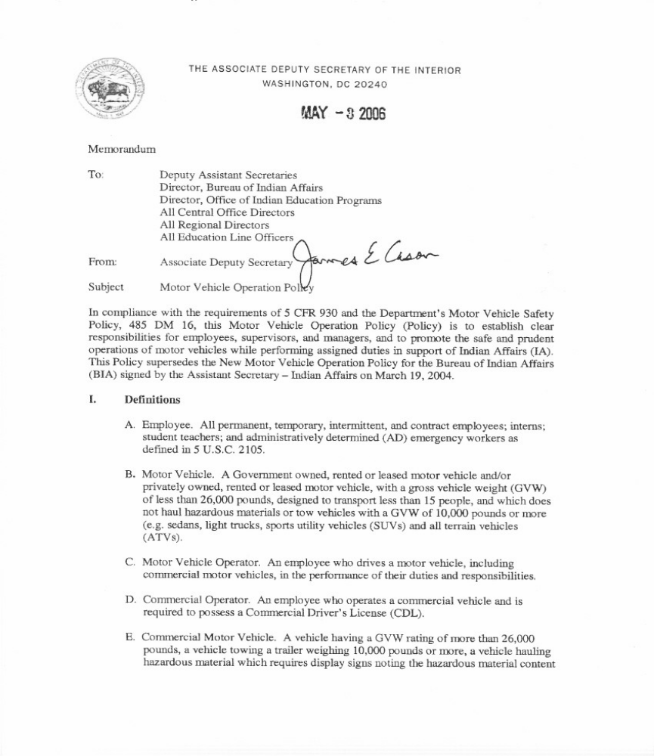
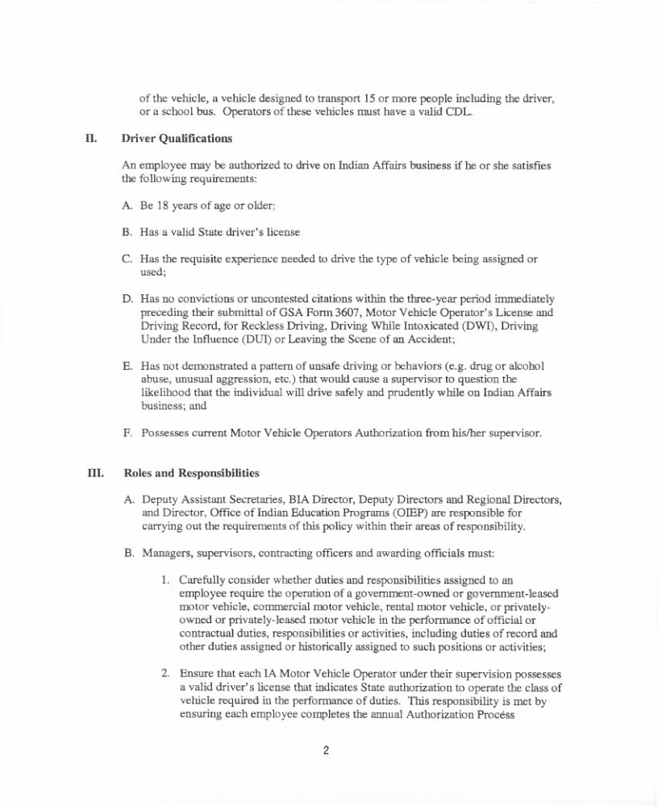

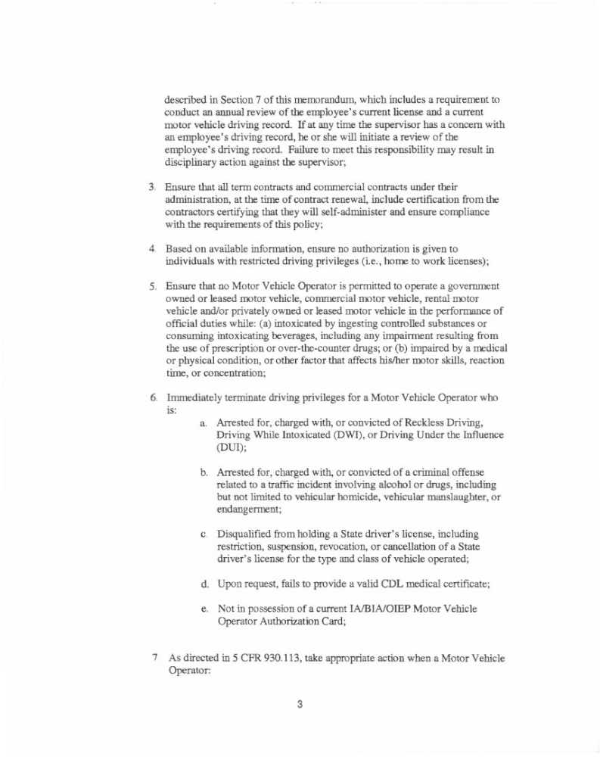

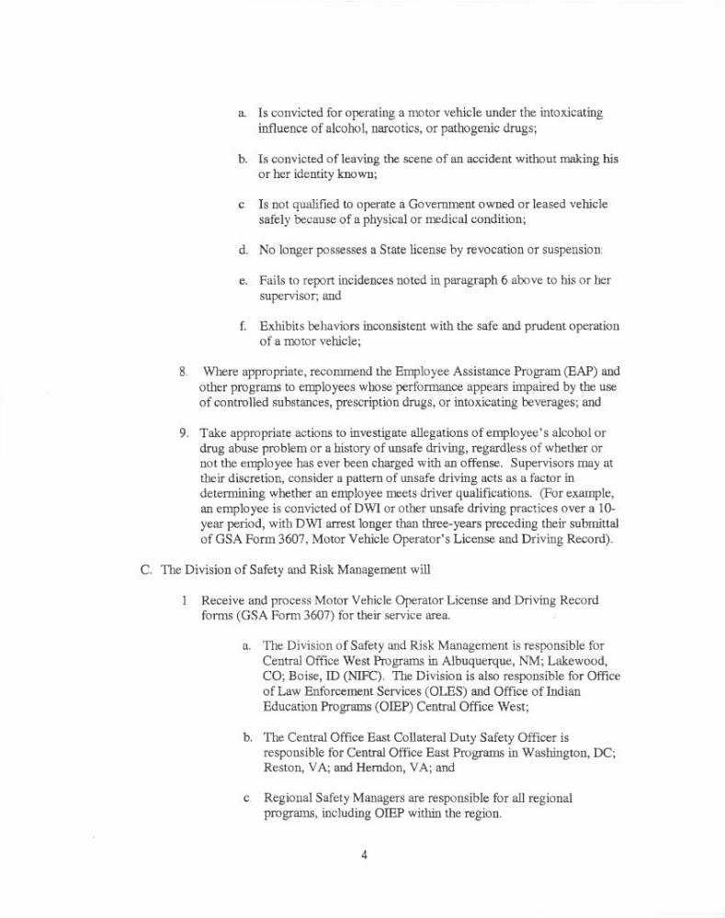

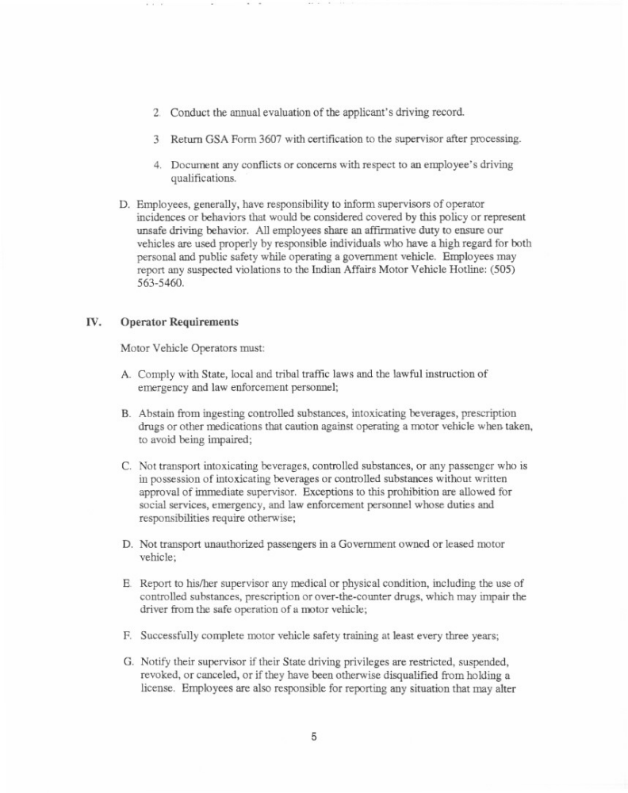

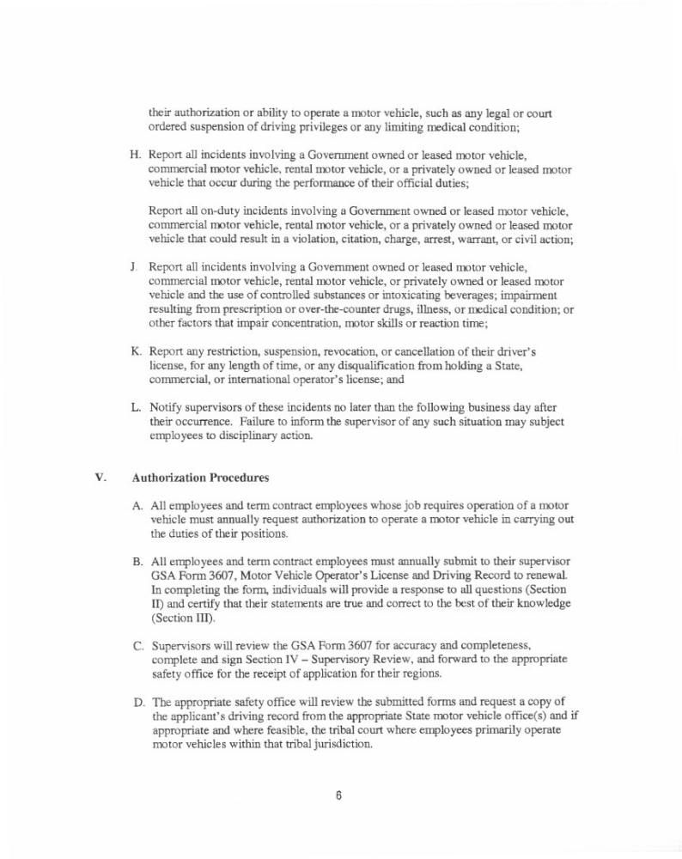

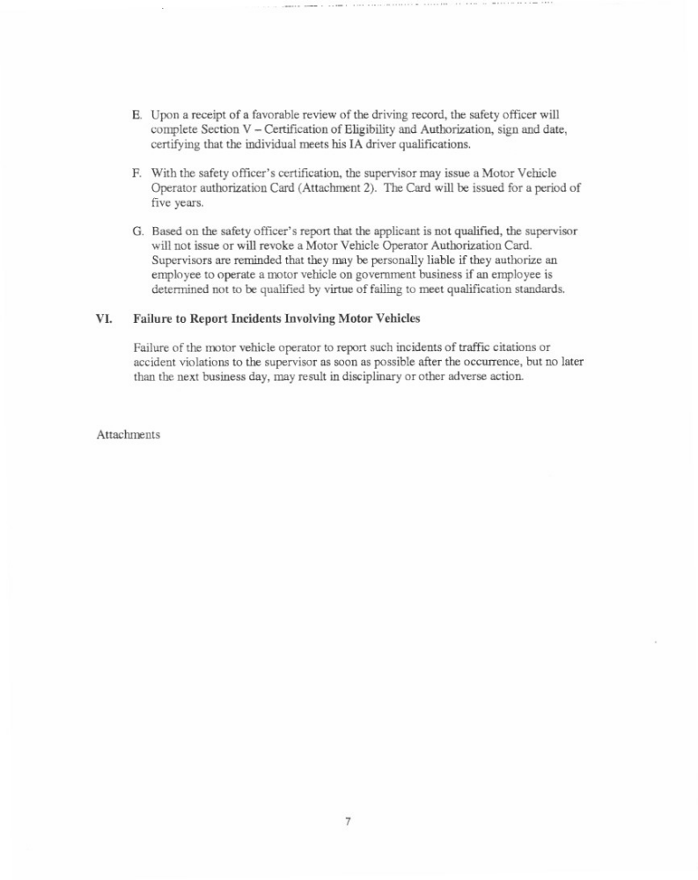
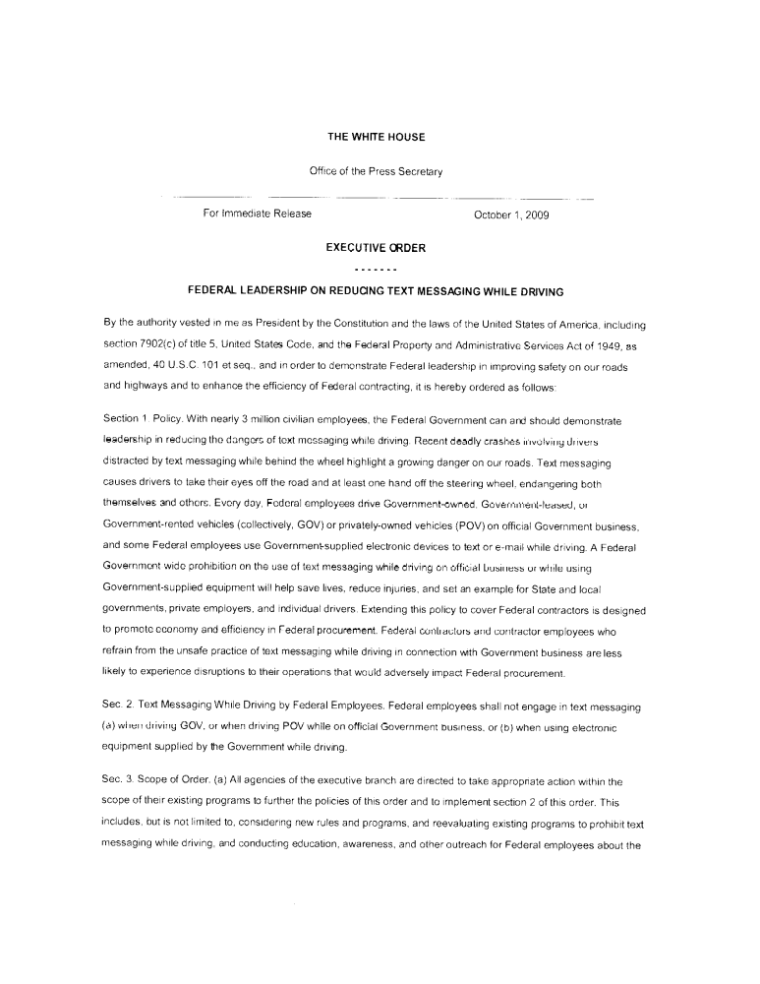
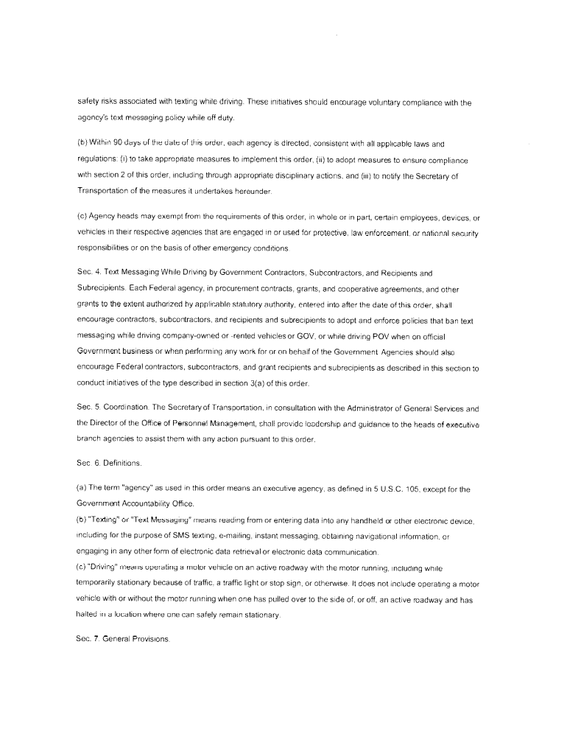
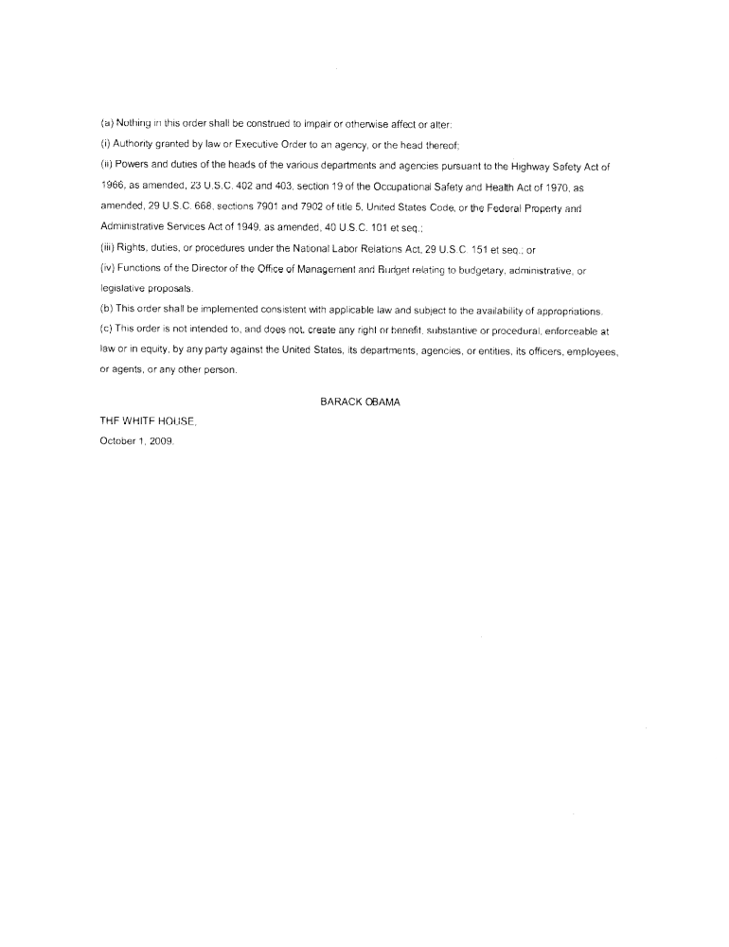

Some tribes have OSG shortfall funds in their base budgets that, before the year 2000, had been used for law enforcement programs.
A full-year appropriation for the Operation of Indian Programs (OIP) account was not enacted at the time the 2020 budget was prepared. Therefore, the budget assumes this account is operating under the Continuing Appropriations Act, 2019 (Division C of P.L. 115-245, as amended). The amounts included for 2019 reflect the annualized level provided by the continuing resolution. The amount shown reflects an increase of $21.119 million (13.38 %) from the enacted 2019 Continuing Resolution Self-Governance Compact Line amount of $157.790 million.

