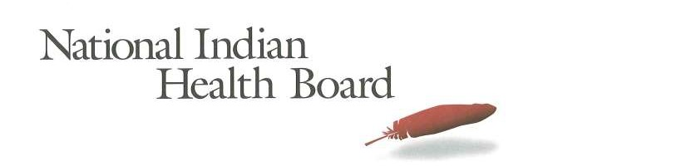

National Indian Health Board Resolution 18-17

Call to Congress to Enact Legislation Ensuring Medicaid Advances the Federal Trust Responsibility to American Indians/Alaska Natives

WHEREAS, the National Indian Health Board (NIHB), established in 1972, serves all Federally recognized American Indian/Alaska Native (AI/AN) Tribal governments by advocating for the improvement of health care delivery to AI/ANs, as well as upholding the Federal government’s trust responsibility to AI/AN Tribal governments; and

WHEREAS, Tribal Nations are political, sovereign entities whose status stems from the inherent sovereignty they possess as self-governing people predating the founding of the United States, and since its founding the United States has recognized them as such and entered into treaties with them on that basis; and,

WHEREAS, Tribal Nations have a unique government-to-government relationship with the Federal government, and it is required that the Federal government consult with Tribal Nations on any policy or action that will significantly impact Tribal governments and American Indians and Alaska Natives; and,

WHEREAS, in 24 U.S.C. § 1602(a)(1) Congress declared that “it is the policy of this Nation, in fulfillment of its special trust responsibilities and legal obligations to Indians…to ensure the highest possible health status for Indians and urban Indians and to provide all resources necessary to effect that policy”; and

WHEREAS, in 1955, Congress created the Indian Health Service (IHS) in order to help fulfill its trust responsibility for health care to Tribes; and

WHEREAS, the unmet health needs of AI/ANs are severe and the health status of AI/ANs is far below that of the general population of the United States, resulting in an average life expectancy for AI/ANs 4.5 years less than that for the U.S. all races population; and

WHEREAS, in 1976, Congress noted that Medicaid payments were a “needed supplement to a health care program which has for too long been insufficient to provide quality health care to the American Indian” (H.R. Rep. No. 94-1026-Part III); and

WHEREAS, in 1976, Congress established the authority for the IHS, Tribal Nations, and Tribal health organizations, to seek reimbursement under the federal Medicaid program in order to help fulfill its trust responsibility for health care to the Tribes; and

WHEREAS, in FY 2017, the congressional appropriations for IHS was only $3,026 per person,1 as compared to average per capita spending nationally for personal health care services of
$9,207;2 and

WHEREAS, the IHS continues to be funded by Congress at less than half of expected need— even when considering available government health insurance resources—leading to rationed care and worse health outcomes for AI/ANs;3 and

WHEREAS, the federal Medicaid program generates significant resources that are critical to the ability of Tribal Nations to meet the health care needs of Tribal citizens, but there are significant gaps in access to quality health care services under the federal Medicaid program for low- and moderate-income AI/ANs, depending upon state of residence; and

WHEREAS, AI/ANs across the United States have substantially different eligibility and access to services under the federal Medicaid program based on their state of residence; and

WHEREAS, state governments are not reimbursed for the costs of care provided by urban Indian health care providers to AI/ANs to the same degree that state governments are reimbursed for care to AI/ANs provided by IHS and Tribal health care providers; and

WHEREAS, the federal Medicaid program provides insufficient flexibility to Tribes to design and implement health service delivery approaches that meet the often times unique circumstances in Indian country; and

1 The figure on congressional appropriations for IHS includes funding for health care delivery as well as sanitation, facilities and environmental health. Per capita IHS appropriation was calculated from $4,957,856,000 in total appropriations divided by 1,638,687 Active Users. Source: 2017 IHS Expenditures Per Capita and Other Federal Health Care Expenditures Per Capita," February 26, 2018, available at: https://www.ihs.gov/ihcif/includes/ themes/responsive2017/display_objects/documents/2018/2017_IHS_Expenditures.pdf, last accessed 10/15/2018.
2 NHE Projections 2016-2025 –Tables, Table 5 Personal Health Care Expenditures; Aggregate and per Capita Amounts, Percent Distribution and Annual Percent Change by Source of Funds: Calendar Years 2016-2025; Per Capita Amount; Projected; available at https://www.cms.gov/Research-Statistics-Data-and-Systems/Statistics- Trends-and-Reports/NationalHealthExpendData/NationalHealthAccountsProjected.html.
3 “FY2017 Indian Health Service Level of Need Funded (LNF) Calculation” (shown at https://www.ihs.gov/ihcif/ includes/themes/responsive2017/display_objects/documents/2018/FY_2017_LevelofNeedFunded_(LNF)_Table.pdf
) indicates an LNF funding percentage of 46.6%. A preliminary LNF figure for FY 2018 of 48.6% was calculated by IHS, which includes consideration of third-party coverage made available through the Affordable Care Act.

WHEREAS, Tribal Nations have developed a legislative proposal to address these gaps in access to quality health care services which will create authority for states to extend Medicaid eligibility to all AI/ANs with household income up to 138% of the federal poverty level; authorize Indian Health Care Providers in all states to receive Medicaid reimbursement for health care services authorized under the Indian Health Care Improvement Act and delivered to AI/ANs; extend full federal funding (through 100% FMAP) to states for Medicaid services furnished by urban Indian providers to AI/ANs, in addition to services furnished by IHS/Tribal providers to AI/ANs; clarify that state Medicaid programs are authorized to implement Indian- specific policies and are not permitted to override Indian-specific Medicaid provisions in federal law through state waivers; and removes the limitation on billing by Indian health care providers for services provided outside the four walls of a clinic facility.

NOW THEREFORE BE IT RESOLVED, that the National Indian Health Board calls on Congress to enact legislation ensuring Medicaid advances the federal trust responsibility to American Indians and Alaska Natives; and

BE IT FURTHER RESOLVED, that this resolution shall be the policy of NIHB until it is withdrawn or modified by subsequent resolution.

CERTIFICATION

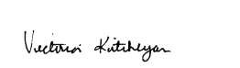The foregoing resolution was adopted by the Board, with quorum present, on the 8th day of November, 2018.

ATTEST:

___________________
Vice-Chair, Victoria Kitcheyan

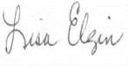
Recording Secretary, Lisa Elgin

