Attorney General's Advisory Subcommittee on Native American Issues Meets in New Mexico
August 30, 2019
U.S. Attorneys Visit Santa Ana and Acoma Pueblos, Discuss Missing and Murdered People, and Strategies to Reduce Crime and Violence in Indian Country
The Attorney General’s Advisory Subcommittee on Native American Issues (NAIS) convened August 28-30, in Santa Ana Pueblo, New Mexico, to discuss crime reduction strategies and victim services in Indian country. The NAIS consists of 53 U.S. Attorneys serving in districts that include Indian country or one or more federally recognized tribes and makes policy recommendations to Attorney General William Barr regarding public safety and legal issues in tribal communities.
On Wednesday, August 28, U.S. Attorney Trent Shores of the Northern District of Oklahoma and NAIS Chair, U.S. Attorney John Anderson of the District of New Mexico, and Governor Timothy Menchego of the Pueblo of Santa Ana provided opening remarks.
The morning’s first panel discussion centered on missing and murdered indigenous persons and was led by NAIS Vice Chair, U.S. Attorney Kurt Alme of the District of Montana. Panelists included Director Tracy Toulou of the Office of Tribal Justice, Department of Justice; Charles Addington, BIA Office of Justice Services; Supervisory Special Agent Briana Grant of the FBI Indian Country and Violent Crimes Unit. Panelists discussed tools for gathering and maintaining accurate missing persons data in Indian Country and guidelines and protocols for reporting and investigating murdered and missing persons cases.
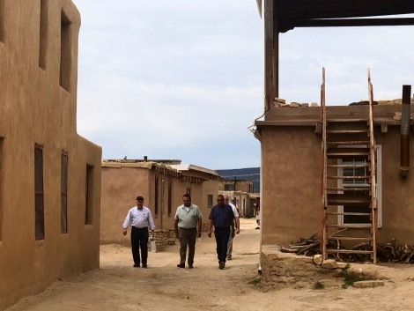
US Attorneys met with Pueblo of Acoma and toured Sky City, the oldest continuously inhabited settlement in North America.
During the panel, the NAIS reaffirmed its support for legislative efforts to address missing and murdered women and girls, including the goals of Savanna’s Act. Learn more about Savanna’s Act here. The NAIS also joined with Department of Justice officials in announcing the expansion of the Justice Department’s Tribal Access Program (TAP) in Indian country. TAP is a crucial tool for Indian Country law enforcement, especially when responding to murdered and missing cases. TAP provides federally recognized tribes the ability to access and exchange data with national crime information databases for both civil and criminal purposes and provides training as well as software and biometric/biographic kiosk workstations to process finger and palm prints. TAP also gives Tribes the ability to take mugshots and submit information to FBI CJIS. By the end of 2019, TAP will be deployed to more than 70 tribes with over 300 Tribal agencies participating. Nationwide, tribal leaders who utilize TAP have consistently discussed the benefits of the program with U.S. Attorneys serving on the NAIS and tribal liaisons.
The Justice Department will accept TAP applications from September 1 through October 31, 2019. Eligible tribes that are selected for participation will be notified in November. Learn about the fifth expansion of the program here.
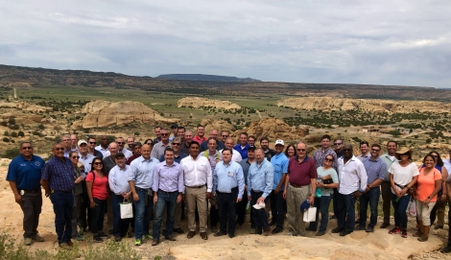
U.S. Attorneys and their tribal liaisons met with the Pueblo of Acoma during the NAIS meeting held August 28-30, 2019
The afternoon session kicked off with remarks from Principal Deputy Assistant Attorney General Katharine Sullivan of the Office of Justice Programs, identifying grants available to improve public safety in Indian country and rural Alaska. Ms. Sullivan leads the Department of Justice's principal funding, research and statistical component, overseeing more than $5 billion in grants and other resources to support state, local and tribal criminal and juvenile justice activities and victim services.
U.S. Attorney Bill Williams of the District of Oregon, led a panel highlighting drug trafficking strategies. The panel reiterated the importance of collaborative multi-agency efforts and showcased examples of disruption and deterrence of illicit drug rings.
Wednesday’s agenda also included a panel discussion that focused on investigating and prosecuting sex crimes perpetrated against Native American children. U.S. Attorney Erica McDonald of the District of Minnesota led the panel, which focused on the importance of multi-disciplinary teams and coordination with tribal services.
On Thursday, August 29, the NAIS traveled to the Pueblo of Acoma. NAIS members and tribal liaisons were greeted by Governor Brian Vallo who took part in discussions about building cultural understanding when working with Native American and Alaska Native peoples. The Pueblo of Acoma provided a tour of Sky City Cultural Center and Haak’u Museum. Sky City is the oldest continuously inhabited settlement in North America and is of significant cultural value to the Pueblo of Acoma and the state of New Mexico.

U.S. Attorneys and their tribal liaisons met with the Pueblo of Acoma Thursday and visited Sky City, the oldest continuously inhabited settlement in North America
In addition, Phillip Francisco, Chief of Police for the Navajo Nation, joined a panel discussion on law enforcement resources in Indian country. The panel stressed the importance of recruiting and retaining officers and investigators to serve in Indian country. U.S Attorney Ron Parsons of South Dakota led the discussion.
The day ended with a panel addressing tools to help protect Native cultural patrimony, including the Indian Arts and Crafts Act, Native American Graves Protection and Repatriation Act (NAGPRA), and the Archaeological Resources Protection Act (ARPA).The Indian Arts and Crafts Act of 1990 is a truth-in-advertising law that prohibits misrepresentation in the marketing of Indian arts and crafts products within the United States. NAGPRA is a federal law passed in 1990, providing a process for museums and federal agencies to return certain Native American cultural items—human remains, funerary objects, sacred objects, or objects of cultural patrimony—to lineal descendants, and culturally affiliated Indian tribes and Native Hawaiian organizations. ARPA secures, for the present and future benefit of the American people, the protection of archaeological resources and sites which are on public lands and Indian lands.
On Friday, August 30, U.S. Attorneys met in breakout sessions to discuss the subcommittee’s four priority areas in Indian country and rural Alaska: violent crime, drug trafficking, law enforcement resources, and white collar crime.

