GAO Strategic Planning Process
GAO publishes a strategic plan every 4 years to guide our work as we help lawmakers oversee federal operations and address the most important issues facing government and society. GAO’s current strategic plan covers 2022 to 2027. The GAO strategic plan is organized around four goals with associated strategic objectives and performance goals. Although the topics of individual engagements are primarily driven by Congress—either through request letters or mandates in law—the strategic planning process helps GAO ensure our aggregate body of work over time is coordinated and aligned around a set of key goals and objectives. While GAO constantly monitors developments that could affect Congressional priorities, GAO will begin the next formal strategic planning process sometime in 2026.
How Are Tribal and Native American Issues Incorporated Into the Strategic Plan?
Tribal and Native American issues have a dedicated strategic objective and associated performance goals reflecting ongoing and anticipated future engagements (see fig. 1 below).
Efforts to Fulfill the Federal Government’s Responsibilities to Tribes, Their Members, and Individual Descendants (Strategic Objective 1.10)
- Evaluate federal policies and programs that serve Indian Tribes, their members, and other indigenous groups (Performance goal 1.10.1)
- Assess federal efforts to protect Native American cultural, environmental, and natural resources (Performance goal 1.10.2)
- Examine federal efforts to foster tribal self-determination, self-governance, and economic development (Performance goal 1.10.3)
Underneath each performance goal, GAO also identifies high-level topics called key efforts that detail the agency’s near-term priorities to help the agency meet its performance goals and provide Congress with timely analysis of the most important issues facing the nation. For example, a key effort under Performance Goal 1.10.2 is “assess efforts to remediate environmental contamination affecting tribal lands.” (see fig. 2 below) During the five year period of the strategic plan, GAO may update these key efforts to reflect shifts in congressional priorities and our expected areas of work.
Tribal Issues Beyond the Strategic Objective
In addition to the tribal strategic objective above, tribal issues are also featured in other strategic objectives and performance goals.
Additional Strategic Objectives and Performance Goals Related to Tribal Issues
Strategic Objective | Related Performance Goal
Fair, Responsive, and Effective System of Justice | Evaluate federal efforts to assist states, Tribes, and localities with ensuring an effective law enforcement and justice system
Analyze the Government’s Fiscal Condition and Opportunities to Strengthen Management of Federal Finances | Analyze and examine the intersection of the federal government’s federal grant funding and other fiscal assistance to states, localities, territories, and Tribes
Programs and Financing to Serve the Health Needs of an Aging and Diverse Population | Assessing efforts to provide health care for potentially vulnerable populations, including programs serving Tribes and their members
Source: GAO 2022-2027 Strategic Plan, GAO 2022-2027 Strategic Plan: Goals and Objectives for Serving Congress and the Nation | U.S. GAO
How Does GAO Link its Work to its Strategic Plan?
On an annual basis, GAO teams work together to identify engagement topics that reflect the key efforts included under each performance goal. To do so, GAO staff review existing requests from Congress, Congressional mandates, and recent reports where follow-on work may be timely. We also have conversations with key Congressional committees (i.e., the Senate Committee on Indian Affairs and the House Subcommittee for Indigenous Peoples) and Congressional requesters to understand Congress’ short and medium term priorities.
Unique to the tribal issue area, staff also identify issues of concern we have heard directly from Tribes and at tribal conferences. GAO staff also take part in broader foresight analysis of key issues facing government and conduct background and media research to identify additional emerging topics of interest. Although individual engagements on issues of concern typically require a request from Congress or a mandate in law—understanding these and other emerging issues helps GAO ensure its work is timely and relevant.
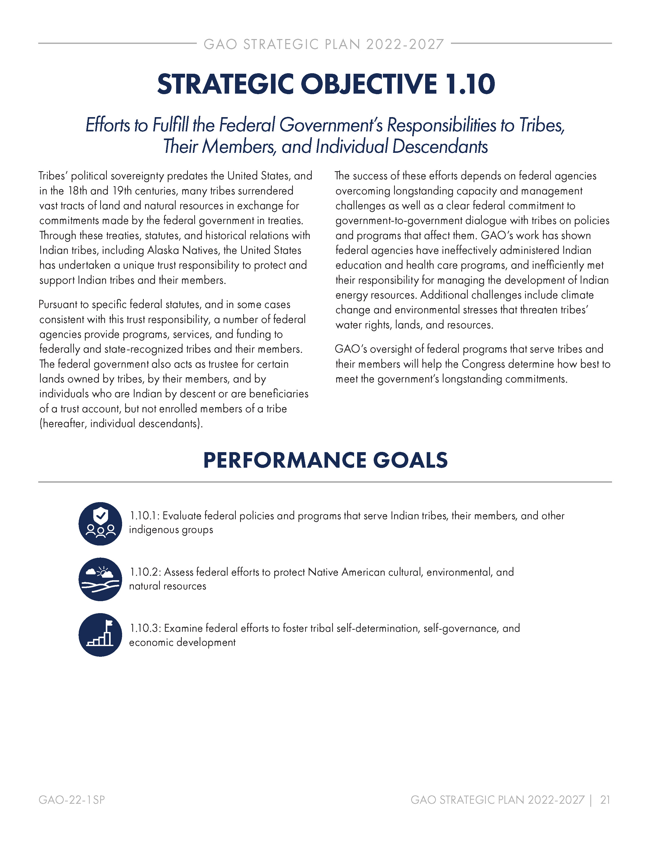
Figure 1: Excerpt from GAO’s Strategic Plan

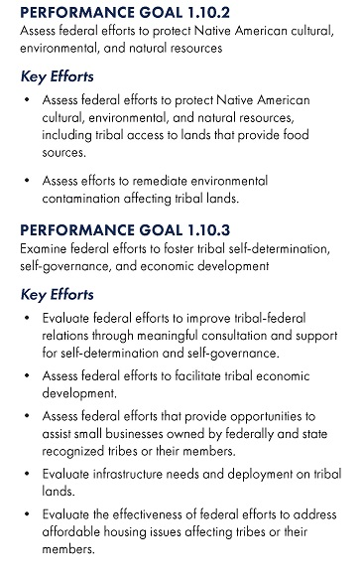
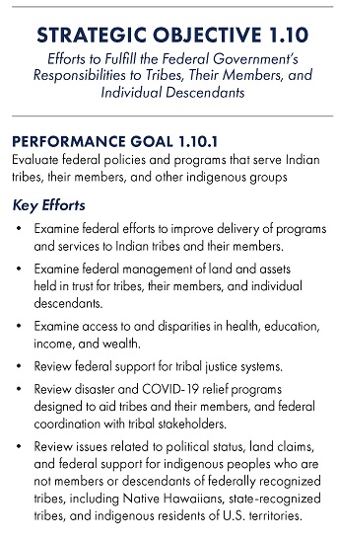
Figure 2: Excerpt from GAO’s Strategic Plan: Key Efforts

GAO 2022-2027 Strategic Plan: Key Efforts (GAO-22-2SP)
In certain instances, GAO may initiate an engagement without a request letter or mandate—under the Comptroller General’s Authority. These engagements are typically focused on cross-cutting issues that span multiple congressional committees, such as oversight of the federal government’s implementation of fraud risk controls.

